MY474 – Applied Machine Learning for Social Sciences

**Lecture 1 – Introduction**

Big data, high-dimensionality, high levels of covariate interactability – conventional parametric approaches are ill-equipped to model complexity effectively.

**Key concepts:**

* Bias/Variance tradeoff
  + Introduction of intended bias via ML
* Generalisability
  + Train/Test split
* Cross-validation
  + Estimation of generalization error without throwing away data
* Regularisation
  + How do we triangulate and weight important feature variables in our data?
* Feature engineering
  + How can we best represent the data for our specific task?
* Model selection
  + How do we select a model in a principled way?

**Methods & Tools:**

* Estimation
  + Gradient descent, maximum likelihood, expectation maximization (EM)
* Linear Models
  + Logistic regression, LDA, SVM, perceptron
* Regularisation
  + Cost-complexity pruning, lasso regression, ridge regression, elasticnet
* Non-parametric methods
  + Knn, decision trees, random forests, gradient boosting trees
* Dimension reduction
  + Principal component analysis (PCA)
* Clustering
  + K-means, hierarchical clustering

**Social Science Implications of the rise of ML**

Governance

* How do ML tools affect the durability of democracies/autocracies?
* How can we ensure critical mL systems are transparent?
* How do we hold organisations/governments accountable for misuse?

Social Impact

* How to avoid algorithmic bias and ensure fairness in our systems?
* How can we avoid negative externalities from ML systems? (violence, discrimination, false news, misinformation)

What is ML?

* Method of mining data for patterns or unobserved **latent variables**
* A method of **approximating unknown functions** using available data
* A predictive framework for **forecasting** future events
* A framework for **augmenting** and **automating** human decisions or tasks

**Unsupervised vs Supervised**

* **Unsupervised**
  + Inductive
  + Find patterns and structures among inputs x in the data D.
    - Clustering
      * Given data X, identify clusters of objects that balance within-cluster similarity and distinctness between clusters.
    - Dimension Reduction
      * Given data X, identify manifolds or underlying factors that represent the data in fewer dimensions.
  + Training data does not contain any outputs y. Structure is instead learned from underlying patterns and structure of the inputs x.
  + Examples included Topic Modelling, Word Embeddings, etc.
* **Supervised**
  + Learn an approximation g(x) of an unknown target function f:x -> y from data D.
    - X represents the input space of all possible inputs x.
    - Y represents the output space of all possible outputs y
  + Regression
    - y is quantitative & continuous
  + Classification
    - y is a value in a finite, unordered set
  + Data
    - D, a set of input-output examples
  + Active learning
    - Classifier -> unlabeled observations it has trouble clarifying -> labeled by expert -> labeled data added back to training set and fed back to model

**Perceptron Models (Linear)**

* Combination of inputs & weights
  + Takes weighted sum, assesses whether it is positive or negative.
    - Operationalized as 1 or -1.
  + Output is the sign: h(x) = sign(weights x)
    - P = inputs with label 1,
    - N = inputs with label -1,
    - Initialise w (weights) randomly,
    - While any input is misclassified, do the following:
      * Choose random observations,
      * If observation and weight*x < 0 then,
        + W = w+x, end
      * If observation and w*x => 0 then
        + W = w - x

**K-Nearest Neighbours (Knn)**

* The Knn learning model is the entire training dataset D, there is no learning required, just memorization.
* Instead of learning weights or parameters, each xi is laoded into memory
* Non-parametric model where the model structure is determined from the dataset with no assumptions about the underlying data distribution.
* Knn does not work well in high-dimensional space due to curse of high-dimensionality.
* Returns the majority class of the k nearest xi in the dataset D
* Nk(x*) consists of the k closest points to reference point x* in the training data (k-nearest neighborhood).

**OLS regression in ML framework**

* Assume f(.) is linear on coefficients Beta and has additive separable stochastic component epsilon.
* Our learning model would have a hypothesis set containing all possible linear functions in the form h(X) = X*Beta-hat
* In this example, g(x) Epsilon H is usually the least squares learning algo.
* g(x) is the best representation of the data in H because it minimizes the residual sum of squares.

**How do we choose a model?**

* **Parametric vs non-parametric**
  + **Parametric**
    - **Objective is to estimate parameters from training data**
    - **Assumptions about functional form**
      * **More interpretable, faster, more suited to statistical inference, require less data**
      * **Unlikely to closely match the true data generation process**
  + **Non-parametric**
    - **Objective is to get as close as possible to the data**
    - **Fewer assumptions about the functional form**
      * **Fewer assumptions, sometimes more accurate**
      * **Slow, prone to overfitting and the curse of dimensionality, requires more data**
* **Interpretable vs. Black Box**

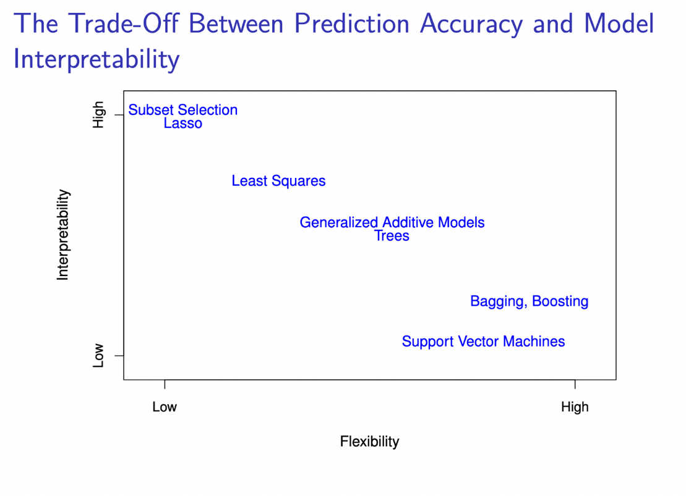

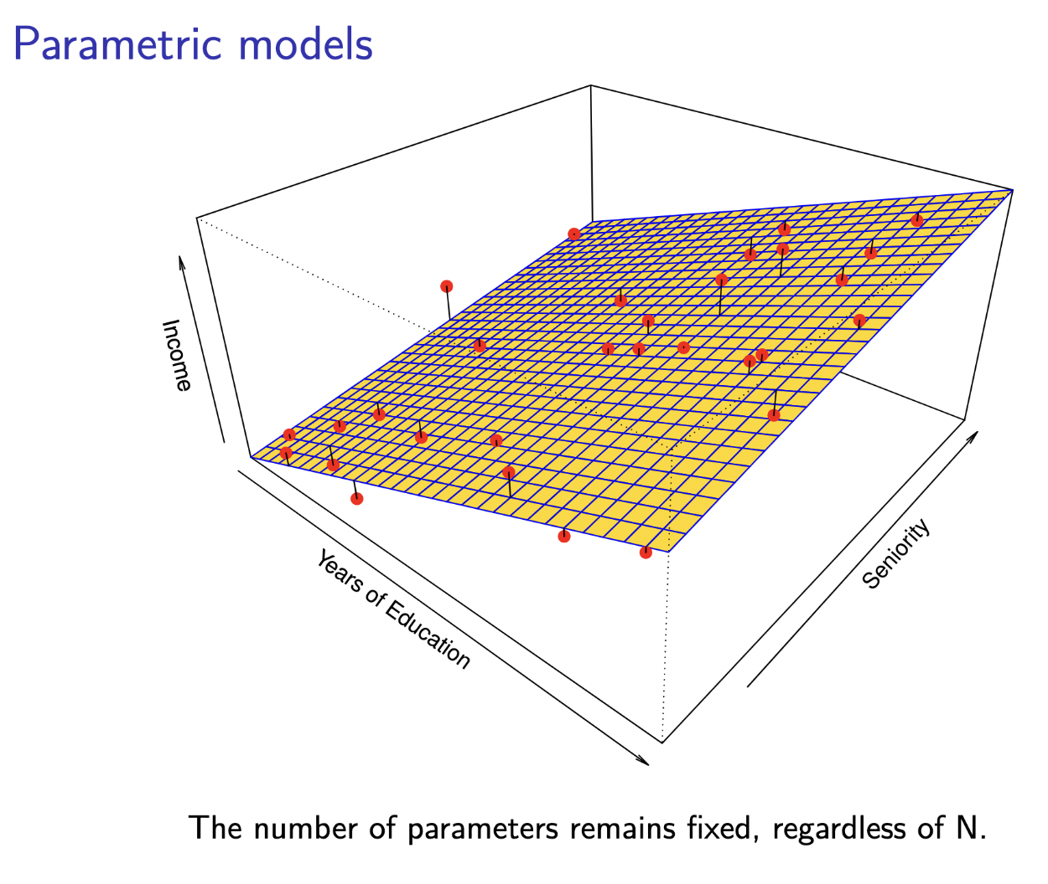

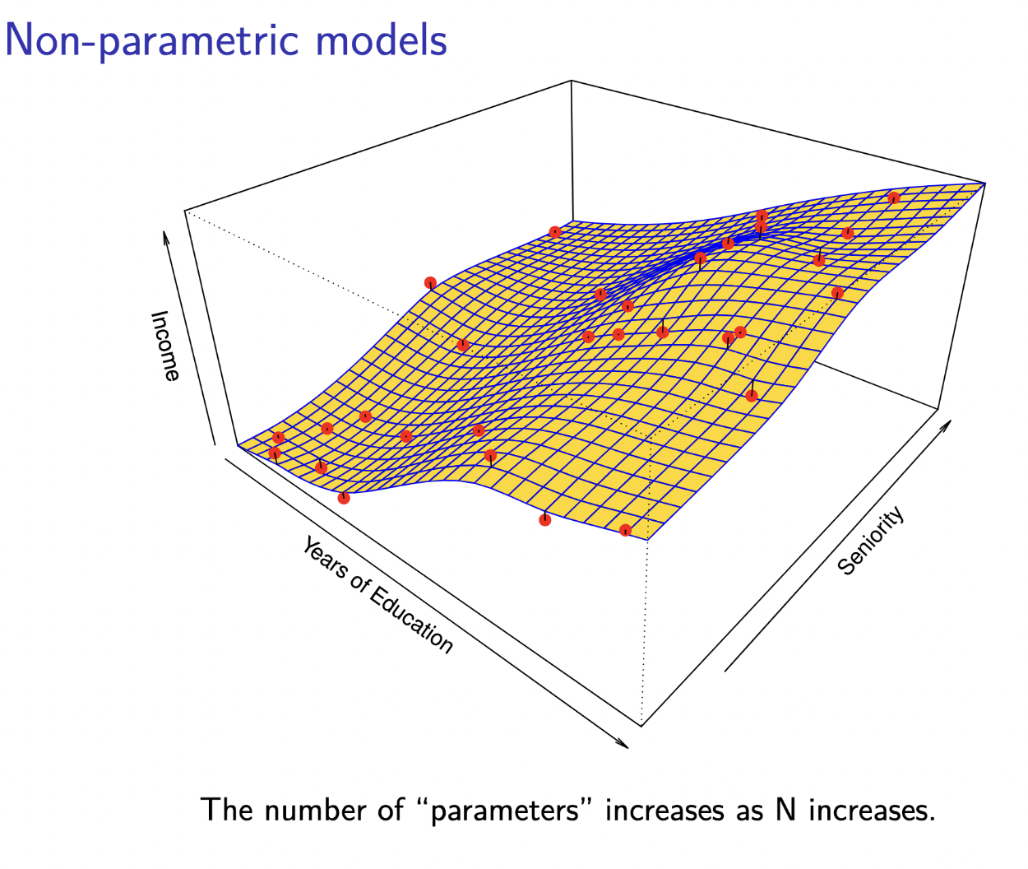

**Curse of dimensionality**

* As we increase the dimensions in our feature space it becomes sparser if we’re holding the number of observations constant.
  + Simply put, as we increase dimensions there are more possible variations and thus less ‘similar’ observations across the entire feature space.
* Implications
  + ‘Local’ methods are no longer local as dimensionality increases
  + If n points are sufficient to estimate a function in R^1, nP are needed to achieve similar accuracy in R^p.

**Lecture 2 – Generalisation, Inference, Prediction, and Causality**

**Explain vs. Prediction (Beta-hat vs. y-hat)**

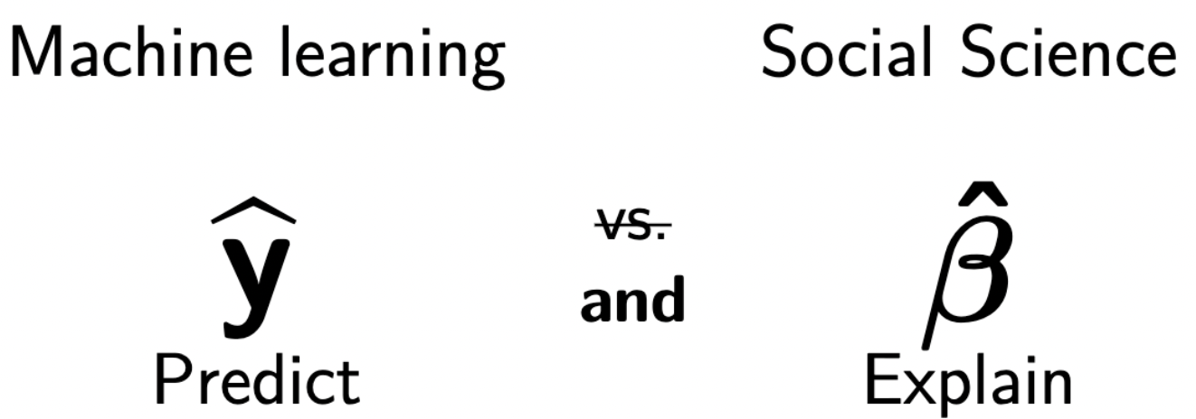

It’s important to view prediction and explanation as compliments.

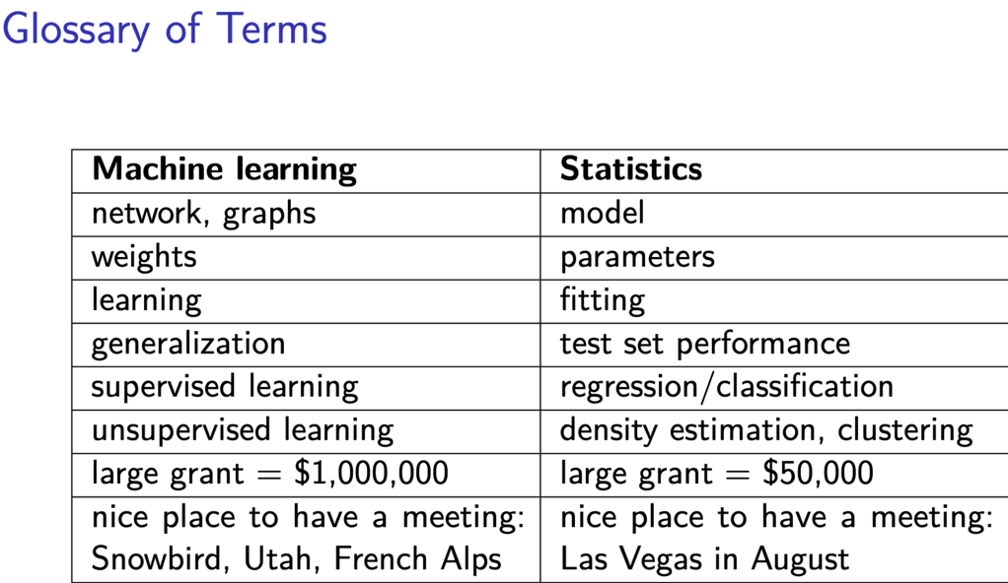

To explain or predict?

* Can use the same model to explain and predict, but the approaches are distinct!
  + Explain
    - Causality comes from theory, usually not the model itself
    - Inference, parameter estimates help us explain causal relationships
    - Simpler model variables that are statistically significant … not collinear
    - Model should be close to ‘true model.’
    - Look at p-values
  + Predict
    - Predict future outcomes given past observations
    - Evaluated based on generalization error
    - Collinearity does not matter
    - Model does not have to resemble a ‘true model.’

**Generalisation**

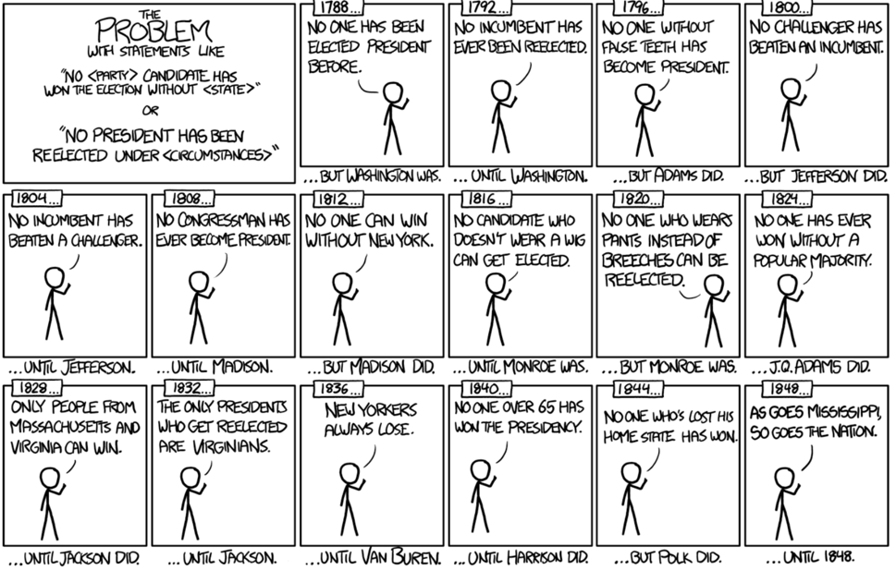 **OVERFITTING**

There will be a best possible model for our training data – but that doesn’t necessarily generalize best. We are trying to minimize generalization error.

Training error refers to ‘goodness of fit’ to our training data.

Test error refers to ‘generalisation error,’ that which we are trying to minimize.

**Two simple measures for error**

1. **Mean-squared prediction error** 
   1. A measure used to evaluate performace of g(x) for regression problems.
      1. Average of all errors squared
2. Misclassification error rate:
   1. A measure used to evaluate performance of g(x) for classification problems.
      1. TP, TN, FP, FN.

**The Bias/Variance Tradeoff**

Recall the bias of an estimator is defined as: the estimate, minus the expectation

Recall the variance of an estimator is: the estimate, minus the expectations of the estimates squared

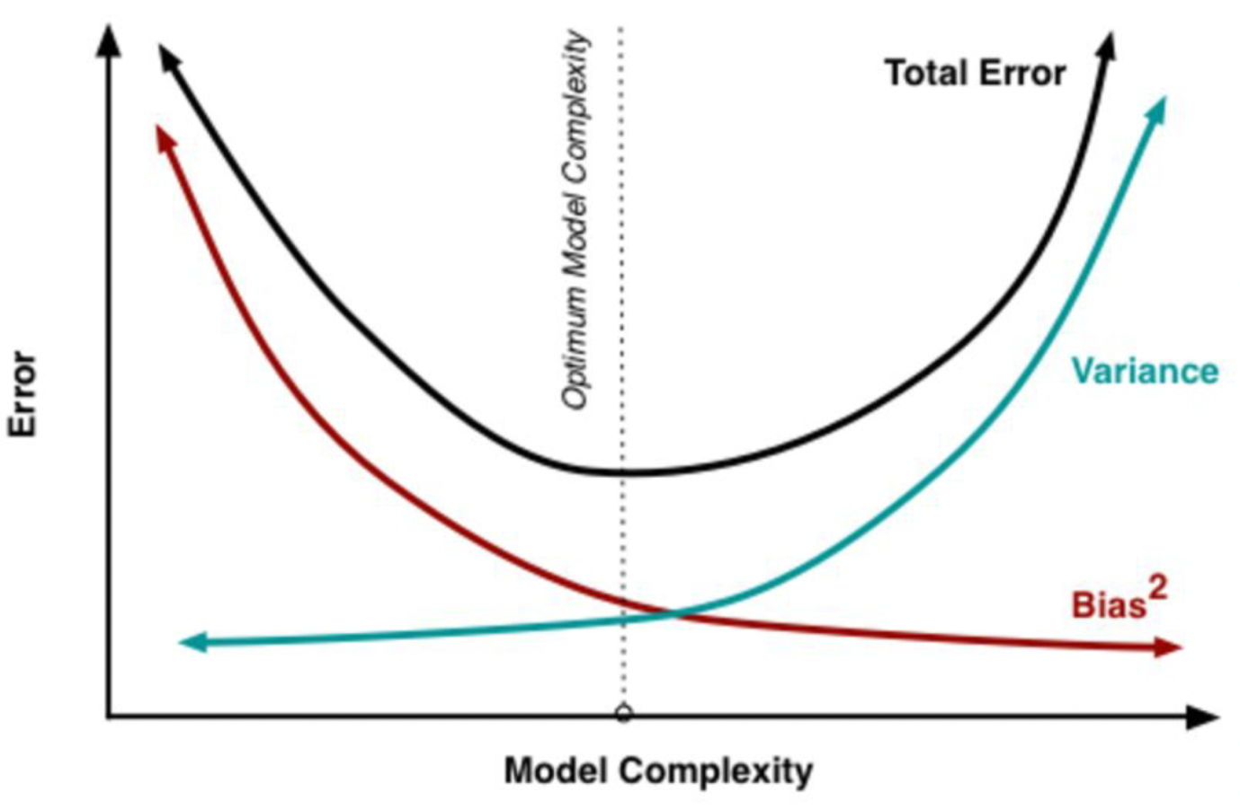

As complexity of g(x) increases, the variance increases and its bias decreases.

As complexity of g(x) decreases, the variance decreases and the bias increases.

Choosing the complexity based on average test error amounts to a bias-variance trade-off.

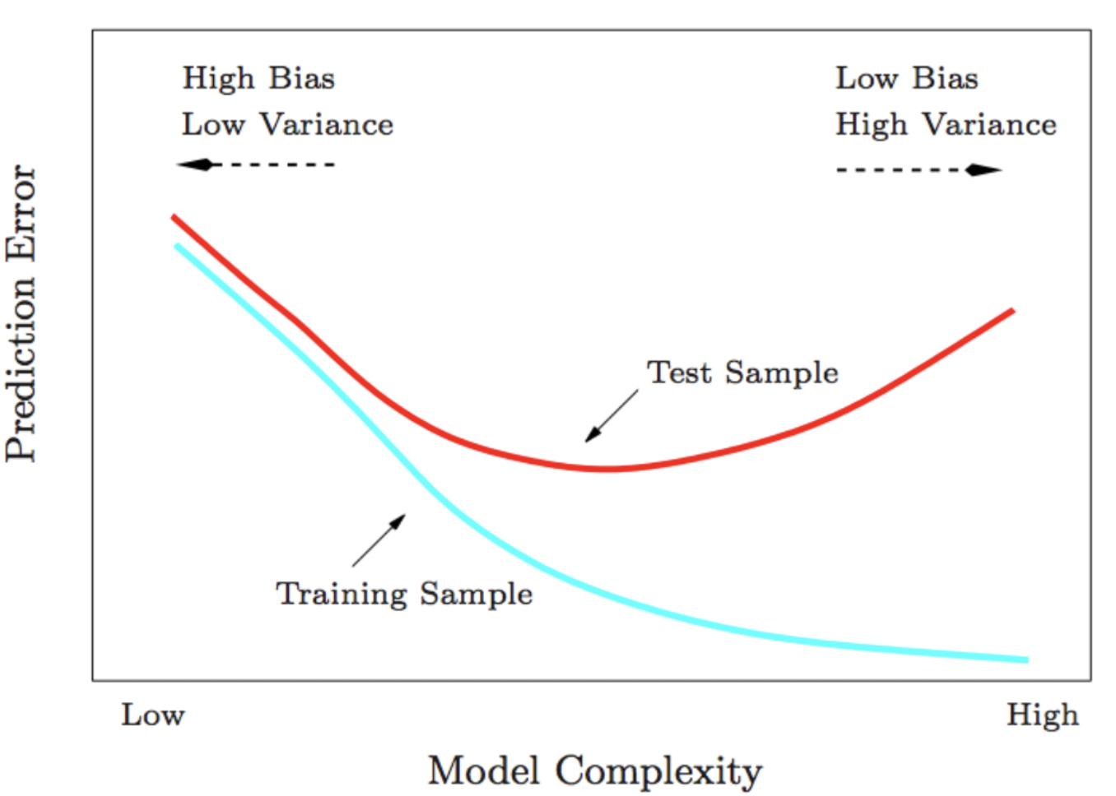

Complexity increases (more like k=1 rather than k=100, so overfitting), thus variance increases, and bias **decreases**.

As complexity increases(k = 100, rather than k = 1, so underfitting and oversmoothing), thus **variance decreases** and **bias increases.**

**Intuition behind bias and variance**

Models are biased when:

* Parametric: The form of the model does not include all the necessary variables (omitted variable bias)
* Parametric: The functional form is too simple (e.g., a linear approximation)
* Non-parametric: The model provides too much smoothing.

Models are variable when:

* Parametric: The form of the model incorporates too many variables.
* Parametric: The functional form is too complex.
* Non-parametric: The model does not provide enough smoothing.

**Class-imbalanced Data**

How do we deal with class-imbalanced data? We get a strong accuracy score by just predicting the majority class – but this is unhelpful. For example, predicting lack of COVID-19 will have a fairly high accuracy but is unhelpful.

Recall = TP / TP + FN (Of all the positives (actual), how many did we predict as positive?)

* E.g., we got 4/10 of the positives, so 0.4

Precision = TP/ TP + FP (What proportion of predicted positives are in fact positive?)

* E.g., we said 6 were positive, and only 4 actually were, so 0.666

Performance measures: F1, Fk

* F1 is a performance measure that balances precision and recall
* F1 is the harmonic mean of the two measures
* The ‘1’ in F1 represents a parameter that can be adjusted to weight the relative importance of precision and recall:
  + A bigger k weights recall higher than precision, a smaller k weights precision higher than recall.

**Reducible vs. Irreducible Error**

We can reduce the reducible error by usig the most appropriate statistical learning technique to estimate f. However, our prediction would still have some erorr in it because Y is also a function of epsilon, which, by definition, cannot be predicted using X. Therefore, variability associated with epsilon also affects the accuracy of our predictions. This is known as the irreducible error.

**Estimating f**

**Parametric**

* Assumptions about the functional form, or shape, of f.

**Non-parametric**

* Seek an estimate of f that gets as close to the data points as possible without being too rough or wiggly.
* No assumptions about functional form of f.
* Do not reduce the problem of estimating f to a small number of parameters and thus a large number of observations is required in order to obtain an accurate estimate for f.

**Thus:**

* **There is a trade-off between prediction accuracy and model interpretability.**

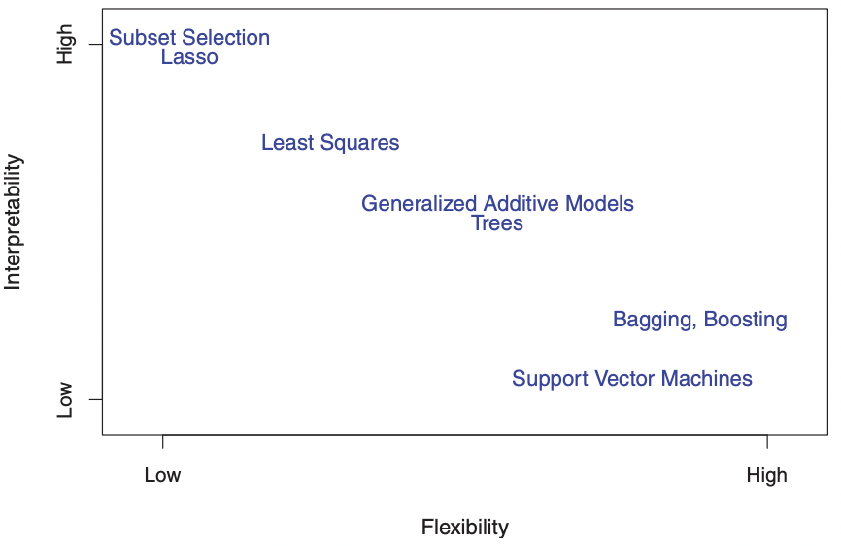

One might reasonably ask the following question: why would we ever choose to use a more restrictive method instead of a very flexible approach?

* More interpretable
* We have established that when inference is the goal, there are clear advantages to using simple and relatively inflexible statistical learning methods. In some settings, however, we are only interested in prediction, and the interpretability of the predictive model is simply not of interest.
* We will often obtain more accurate predictions using a less flexible method. This phenomenon, which may seem counterintuitive at first glance, has to do with the potential for overfitting in highly flexible methods.

**Degrees of freedom are akin to value of k, determines the number of smoothing splines.**

**Bias/Variance Tradeoff**

it is possible to show that the expected test MSE, for a given value x0, can always be decomposed into the sum of three fundamental quantities: the variance of ˆf(x0), the squared bias of ˆf(x0) and the variance of the error variance bias terms .

in order to minimize the expected test error, we need to select a statistical learning method that simultaneously achieves low variance and low bias. Note that variance is inherently a nonnegative quantity, and squared bias is also nonnegative. Hence, we see that the expected test MSE can never lie below Var(), the irreducible error from

What do we mean by the variance and bias of a statistical learning method?

* Variance refers to the amount by which ˆf would change if we estimated it using a different training data set. Since the training data are used to fit the statistical learning method, different training data sets will result in a different ˆf. But ideally the estimate for f should not vary too much between training sets. However, if a method has high variance then small changes in the training data can result in large changes in ˆf. In general, more flexible statistical methods have higher variance.
* On the other hand, bias refers to the error that is introduced by approximating a real-life problem, which may be extremely complicated, by a much simpler model. For example, linear regression assumes that there is a linear relationship between Y and X1, X2,...,Xp. It is unlikely that any real-life problem truly has such a simple linear relationship, and so performing linear regression will undoubtedly result in some bias in the estimate of f.
* As a general rule, as we use more flexible methods, the variance will increase and the bias will decrease. The relative rate of change of these two quantities determines whether the test MSE increases or decreases. As we increase the flexibility of a class of methods, the bias tends to initially decrease faster than the variance increases. Consequently, the expected test MSE declines. However, at some point increasing flexibility has little impact on the bias but starts to significantly increase the variance. When this happens the test MSE increases
* Good test set performance of a statistical learning method re- bias-variance quires low variance as well as low squared bias. This is referred to as a trade-off trade-off because it is easy to obtain a method with extremely low bias but high variance (for instance, by drawing a curve that passes through every single training observation) or a method with very low variance but high bias (by fitting a horizontal line to the data). The challenge lies in finding a method for which both the variance and the squared bias are low. This trade-off is one of the most important recurring themes in this book.

The Bayes Classifier

It is possible to show that the test error rate given in 2.9 is minimized, on average, by a very simple classifier that assigns each observation to the most likely class, given its predictor values. In other words, we should simply assign a test observation with predictor vector x0 to the class j for which Pr(Y = j|X = x0) is largest.

Note that is a *conditional probability:* it is the probability that Y = j, given the observed predictor vector x0. There is called the Bayes Classifier, and in a two-class problem the Bayes Classifier corresponds to predicting class one if Pr(Y = 1 | X = x0).

**Mullainathan, S., Spiess, J. “Machine Learning: An Applied Econometric Approach,” *The Journal of Economic Perspectives,* 31(2), 87-106, 2017.**

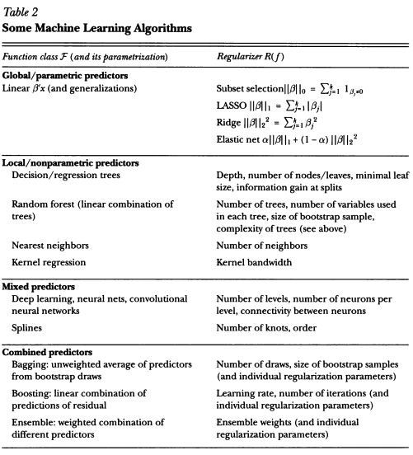

**Introduction to Statistical Learning – Chapter 3: Linear Regression**

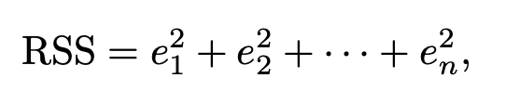

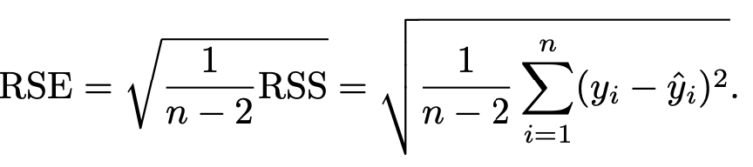

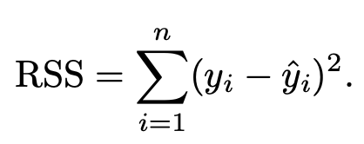

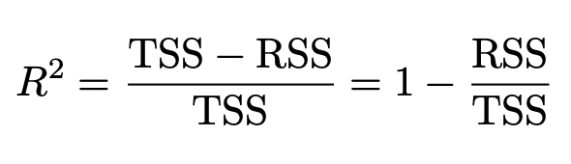

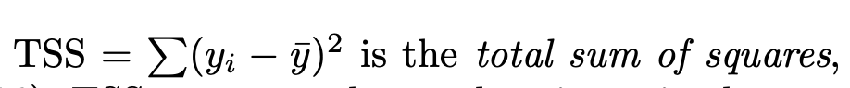

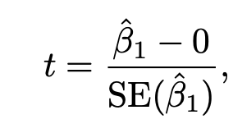

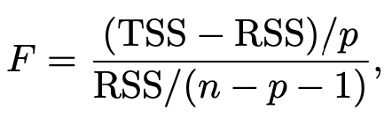 (At least one Bj is non-zero)

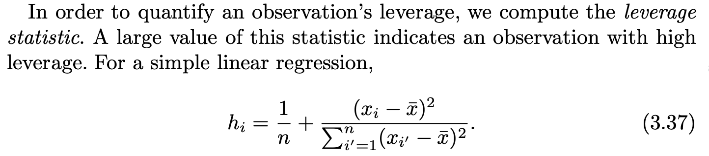

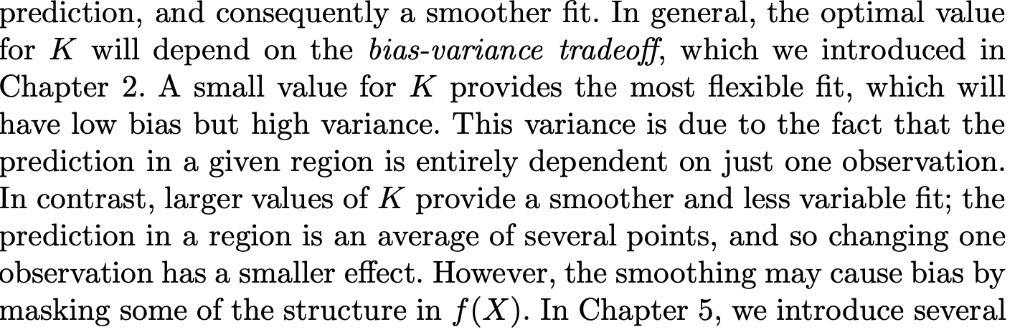

Bias variance tradeoff explained well

**Introduction to Statistical Learning – Chapter 4: Classification**

**Logistic Regression**

Need to define probability limits of outcome variable between 0 and 1, so we use the logistic function!

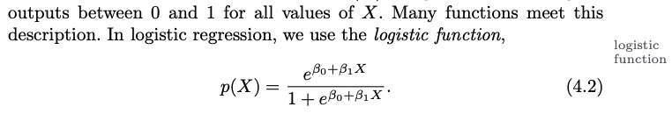

To fit the model, we use the *maximum likelihood* function.

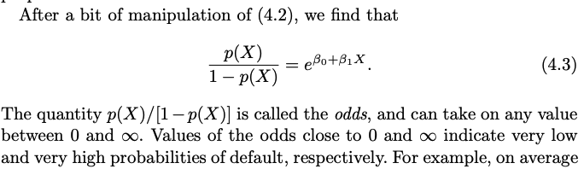

Odds above

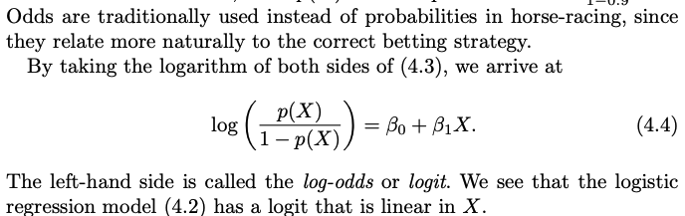

Log odds!

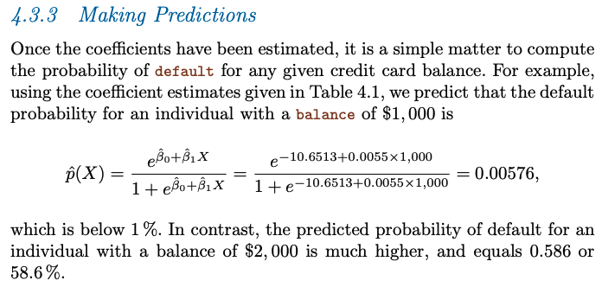

Calculating logistic regression predictions

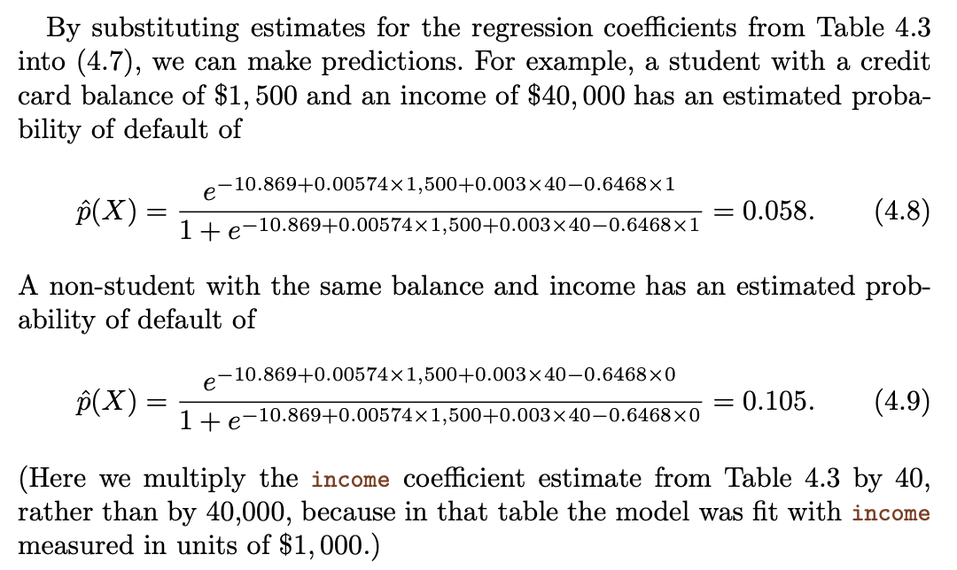

Calculating multiple logistic regression predictions

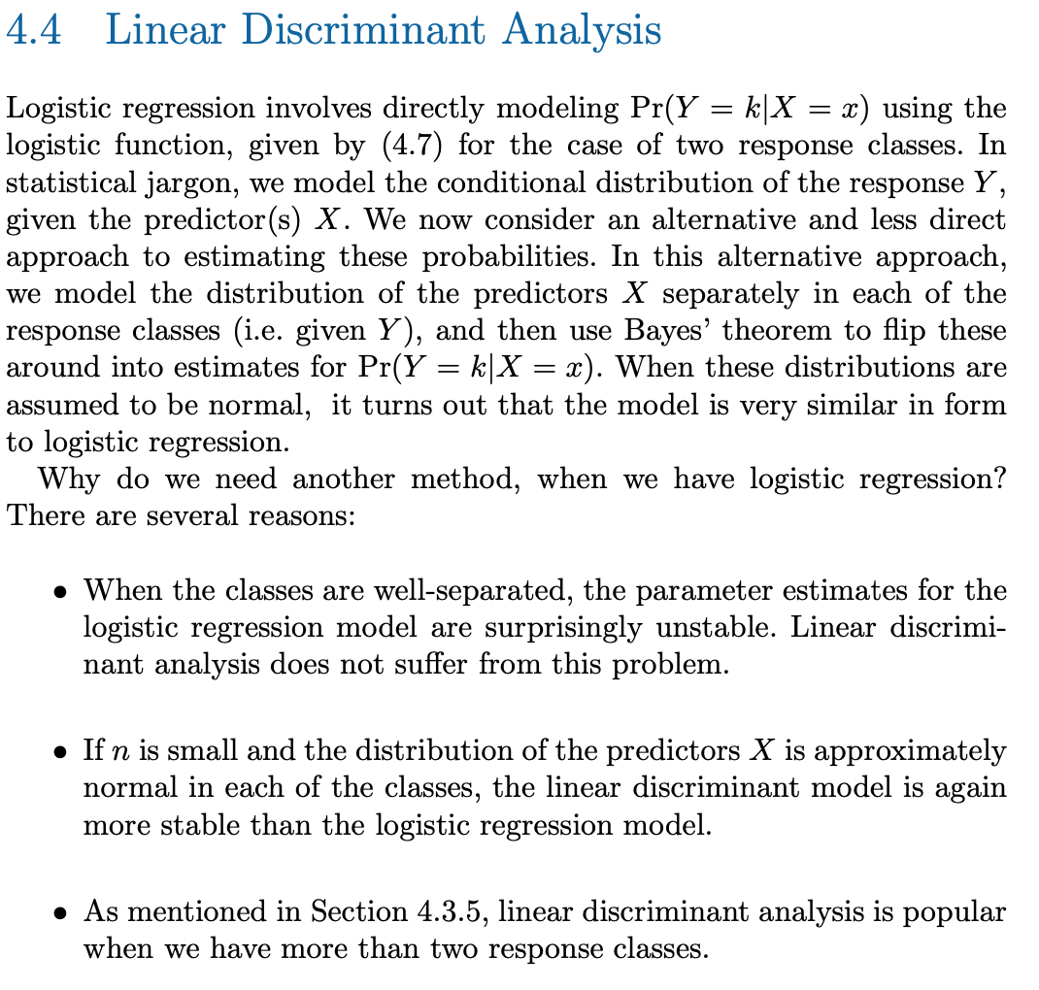

LDA use cases and benefits

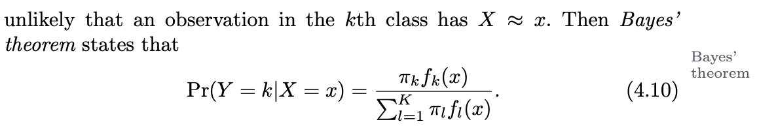

Bayes’ Theorem

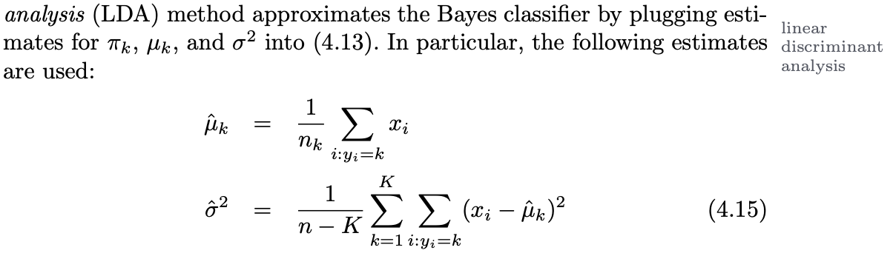

LDA approximating the bayes classifier - The word linear in the classifier’s name stems from the fact that the discriminant functions δˆk(x) in (4.17) are linear functions of x (as opposed to a more complex function of x).

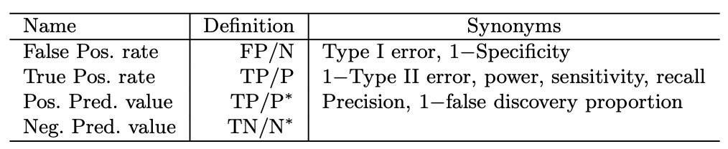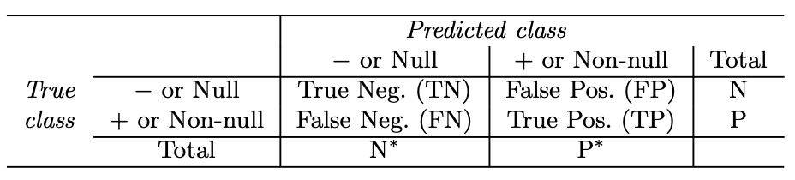

Sensitivity, specificity, 1 – specificity, recall, precision

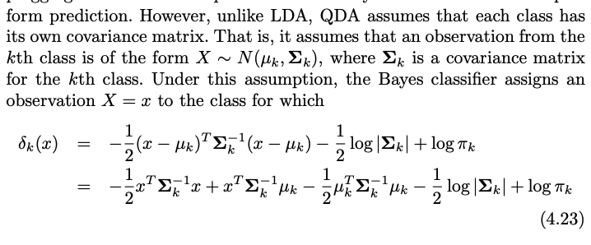

Difference between QDA & LDA

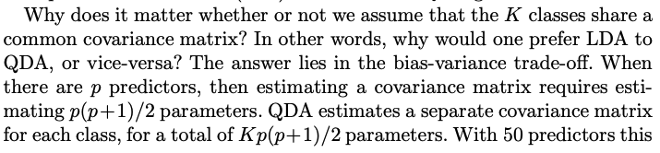

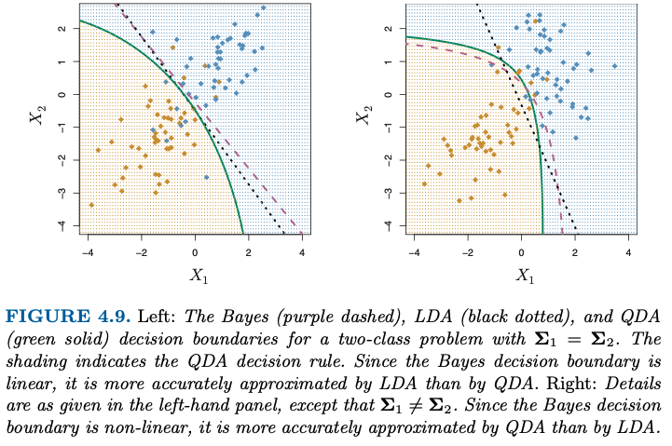

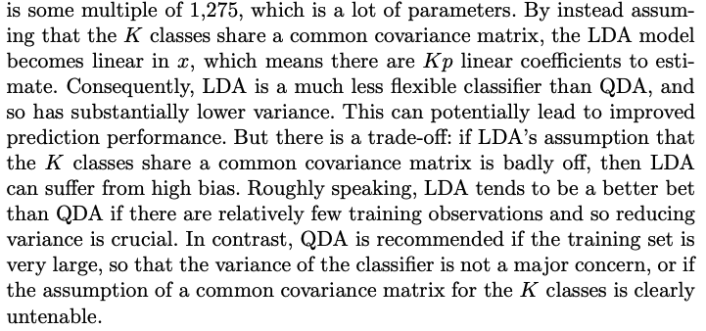

**Lecture 3: Linear Discriminant Analysis, Logistic Regression**

**Decision-Theoretic Framework for Classification**

The **class prior** gives us the probability of observing each class k, e.g. ( ¼ , ½, ¼ )

**Loss Function – Calculates a penalty for incorrect classifications**

Let the loss function be L(y-hat, y) be the loss associated with the assigning class y-hat to the feature vector x when its true class is y. Loss is 0 is y-hat equals y, it’s greater than 1 if not.

For **classification error loss,** all errors are treated equally: loss is 0 if the label is correct and 1 if it is incorrect.

In practice, the loss is not symmetric:

* Because of the task at hand: e.g. a false negative for a coronavirus test is more serioud than a false positive.
  + Solution: choose a loss function that tolerates false positives more than false negatives.
* Because of class imbalance: we want the classifier to identify all classes regardless of how many examples of each class we have.
  + Solution: multiple loss function by weights that are inversely proportional to class frequencies Pi-k.:
    - Wk = N / (|y| * nk)

**Bayes Rule – Assign observation x to the class with the maximum posterior probability given x.**

1. Assume class densities pk(x) and the prior probabilities pi-k are known in advance for all k.
2. Use the classification error loss
3. The posterior probability of class k given x is p( k | x )

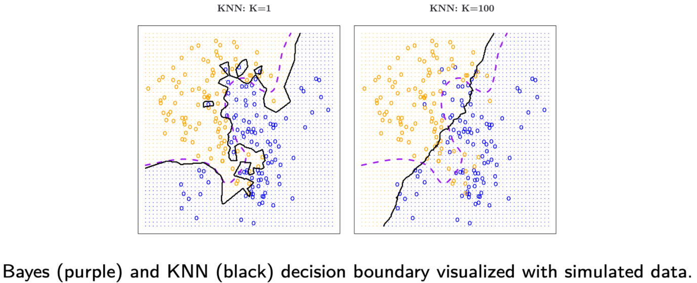

The true risk cannot be calculated, as we don’t have the true priors.

In practice, we assess performance with:

* Apparent error rate, or training error: error rate of our decision rule when applied to the training data
* True error rate, or test error: the error rate of our decision rule when applied to new independent data.

Discriminant Analysis is a special case of the Bayes classifier when we assume normal densities and equal covariances.

**Lecture 4: Gradient Descent, Bootstrap, Cross-Validation, Hyperparameters**

**Gradient Descent**

Ambition is to minimize gradient of error function in order to best fit the data. Loss function, in this case, is the gradient of error

The gradient tells us the direction of the greatest increase of the error, and so we move away from it towards the minimum of that function (loss function). In lecture terms: the gradient of the loss gives the direction of the prediction error and we can move in the opposite direction to minimize that error.

How much we move is a parameter lambda called the learning rate, as shown below: 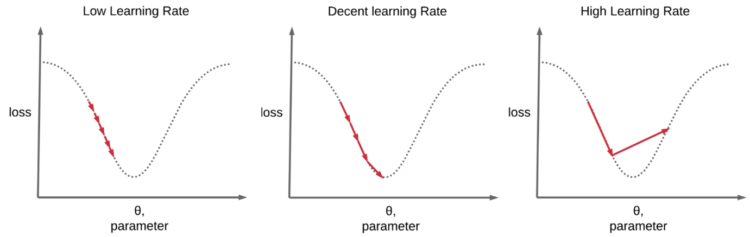

We want to choose lambda that minimises the time to convergence and gives us the right answer.

**Batch Gradient Descent**

* Pseudo-code with algorithmic notation

1. Set tolerance parameter epsilon to positive real value;
2. Set learning rate parameter lambda to positive real value;
3. Initialise Beta-hat to a random non-zero vector;
4. While Loss function is greater than epsilon, do the following:
5. Subtract lambda*loss function from Beta, on entire vector at the same time.

**Stochastic Gradient Descent**

* Look at single observation and update loss function with respect to one observation.
* Then update by going through one observation at a time, with replacement.

1. Set learning rate parameter lambda to positive real value;
2. Initialise Beta-hat to a random non-zero vector;
3. For epsilon <- 0 to E, do:
   1. Shuffle D to prevent cycles;
   2. For each (xi, yi) epsilon D do;
   3. Compute h-hat <- h(xi);
   4. Compute the loss Li(y-hat, y-i);
   5. Compute the gradient of the loss delta*Li(y-hat, y-i);
   6. Update parameters Beta-hat <- Beta-hat – Lambda* delta*Li(y-hat, y-i);
   7. End
4. End

**Cross-validation – A resampling method!**

These methods refit a model of interest to samples formed with the training set, in order to obtain additional information about the fitted model. For example, they provide estimates of test-set prediction error and the standard deviation and bias of our parameter estimates.

We aim to find g(x) that approximates an unknown function f(x).

* There are, however, many model specs to choose from:
* Two important goals:
  + **Model selection:** Estimating the performance of different models in order to choose the best one
    - **We need to train several models, but don’t want to throw away data.**
  + **Model Assessment:** Having chosen a final model, estimating its prediction error on new data.
    - **For model assessment, we would ideally have a large designated test set that is never used to train models; this is often not feasible.**

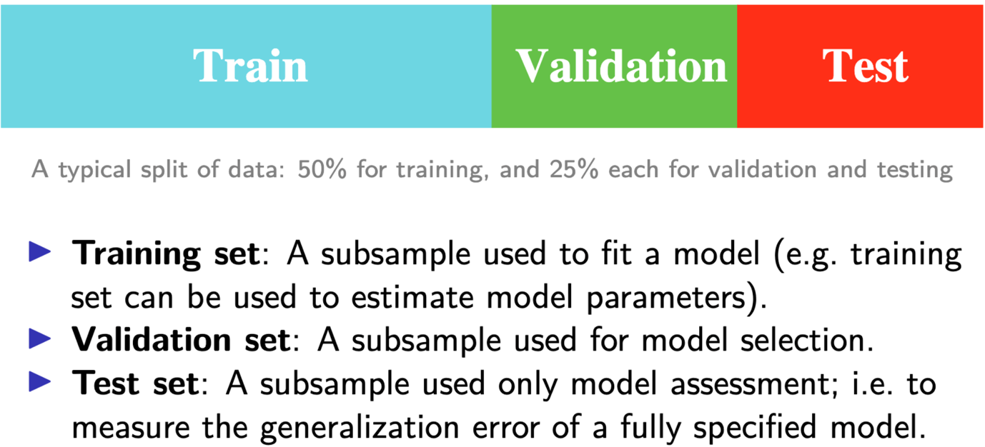

**Validation-Set Approach**

* Here, we randomly divide the available set of samples into two parts: training set and a validation set.
* Model is fit on training,, and the fitted model is used to predict the responses for the observations in the validation set.
* The resulting validation-set error provides an estimate of the test error, typically assessed using MSE (continuous) or misclassification rate (categorical).

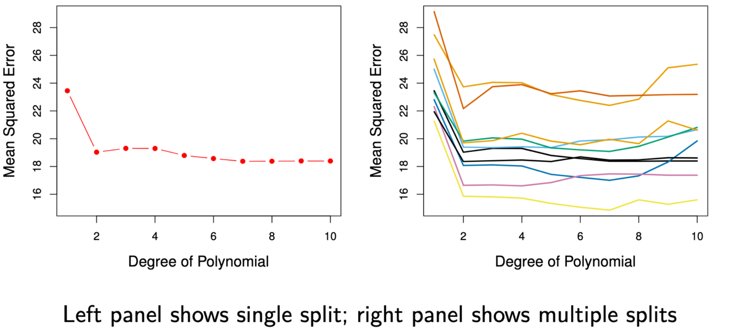

We use multiple splits and average to deal with variation.

**K-fold Cross-Validation**

Estimates of generalization error from one train/validation split can be noisy, so shuffle data and average over K distinct validation partitions instead.

* Widely used approach for estimating test error
* Can be used to select best model.

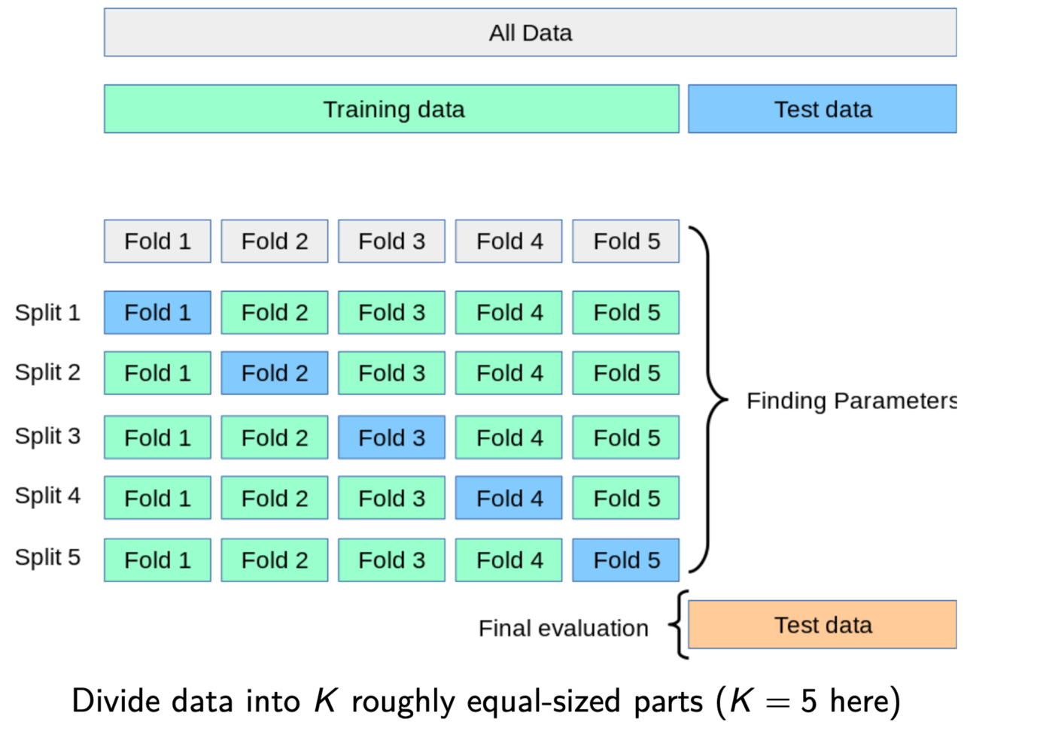

How it works:

1. Randomly divide the data into K parts of equal length.
2. Hold out one of the parts to be the ‘test’ data.
3. Use all remaining data to train the model.
4. Predict on the held-out part and compute error rate
5. Repeat steps 2-4 for each of the K parts.
6. Average all ‘test’ errors to obtain the cross-validation error.

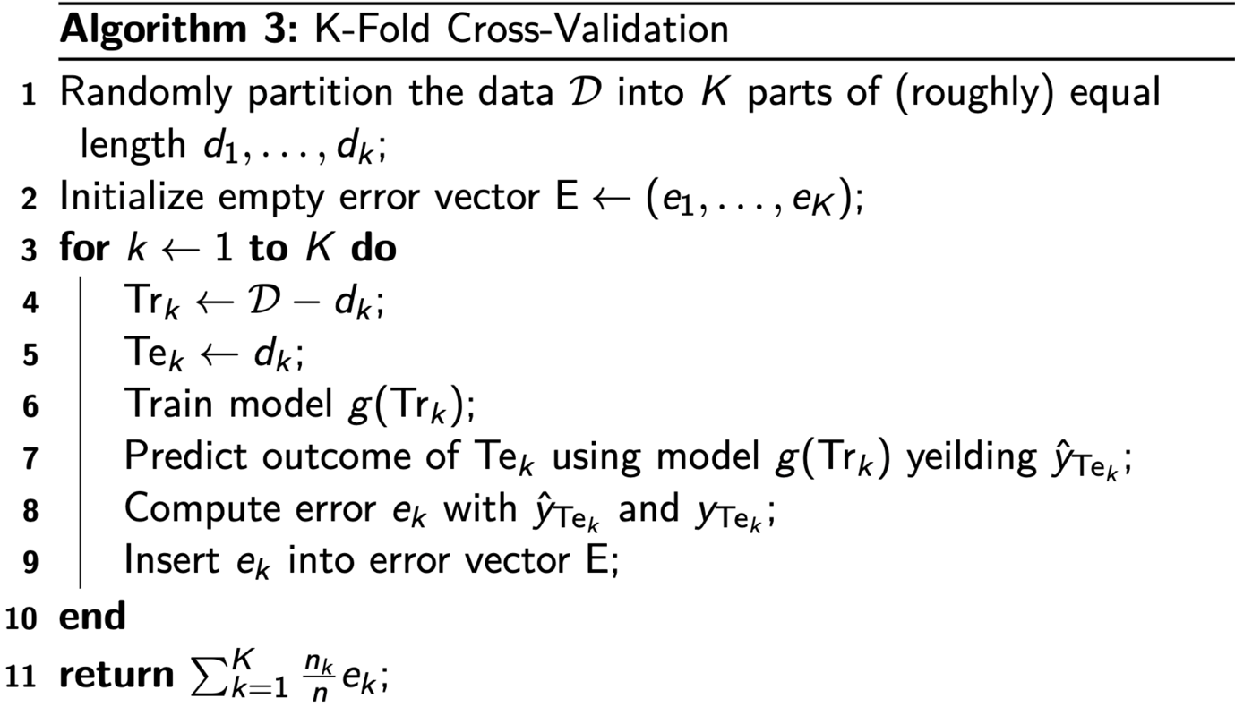

**Leave one out Cross-Validation (LOOCV) – Test set is just on one observation; you’re going to have an accuracy of 0 or 1 at each step. Then, we’re going to average over n of these splits.**

By increasing the number of folds, we are getting rid of some of the variance, as we average over splits then the particularities of **each split** has less of an impact on the overall model, and thus we minimize variance.

When it comes to bias, bias is minimized when K = n (LOOCV), but this estimate has high variance.

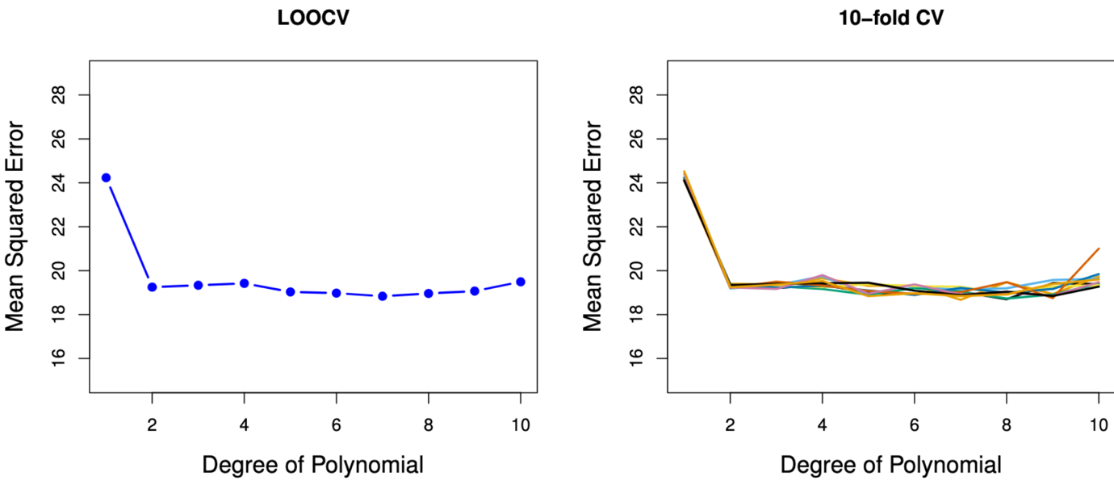

**Hyperparameter Selection**

* Also called tuning parameters, refer to specs that change the behaviour of the learning model or algo.
* Cross-val is used to select the hyperparameters that will give us a g(x) that best generalizes to new data.
* The cross-validation procedure is performed in a hyperparameter search, which can be conducted in several ways.

**Epoch is number of times in stochastic gradient descent that we go through the whole data.**

Hyperparameters vs. Parameters

* While parameters like Beta in regression are set during training, **hyperparameters** are set before training.
* Hyperparameters come in two main types:
  + **Model hyperparameters** are attributes of models, usually refer to flexibility of fit.
  + **Algorithm hyperparameters** refer to methods of training the model, don’t as directly impact the functional form, or change the fit.

Hyperparameter Example: Kernel Knn

* K in Knn is a model hyperparameter.
* Knn can also be extended to use additional **model hyperparameters.**
* Ordinary Knn gives equal weight to all neighbors, the equivalent of a ‘uniform’ kernel.
* We could potentially improve performance by adding a weight to each of these neighbors based on their distance from the reference observation.
* Weighted Knn downweights neighbors further away from the target point:
  + We want our weight wi to be:
    - Small if the distance to our reference point is large,
    - Large is the distance to our reference point is small.

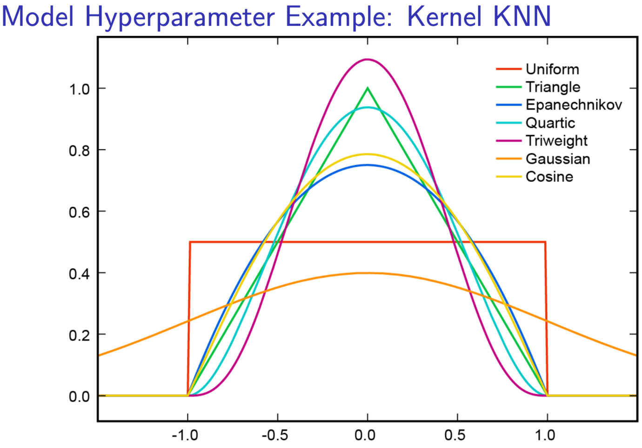

**K-D Tree**

* Recall the Knn algo: in order to find the k nearest neighbors, we have to calculate the distance between ref point and all of our training obs.
* Can be very expensive, so we need a shortcut.

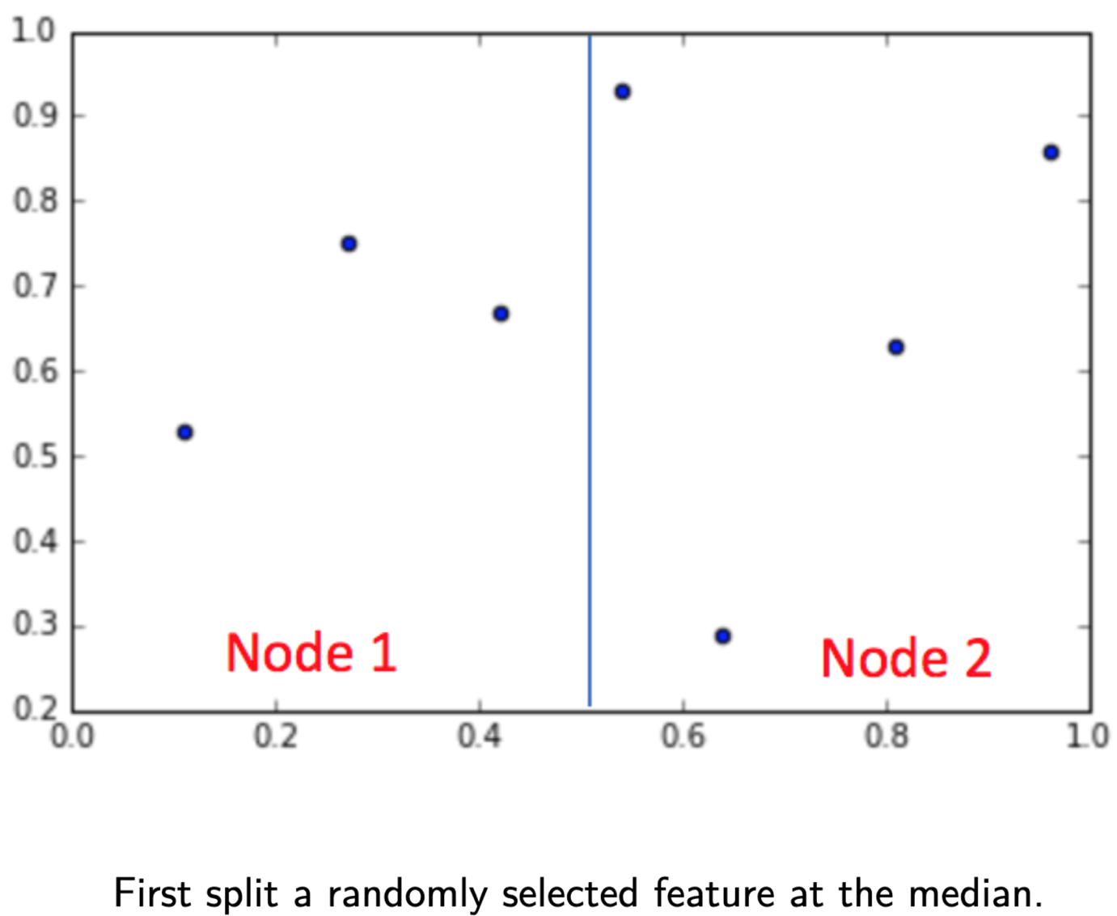

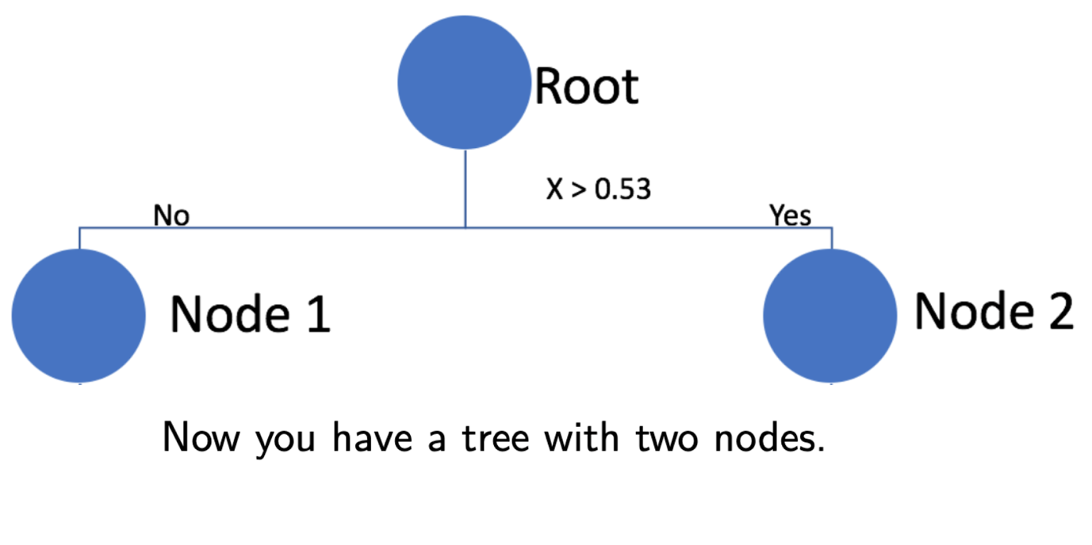

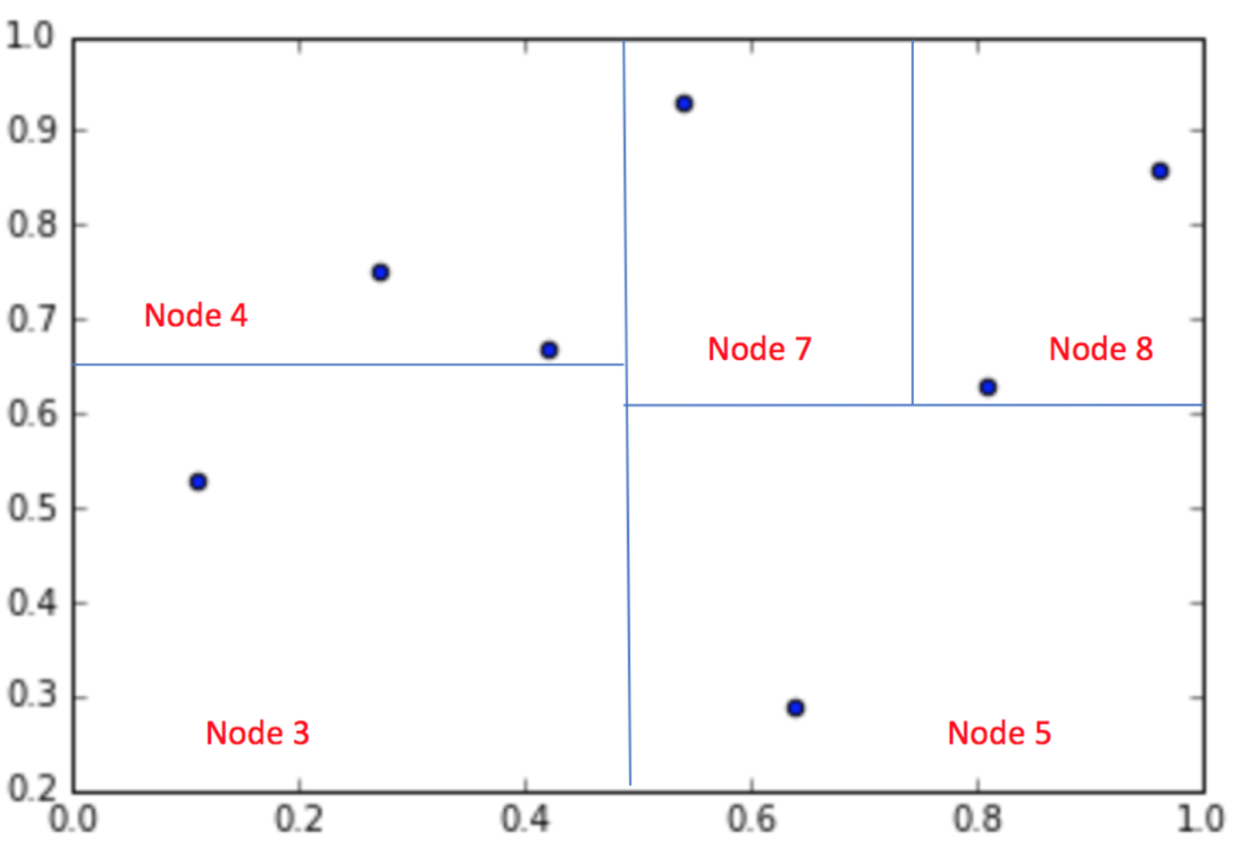

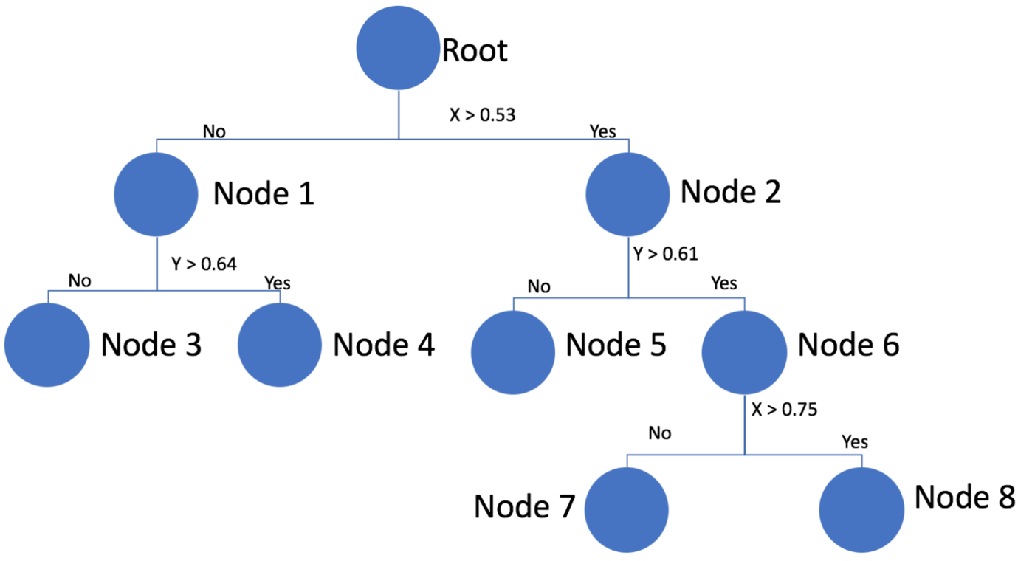

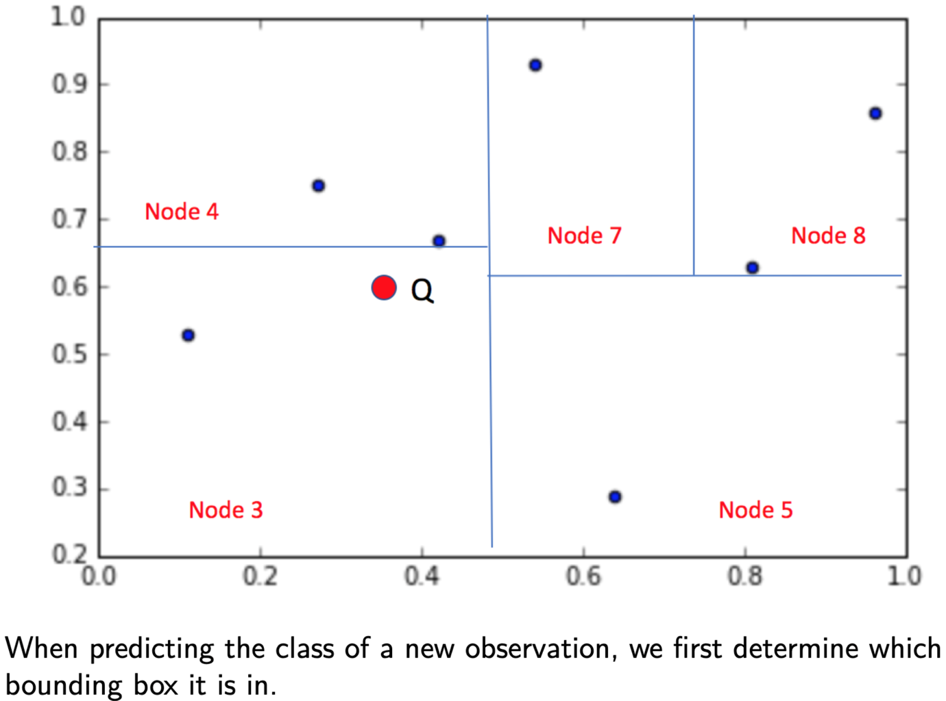

Instead of calculating the distance between all observations in the training data, we restrict our search to the bounding box where the ref point resides. 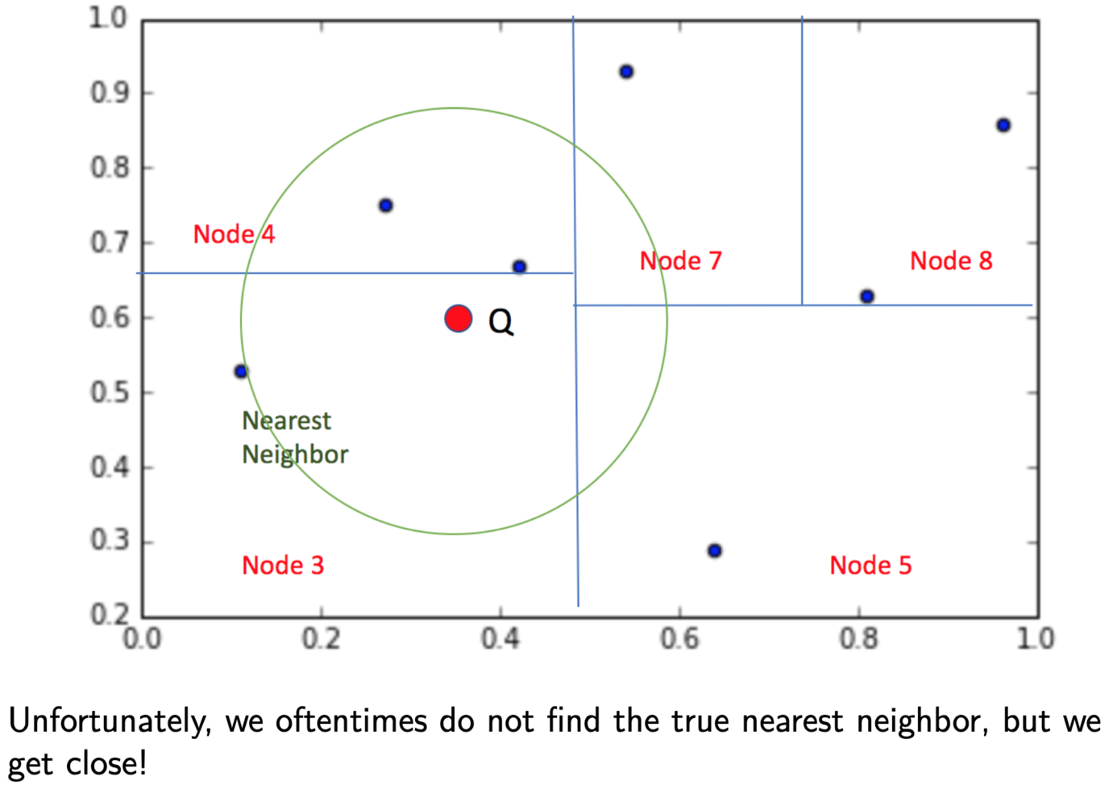

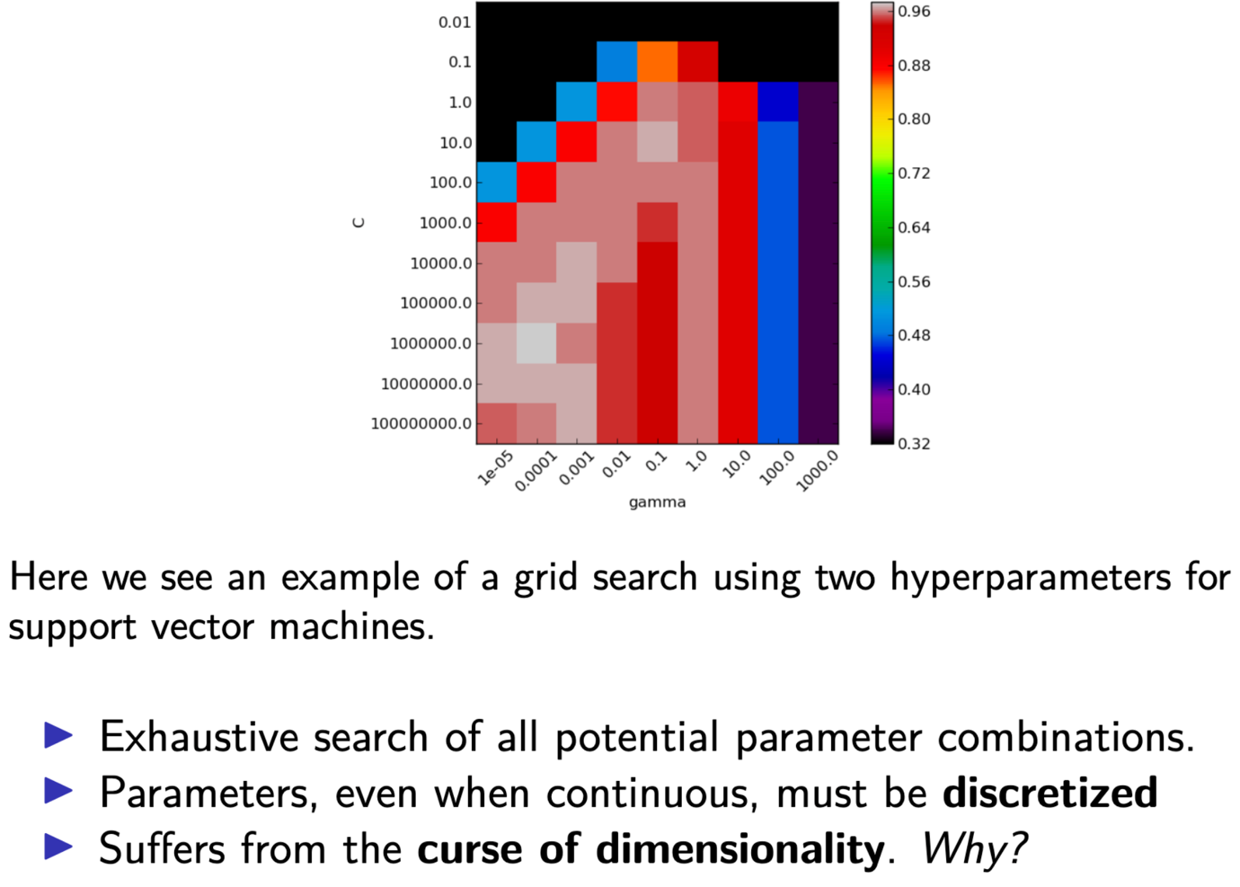

Curse of dimensionality because as we add more hyperparameters then the space of possible hyperparameters is increasing the good solution combination of all hyperparameters remains in a small manifold of that increasing space.

**Randomized Hyperparameter Search**

* In randomized search, we treat each hyperparameter as a **distribution** and sample values from it at random.
* Randomized search deos not exhaustively search the space, nstead taking repeated random samples from distributions of hyperparameters.
  + Because of this, a **computational budget** can be set ahead of time.
  + Randomized search can discretize parameters, but doesn’t have to.

**AutoML**

* Why not take humans out of the loop altogether?
* ML algos (KNN, Logistic Reg, NN, RF) can be treated like hyperparameters (choose the algo that minimizes validation error).
* Features and preprocessing can also be treated like hyperparameters (choose feature representations that minimize validation error).

**Chapter 5: Resampling Methods**

In this chapter, we discuss two of the most commonly used resampling methods, cross-validation and the bootstrap. Both methods are important tools in the practical application of many statistical learning procedures.

The process of evaluating a model’s performance is known as model assessment, whereas the process of selecting the proper level of flexibility for a model is known as model selection. The bootstrap is used in several contexts, most commonly to provide a measure of accuracy of a parameter estimate or of a given statistical learning method.

* 1. **Cross-Validation**

In this section, we instead consider a class of methods that estimate the test error rate by holding out a subset of the training observations from the fitting process, and then applying the statistical learning method to those held out observations.

Estimating generalisation error without wasting data as we would if we used a held-out test set.

5.1.1 The Validation Set Approach

The validation set approach, displayed in Figure 5.1, is a very simple strategy for this task. It involves randomly dividing the available set of observa- tions into two parts, a training set and a validation set or hold-out set.

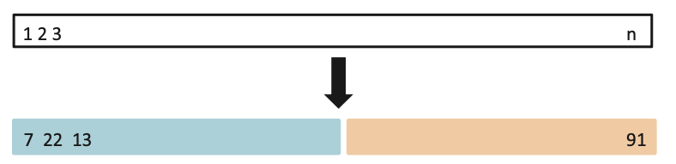

Do this split N times and average over the lot.

If we repeat the process of randomly splitting the sample set into two parts, we will get a somewhat different estimate for the test MSE. As an illustration, the right-hand panel of Figure 5.2 displays ten different vali- dation set MSE curves from the Auto data set, produced using ten different random splits of the observations into training and validation sets. All ten curves indicate that the model with a quadratic term has a dramatically smaller validation set MSE than the model with only a linear term. Fur- thermore, all ten curves indicate that there is not much benefit in including cubic or higher-order polynomial terms in the model. But it is worth noting that each of the ten curves results in a different test MSE estimate for each of the ten regression models considered. And there is no consensus among the curves as to which model results in the smallest validation set MSE. Based on the variability among these curves, all that we can conclude with any confidence is that the linear fit is not adequate for this data.

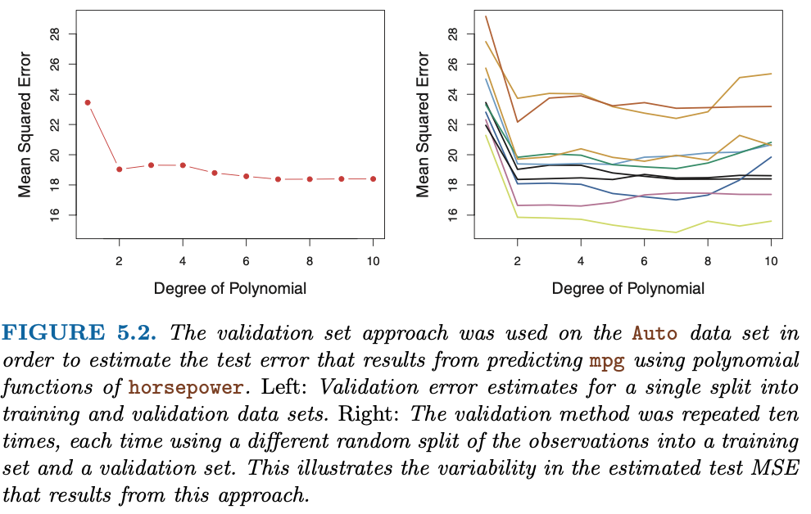

1. As is shown in the right-hand panel of Figure 5.2, the validation esti- mate of the test error rate can be highly variable, depending on pre- cisely which observations are included in the training set and which observations are included in the validation set.
   1. Shuffle and average over K to deal with this.
2. In the validation approach, only a subset of the observations—those that are included in the training set rather than in the validation set—are used to fit the model. Since statistical methods tend to per- form worse when trained on fewer observations, this suggests that the validation set error rate may tend to overestimate the test error rate for the model fit on the entire data set.

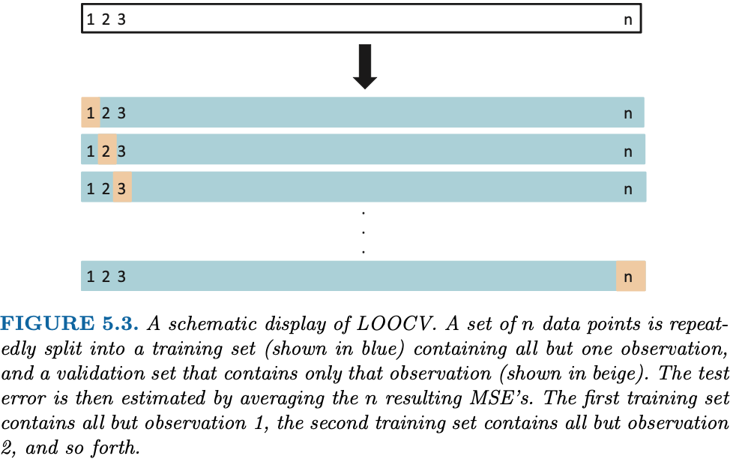

LOOCV has far less bias as almost the whole data set is used to train each time. Consequently, the LOOCV approach tends not to overestimate the test error rate as much as the validation set approach does. Second, in contrast to the validation approach which will yield different results when applied repeatedly due to randomness in the training/validation set splits, performing LOOCV multiple times will always yield the same results: there is no randomness in the training/vali- dation set splits.

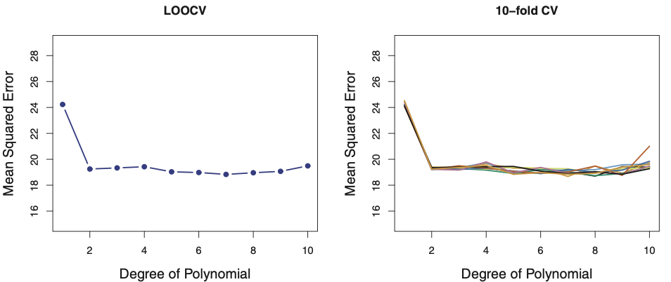

**5.1.3 k-Fold Cross-Validation**

An alternative to LOOCV is k-fold CV. This approach involves randomly dividing the set of observations into k groups, or folds, of approximately equal size. The first fold is treated as a validation set, and the method is fit on the remaining k − 1 folds. The mean squared error, MSE1, is then computed on the observations in the held-out fold. This procedure is repeated k times; each time, a different group of observations is treated as a validation set.

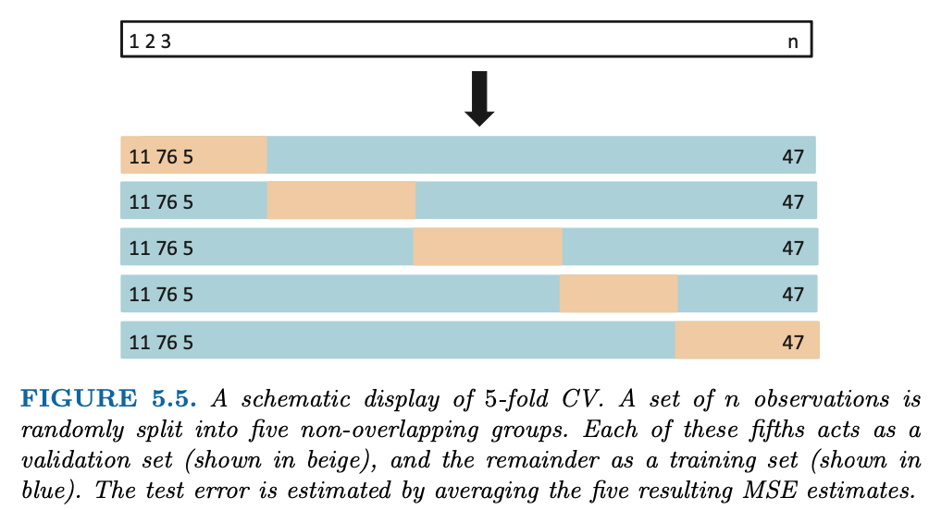

When we perform cross-validation, our goal might be to determine how well a given statistical learning procedure can be expected to perform on independent data; in this case, the actual estimate of the test MSE is of interest. But at other times we are interested only in the location of the minimum point in the estimated test MSE curve. This is because we might be performing cross-validation on a number of statistical learning methods, or on a single method using different levels of flexibility, in order to identify the method that results in the lowest test error. For this purpose, the location of the minimum point in the estimated test MSE curve is important, but the actual value of the estimated test MSE is not. 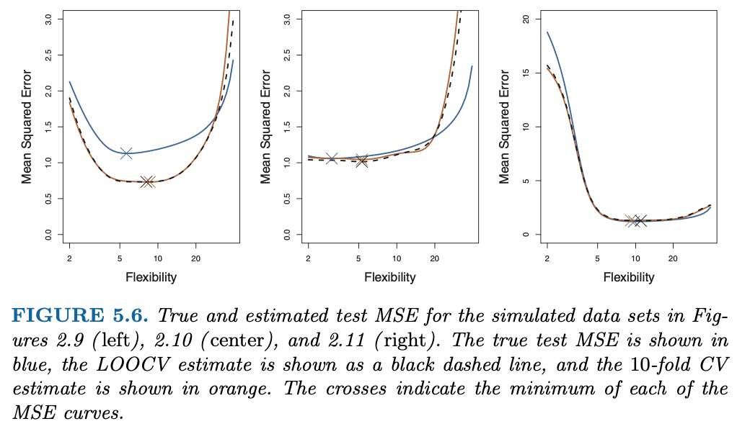

We find in Figure 5.6 that despite the fact that they sometimes underestimate the true test MSE, all of the CV curves come close to identifying the correct level of flexibility—that is, the flexibility level corresponding to the smallest test MSE.

We mentioned in Section 5.1.3 that k-fold CV with k < n has a compu- tational advantage to LOOCV. But putting computational issues aside, a less obvious but potentially more important advantage of k-fold CV is that it often gives more accurate estimates of the test error rate than does LOOCV. This has to do with a bias-variance trade-off. 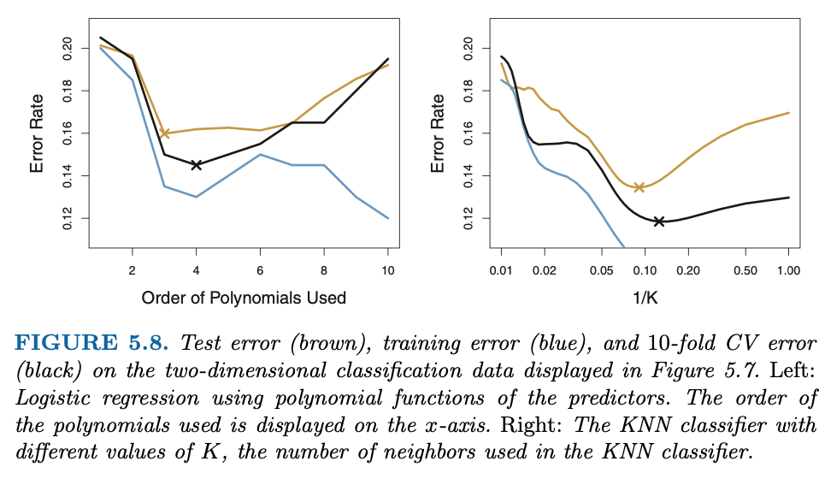

* Since each training set in K CV is only (K-1)/K as big as the original training set, the estimates of prediction error will typically be biased upward.
* This bias is minimises when K = n (LOOCV) but this estimate has high variance, as noted earlier.
* K = 5 or 10 provides a good compromise for this bias-variance tradeoff.

**The Bootstrap (Resampling)**

The bootstrap is a widely applicable and extremely powerful statistical tool that can be used to quantify the uncertainty associated with a given estimator or statistical learning method.

The power of the bootstrap lies in the fact that it can be easily applied to a wide range of statistical learning methods, including some for which a measure of variability is otherwise difficult to obtain and is not automatically output by statistical software.

**Bottou, L. “Large-Scale Machine Learning with Stochastic Gradient Descent,” *Proceedings of COMPSTAT’2010,* 2010, 177-186.**

Fairly old paper – deals with issue of computing time/cost limitations over sample-size limitations – stochastic gradient descent as the solution.

Second order stochastic gradient and averaged stochastic gradient are asymptotically efficient after a single pass on the training set.

Gradient descent – each iteration updates the weights w on the basis of the gradient En(fw). Under sufficient regularity assumptions, when the initial estimate weight-0 is close enough to the optimum, and when the gain lambda is sufficiently small, this algorithm achieves linear convergence.

Second order gradient descent (2GD) is a variant of a well-known Newton algorithm. Under sufficiently optimistic regularity assumptions, and provide that w0 is sufficiently close to the optimum, second order gradient descent achieves quadratic convergence.

Stochastic gradient descent is a simplification. Instread of computing the gradient of En(fw) exactly, each iteration estimates this gradient on the basis of a single randomly picked observation. It thus depends on these examples.

**ISL Chapter 6.2: Shrinkage Methods**

The subset selection methods described in Section 6.1 involve using least squares to fit a linear model that contains a subset of the predictors. As an alternative, we can fit a model containing all p predictors using a technique that constrains or regularizes the coefficient estimates, or equivalently, that shrinks the coefficient estimates towards zero. It may not be immediately obvious why such a constraint should improve the fit, but it turns out that shrinking the coefficient estimates can significantly reduce their variance. The two best-known techniques for shrinking the regression coefficients towards zero are ridge regression and the lasso.

**Ridge Regression**

Ridge regression is very similar to least squares, except that the coefficients are estimated by minimizing a slightly different quantity. In particular, the ridge regression coefficient estimates βˆR are the values that minimize 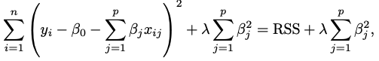

where λ ≥ 0 is a tuning parameter, to be determined separately. RR seeks coefficient estiamtes that fit the data well by making RSS small, but the term λ􏰂 β2, is a shrinkage penalty which is small when Beta-1, …, Beta-p are close to zero, and so it has the effect of shrinking the estimates of Bj towards zero. The tuning parameter λ serves to control the relative impact of these two terms on the regression coefficient esti- mates. When λ = 0, the penalty term has no effect, and ridge regression will produce the least squares estimates. However, as λ → ∞, the impact of the shrinkage penalty grows, and the ridge regression coefficient estimates will approach zero. Unlike least squares, which generates only one set of co- efficient estimates, ridge regression will produce a different set of coefficient estimates, βˆλR, for each value of λ. Selecting a good value for λ is critical. Shrinkage is applied to coefficients but not the intercept. 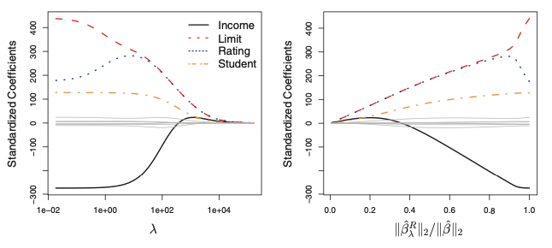

At the extreme left-hand side of the plot, λ is essentially zero, and so the corresponding ridge coefficient estimates are the same as the usual least squares esti- mates. But as λ increases, the ridge coefficient estimates shrink towards zero. When λ is extremely large, then all of the ridge coefficient estimates are basically zero; this corresponds to the null model that contains no predictors.

Best to apply after standardised the predictors as they can vary at different rates.

Ridge regression’s advantage over OLS is rooted in the bias-variance tradeoff. As lambda increases, the flexibility of the ridge regression fit decreases, leading th decreases variance but increased bias.

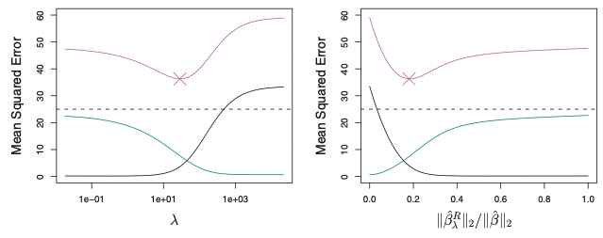

Ridge regression works best in situations where the least squares estimates have high variance.

**The Lasso**

Ridge regression has one obvious disadvantage – it includes all p predictors in the final model. The shrinkage penalty will shrink all coefficients towards 0, but never exactly to zero.

The lasso is an alternative that overcomes this disadvantage. The Beta-j^2 term in the ridge regression penalty is replaced by |Bj| The lasso uses an ell-1 penalty instead of an ell-2 penalty. Still shrinks coefficient estimates towards zero, but also forces some of the coefficients estimates to exactly 0. Thus, it performs variable selection.

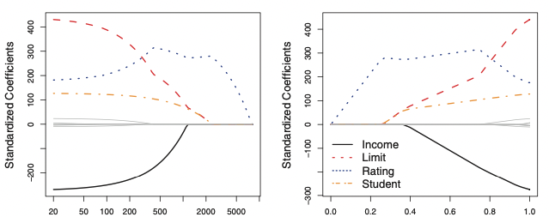

When λ = 0, then the lasso simply gives the least squares fit, and when λ becomes sufficiently large, the lasso gives the null model in which all coefficient estimates equal zero. However, in between these two extremes, the ridge regression and lasso models are quite different from each other. Moving from left to right in the right-hand panel of Figure 6.6, we observe that at first the lasso re- sults in a model that contains only the rating predictor. Then student and limit enter the model almost simultaneously, shortly followed by income. Eventually, the remaining variables enter the model. Hence, depending on the value of λ, the lasso can produce a model involving any number of vari- ables. In contrast, ridge regression will always include all of the variables in the model, although the magnitude of the coefficient estimates will depend on λ.

One can show that the lasso and ridge regression coefficient estimates solve the problems: 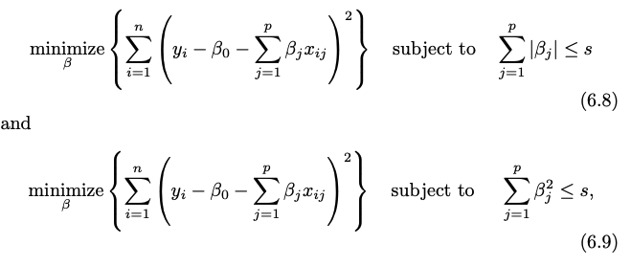

In other words, for every value of λ, there is some s such that the Equations (6.7) and (6.8) will give the same lasso coefficient estimates. Similarly, for every value of λ there is a corresponding s such that Equa- tions (6.5) and (6.9) will give the same ridge regression coefficient estimates.

The Variable Selection Property of the Lasso

Why is it that the lasso, unlike ridge regression, results in coefficient estimates that are exactly equal to zero?

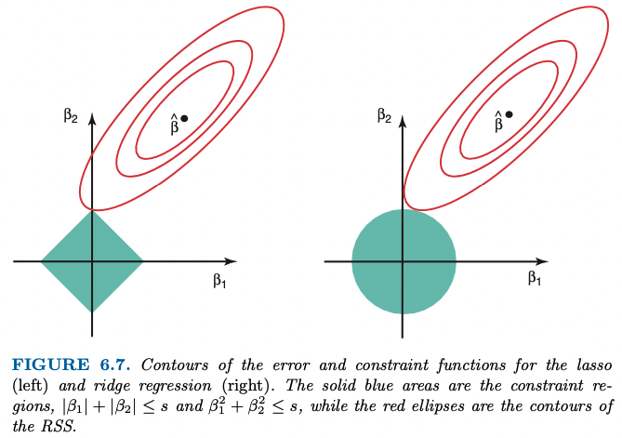

The ellipses that are centered around βˆ represent regions of constant RSS. In other words, all of the points on a given ellipse share a common value of the RSS. As the ellipses expand away from the least squares co- efficient estimates, the RSS increases. Equations (6.8) and (6.9) indicate that the lasso and ridge regression coefficient estimates are given by the first point at which an ellipse contacts the constraint region. Since ridge regression has a circular constraint with no sharp points, this intersection will not generally occur on an axis, and so the ridge regression coefficient estimates will be exclusively non-zero. However, the lasso constraint has corners at each of the axes, and so the ellipse will often intersect the con- straint region at an axis. When this occurs, one of the coefficients will equal zero. In higher dimensions, many of the coefficient estimates may equal zero simultaneously.

In Figure 6.7, the intersection occurs at β1 = 0, and so the resulting model will only include β2.

It is clear that the lasso has a major advantage over ridge regression, in that it produces simpler and more interpretable models that involve only a subset of the predictors. However, which method leads to better prediction accuracy? Ridge Regression outperforms LASSO when none of the true coefficients equal zero. The lasso implicitly assumes that a number of coefficients truly equal zero. Thus, ridge regression outperforms the LASSO in prediction error in a setting where all TRUE coefficients are non-zero.

6.2.3 Selecting the Tuning Parameter

Just as the subset selection approaches considered in Section 6.1 require a method to determine which of the models under consideration is best, implementing ridge regression and the lasso requires a method for selecting a value for the tuning parameter λ in (6.5) and (6.7), or equivalently, the value of the constraint s in (6.9) and (6.8). Cross-validation provides a sim- ple way to tackle this problem. We choose a grid of λ values, and compute the cross-validation error for each value of λ, as described in Chapter 5. We then select the tuning parameter value for which the cross-validation error is smallest. Finally, the model is re-fit using all of the available observations and the selected value of the tuning parameter.

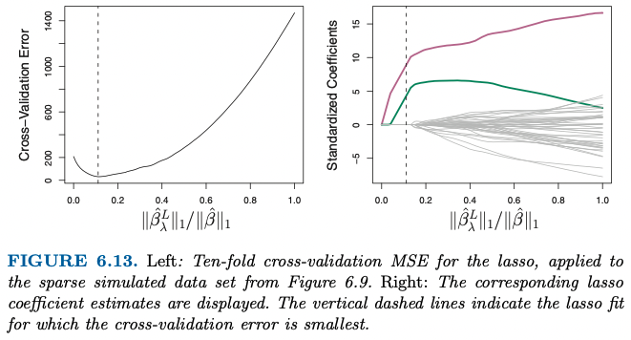

Figure 6.13 provides an illustration of ten-fold cross-validation applied to the lasso fits on the sparse simulated data from Figure 6.9. The left-hand panel of Figure 6.13 displays the cross-validation error, while the right-hand panel displays the coefficient estimates. The vertical dashed lines indicate the point at which the cross-validation error is smallest. The two colored lines in the right-hand panel of Figure 6.13 represent the two predictors that are related to the response, while the grey lines represent the unre- lated predictors; these are often referred to as signal and noise variables, respectively. Not only has the lasso correctly given much larger coeffi- cient estimates to the two signal predictors, but also the minimum cross- validation error corresponds to a set of coefficient estimates for which only the signal variables are non-zero. Hence cross-validation together with the lasso has correctly identified the two signal variables in the model, even though this is a challenging setting, with p = 45 variables and only n = 50 observations. In contrast, the least squares solution—displayed on the far right of the right-hand panel of Figure 6.13—assigns a large coefficient estimate to only one of the two signal variables.

**6.4 Considerations in High Dimensions**

As shown in the figure, the model R2 increases to 1 as the number of features included in the model increases, and correspondingly the training set MSE decreases to 0 as the number of features increases, even though the features are completely unrelated to the response. On the other hand, the MSE on an independent test set becomes extremely large as the number of features included in the model increases, because including the additional predictors leads to a vast increase in the variance of the coefficient estimates. Looking at the test set MSE, it is clear that the best model contains at most a few variables.

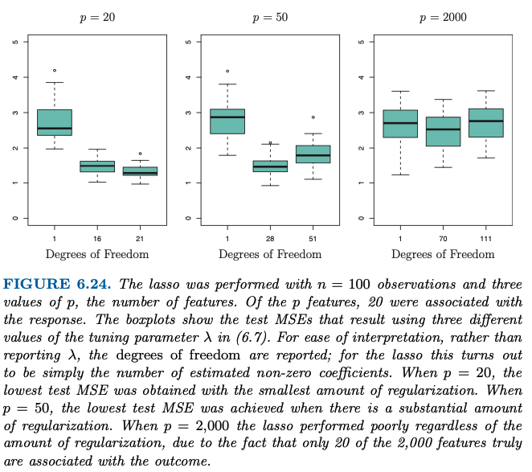 Y axis is number of non-zero coefficient estimates in the LASSO solution, a measure of flexibility of the fit.

Figure 6.24 highlights three important points:

(1) regularization or shrinkage plays a key role in high-dimensional problems,

(2) appropriate tuning parameter selection is crucial for good predictive performance, and

(3) the test error tends to increase as the dimensionality of the problem (i.e. the number of features or predictors) increases, unless the additional features are truly associated with the response.

The third point above is in fact a key principle in the analysis of high- dimensional data, which is known as the curse of dimensionality. In general, adding additional signal features that are truly associated with the response will improve the fitted model, in the sense of leading to a reduction in test set error. However, adding noise features that are not truly associated with the response will lead to a deterioration in the fitted model, and consequently an increased test set error.

This is because noise features increase the dimensionality of the problem, exacerbating the risk of overfitting (since noise features may be assigned nonzero coefficients due to chance associations with the response on the training set) without any potential upside in terms of improved test set error. Thus, we see that new technologies that allow for the collection of measurements for thousands or millions of features are a double-edged sword: they can lead to improved predictive models if these features are in fact relevant to the problem at hand, but will lead to worse results if the features are not relevant. Even if they are relevant, the variance incurred in fitting their coefficients may outweigh the reduction in bias that they bring.

In the high-dimensional setting, the multicollinearity problem is extreme: any variable in the model can be written as a linear combination of all of the other variables in the model. Essentially, this means that we can never know exactly which variables (if any) truly are predictive of the outcome, and we can never identify the best coefficients for use in the regression. At most, we can hope to assign large regression coefficients to variables that are correlated with the variables that truly are predictive of the outcome.

*For instance, suppose that we are trying to predict blood pressure on the basis of half a million SNPs, and that forward stepwise selection indicates that 17 of those SNPs lead to a good predictive model on the training data. It would be incorrect to conclude that these 17 SNPs predict blood pressure more effectively than the other SNPs not included in the model. There are likely to be many sets of 17 SNPs that would predict blood pressure just as well as the selected model. If we were to obtain an independent data set and perform forward stepwise selection on that data set, we would likely obtain a model containing a different, and perhaps even non-overlapping, set of SNPs. This does not detract from the value of the model obtained— for instance, the model might turn out to be very effective in predicting blood pressure on an independent set of patients, and might be clinically useful for physicians. But we must be careful not to overstate the results obtained, and to make it clear that what we have identified is simply one of many possible models for predicting blood pressure, and that it must be further validated on independent data sets.*

**Chapter 8: Tree-Based Methods**

These involve stratifying or segmenting the predictor space into a number of simple regions. In order to make a prediction for a given observation, we typically use the mean or the mode of the training observa- tions in the region to which it belongs. Since the set of splitting rules used to segment the predictor space can be summarized in a tree, these types of approaches are known as decision tree methods.

* *Terminal nodes* are the final conditional groupings
* *Internal nodes* are the conditional grouping where the predictor space is split.

To build a regression tree, there are two basic steps:

1. We divide the predictor space, that is, the set of possible values for X1,…,Xp into J distinct non-overlapping regions R1,…,Rj.
2. For every observation that falls into the region Rj, we make the same prediction, which is simply the mean of the response values for the training observations in Rj.

We now elaborate on Step 1 above. How do we construct the regions R1,...,RJ? In theory, the regions could have any shape. However, we choose to divide the predictor space into high-dimensional rectangles, or boxes, for simplicity and for ease of interpretation of the resulting predic- tive model. The goal is to find boxes R1, . . . , RJ that minimize the RSS.

Unfortunately, it is computationally infeasible to consider every possible partition of the feature space into J boxes. For this reason, we take a top down, greedy approach that is known as ***recursive binary splitting***. The approach is top-down because it begins at the top of the tree (at which point all observations belong to a single region) and then successively splits the predictor space; each split is indicated via two new branches further down on the tree. It is *greedy* because at each step of the tree-building process**, the best split is made at that particular step,** rather than looking ahead and picking a split that will lead to a better tree in some future step.

In order to perform recursive binary splitting, we first select the predictor Xj and the cutpoint s such that splitting the predictor space into the regions {X|Xj < s} and {X|Xj ≥ s} leads to the greatest possible reduction in RSS. (The notation {X|Xj < s} means the region of predictor space in which Xj takes on a value less than s.)

That is, we consider all predictors X1, . . . , Xp, and all possible values of the cutpoint s for each of the predictors, and then choose the predictor and cutpoint such that the resulting tree has the lowest RSS.

Next, we repeat the process, looking for the best predictor and best cutpoint in order to split the data further so as to minimize the RSS within each of the resulting regions. However, this time, instead of splitting the entire predictor space, we split one of the two previously identified regions. We now have three regions. Again, we look to split one of these three regions further, so as to minimize the RSS. The process continues until a stopping criterion is reached; for instance, we may continue until no region contains more than five observations.

OncetheregionsR1,...,RJ havebeencreated,wepredicttheresponse for a given test observation using the mean of the training observations in the region to which that test observation belongs.

**Tree Pruning**

The process described above may produce good predictions on the training set, but is likely to overfit the data, leading to poor test set performance. This is because the resulting tree might be too complex. A smaller tree with fewer splits (that is, fewer regions R1,...,RJ) might lead to lower variance and better interpretation at the cost of a little bias.

One possible alternative to the process described above is to build the tree only so long as the decrease in the RSS due to each split exceeds some (high) threshold. This strategy will result in smaller trees, but is too short-sighted since a seemingly worthless split early on in the tree might be followed by a very good split—that is, a split that leads to a large reduction in RSS later on.

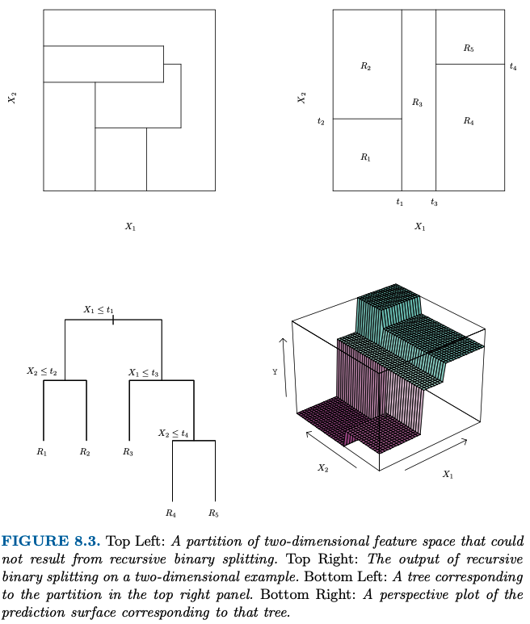

Therefore, a better strategy is to grow a very large tree T0, and then prune it back in order to obtain a subtree. How do we determine the best way to prune the tree? Intuitively, our goal is to select a subtree that leads to the lowest test error rate. Given a subtree, we can estimate its test error using cross-validation or the validation set approach. However, estimating the cross-validation error for every possible subtree would be too cumbersome, since there is an extremely large number of possible subtrees. Instead, we need a way to select a small set of subtrees for consideration.

***Cost complexity pruning*** - also known as ***weakest link pruning -*** gives us a way to do just this. Rather than considering every possible subtree, we consider a sequence of trees indexed by a nonnegative tuning parameter α.

Steps:

1. Use recursive binary splitting to grow a large tree on the training data, stopping only when each terminal node has fewer than some minimum number of observations.
2. Apply cost complexity pruning to the large tree in order to obtain a sequence of best subtrees as function of alpha.
3. Use K-fold cross-validation to choose alpha. That is, divide the training observations into K folds. For each k = 1, …, K:
   1. Repeat steps 1 & 2 on all but the kth fold of the training data.
   2. Evaluate the MS prediction error on the data left-out kth fold, as a function of alpha.
   3. Avwrage the results for each value of alpha, and pick alpha to minimise the average error.
4. Return the subtree from step 2 that corresponds to the chosen value of alpha.

The tuning parameter alpha controls a trade-off between the subtree’s complexity and its fit to the training data. When alpha = 0, the subtree T will simply equal T0 – measuring the training error. As alpha increases, the price to pay for having a tree with many terminal nodes, will tend to be minimised for a smaller subtree. Reminiscent of Lasso in which a similar formulation was used in order to control the complexity of a linear model.

It turns out that as we increase α from zero in (8.4), branches get pruned from the tree in a nested and predictable fashion, so obtaining the whole sequence of subtrees as a function of α is easy. We can select a value of α using a validation set or using cross-validation. We then return to the full data set and obtain the subtree corresponding to α.

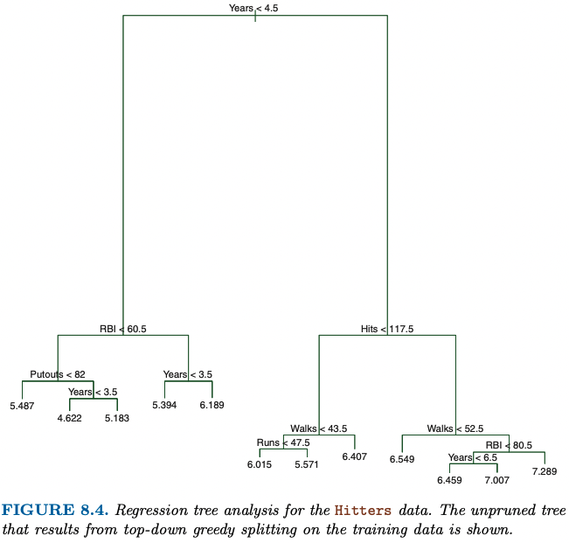

Figures 8.4 and 8.5 display the results of fitting and pruning a regression tree on the Hitters data, using nine of the features. First, we randomly divided the data set in half, yielding 132 observations in the training set and 131 observations in the test set. We then built a large regression tree on the training data and varied α in (8.4) in order to create subtrees with different numbers of terminal nodes. Finally, we performed six-fold cross- validation in order to estimate the cross-validated MSE of the trees as a function of α. (We chose to perform six-fold cross-validation because 132 is an exact multiple of six.) The unpruned regression tree is shown in Figure 8.4. The green curve in Figure 8.5 shows the CV error as a function of the number of leaves,2 while the orange curve indicates the test error.

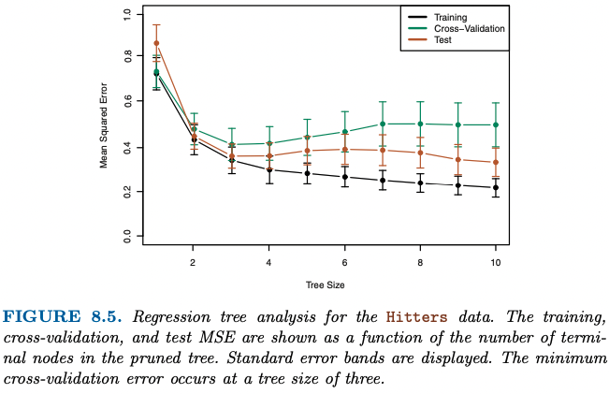

The CV error is a reasonable approximation of the test error: the CV error takes on its minimum for a three-node tree, while the test error also dips down at the three-node tree (though it takes on its lowest value at the ten-node tree). The pruned tree containing three terminal nodes is shown in Figure 8.1.

**Classification Trees**

In contrast, for a classification tree, we predict that each observation belongs to the most commonly occurring class of training observations in the region to which it belongs. In interpreting the results of a classification tree, we are often interested not only in the class prediction corresponding to a particular terminal node region, but also in the class proportions among the training observations that fall into that region.

The task of growing a classification tree is quite similar to the task of growing a regression tree. Just as in the regression setting, we use recursive binary splitting to grow a classification tree. However, in the classification setting, RSS cannot be used as a criterion for making the binary splits. A natural alternative to RSS is the classification error rate. Since we plan to assign an observation in a given region to the most commonly occurring class of training observations in that region, the classification error rate is simply the fraction of the training observations in that region that do not belong to the most common class.

However, it turns out that classification error is not sufficiently sensitive for tree-growing, and in practice two other measures are preferable.

The *Gini index* is defined by a measure of total variance across the K classes. It is not hard to see that the Gini index takes on a small value if all of the pˆmk’s are close to zero or one. For this reason the Gini index is referred to as a measure of node purity—a small value indicates that a node contains predominantly observations from a single class.

An alternative to the Gini index is entropy. One can show that the entropy will take on a value near zero if the pˆmk’s are all near zero or near one. Therefore, like the Gini index, the entropy will take on a small value if the mth node is pure. In fact, it turns out that the Gini index and the entropy are quite similar numerically.

When building a classification tree, either the Gini index or the entropy are typically used to evaluate the quality of a particular split, since these two approaches are more sensitive to node purity than is the classification error rate. Any of these three approaches might be used when pruning the tree, but the classification error rate is preferable if prediction accuracy of the final pruned tree is the goal.

Trees Versus Linear Models

Regression and classification trees have a very different flavor from the more classical approaches for regression and classification presented in Chapters 3 and 4.

If the relationship between the features and the response is well approximated by a linear model as in (8.8), then an approach such as linear regression will likely work well, and will outperform a method such as a regression tree that does not exploit this linear structure. If instead there is a highly non-linear and complex relationship between the features and the response as indicated by model (8.9), then decision trees may outperform classical approaches. An illustrative example is displayed in Figure 8.7. The rela- tive performances of tree-based and classical approaches can be assessed by estimating the test error, using either cross-validation or the validation set approach (Chapter 5). Of course, other considerations beyond simply test error may come into play in selecting a statistical learning method; for instance, in certain set- tings, prediction using a tree may be preferred for the sake of interpretabil- ity and visualization.

Advantages of Trees:

1. Trees are very easy to explain to people. In fact, they are even easier to explain than linear regression!
2. Some people believe that decision trees more closely mirror human decision-making than do the regression and classification approaches seen in previous chapters.
3. Trees can be displayed graphically, and are easily interpreted even by a non-expert (especially if they are small).
4. Trees can easily handle qualitative predictors without the need to create dummy variables.

Disadvantages of Trees:

1. Unfortunately, trees generally do not have the same level of predictive accuracy as some of the other regression and classification approaches seen in this book.
2. Additionally, trees can be very non-robust. In other words, a small change in the data can cause a large change in the final estimated tree.

However, by aggregating many decision trees, using methods like bagging, random forests, and boosting, the predictive performance of trees can be substantially improved. We introduce these concepts in the next section.

**ISL Chapter 9: Supper Vector Machines**

The support vector machine is a generalization of a simple and intu- itive classifier called the maximal margin classifier, which we introduce in Section 9.1. Though it is elegant and simple, we will see that this classifier unfortunately cannot be applied to most data sets, since it requires that the classes be separable by a linear boundary. We introduce the support vector classifier, an extension of the maximal margin classifier that can be applied in a broader range of cases. Section 9.3 introduces the support vector machine, which is a further extension of the support vec- tor classifier in order to accommodate non-linear class boundaries. Support vector machines are intended for the binary classification setting in which there are two classes; in Section 9.4 we discuss extensions of support vector machines to the case of more than two classes. People often loosely refer to the maximal margin classifier, the support vector classifier, and the support vector machine as “support vector machines”. To avoid confusion, we will carefully distinguish between these three notions in this chapter.

**9.1 Maximal Margin Classifier**

**Definition: Hyperplane**

*“In a p-dimensional space, a hyperplane is a flat affine subspace of dimension p-1.”*

For instance, in two dimensions, a hyperplane is a flat one-dimensional subspace—in other words, a line. In three dimensions, a hyperplane is a flat two-dimensional subspace—that is, a plane. In p > 3 dimensions, it can be hard to visualize a hyperplane, but the notion of a (p − 1)-dimensional flat subspace still applies.

The mathematical definition of a hyperplane is quite simple. In two di- mensions, a hyperplane is defined by the equation: 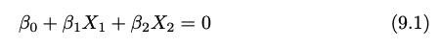

for parameters β0, β1, and β2. When we say that (9.1) “defines” the hyper- plane, we mean that any X = (X1,X2)T for which (9.1) holds is a point on the hyperplane. Note that (9.1) is simply the equation of a line, since indeed in two dimensions a hyperplane is a line. Equation 9.1 can be easily extended to the p-dimensional setting:



defines a p-dimensional hyperplane, again in the sense that if a point X = (X1,X2,...,Xp)T in p-dimensional space (i.e. a vector of length p)satisfies (9.2), then X lies on the hyperplane.

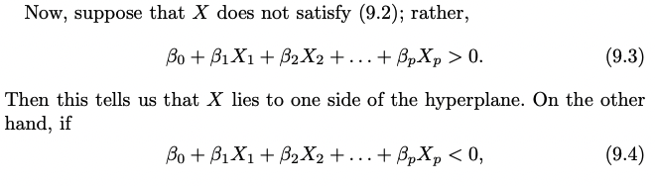

Then X lies on the other side of the hyperplane. So we can think of the hyperplane as dividing p-dimensional space into two halves. One can easily determine on which side of the hyperplane a point lies by simply calculating the sign of the left hand side of (9.2). A hyperplane in two-dimensional space is shown in Figure 9.1.

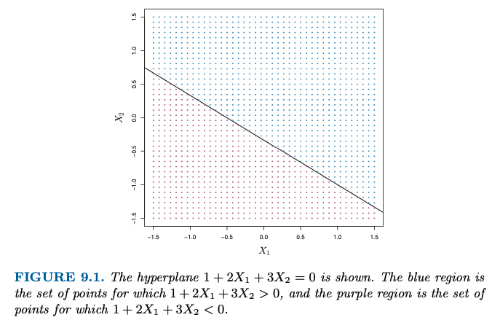

A hyperplane here, then, is just a decision boundary that determines where the algo separates the two classifying categories.

Now suppose that we have a n×p data matrix X that consists of n training observations in p-dimensional space, and that these observations fall into two classes where −1 represents one class and 1 the other class. We also have a test observation, a p-vector of observed features. Our goal is to develop a classifier based on the training data that will correctly classify the test observation using its feature measurements.

We will now see a new approach that is based upon the concept of a separating hyperplane. Suppose that it is possible to construct a hyperplane that separates the training observations perfectly according to their class labels. Examples of three such separating hyperplanes are shown in the left-hand panel of Figure 9.2.

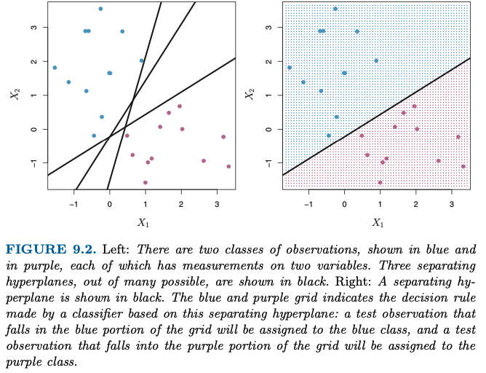

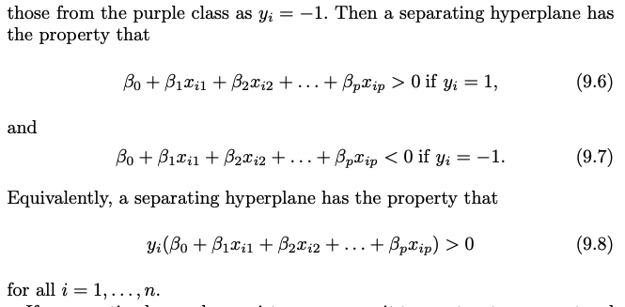

If a separating hyperplane exists, we can use it to construct a very natural classifier: a test observation is assigned a class depending on which side of the hyperplane it is located. (Such as in right-hand side of 9.2).

We can also make use of the magnitude of f(x∗). If f(x∗) is far from zero, then this means that x∗ lies far from the hyperplane, and so we can be confident about our class assignment for x∗. On the other hand, if f(x∗) is close to zero, then x∗ is located near the hyperplane, and so we are less certain about the class assignment for x∗. Not surprisingly, and as we see in Figure 9.2, a classifier that is based on a separating hyperplane leads to a linear decision boundary. **This incorporates confidence in prediction into our algo.**

In general, if our data can be perfectly separated using a hyperplane, then there will in fact exist an infinite number of such hyperplanes. This is because a given separating hyperplane can usually be shifted a tiny bit up or down, or rotated, without coming into contact with any of the observations. In order to construct a classifier based upon a separating hyperplane, we must have a reasonable way to decide which of the infinite possible separating hyperplanes to use.

A natural choice is the maximal margin hyperplane (also known as the optimal separating hyperplane), which is the separating hyperplane that is farthest from the training observations. That is, we can compute the (perpendicular) distance from each training observation to a given separating hyperplane; the smallest such distance is the minimal distance from the observations to the hyperplane and is known as the margin. The maximal margin hyperplane is the separating hyperplane for which the margin is largest—that is, it is the hyperplane that has the farthest minimum dis- tance to the training observations. We can then classify a test observation based on which side of the maximal margin hyperplane it lies. This is known as the maximal margin classifier.

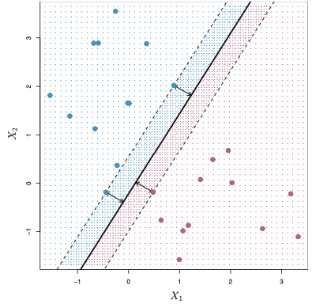

Figure 9.3 shows the maximal margin hyperplane on the data set of Figure 9.2. Comparing the right-hand panel of Figure 9.2 to Figure 9.3, we see that the maximal margin hyperplane shown in Figure 9.3 does in- deed result in a greater minimal distance between the observations and the separating hyperplane—that is, a larger margin. In a sense, the maximal margin hyperplane represents the mid-line of the widest “slab” that we can insert between the two classes.

Examining Figure 9.3, we see that three training observations are equidis- tant from the maximal margin hyperplane and lie along the dashed lines indicating the width of the margin. These three observations are known as support vectors, since they are vectors in p-dimensional space (in Figure9.3, p = 2) and they “support” the maximal margin hyperplane in the sense that if these points were moved slightly then the maximal margin hyper- plane would move as well. Interestingly, the maximal margin hyperplane depends directly on the support vectors, but not on the other observations: a movement to any of the other observations would not affect the separating hyperplane, provided that the observation’s movement does not cause it to cross the boundary set by the margin. The fact that the maximal margin hyperplane depends directly on only a small subset of the observations is an important property that will arise later in this chapter when we discuss the support vector classifier and support vector machines.

The maximal margin classifier is a very natural way to perform classifiation, if a separating hyperplane exists. However, as we have hinted, in many cases no separating hyperplane exists, and so there is no maximal margin classifier. In this case, the optimization problem (9.9)–(9.11) has no solution with M > 0. However, as we will see in the next section, we can extend the concept of a separating hyperplane in order to develop a hyperplane that almost separates the classes, using a so-called soft margin. The generalization of the maximal margin classifier to the non-separable case is known as the support vector classifier.

**9.2 Support Vector Classifiers**

As we see below – we can have cases where observations that belong to two classes are not necessarily separable by a hyperplane.

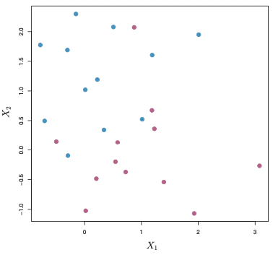

In fact, even if a separating hyper- plane does exist, then there are instances in which a classifier based on a separating hyperplane might not be desirable. A classifier based on a separating hyperplane will necessarily perfectly classify all of the training observations; this can lead to sensitivity to individual observations. An ex- ample is shown in Figure 9.5. The addition of a single observation in the right-hand panel of Figure 9.5 leads to a dramatic change in the maxi- mal margin hyperplane. The resulting maximal margin hyperplane is not satisfactory—for one thing, it has only a tiny margin. This is problematic because as discussed previously, the distance of an observation from the hyperplane can be seen as a measure of our confidence that the obser- vation was correctly classified. Moreover, the fact that the maximal mar- gin hyperplane is extremely sensitive to a change in a single observation suggests that it may have overfit the training data. The additional of a troublesome observation is show below, from left to right:

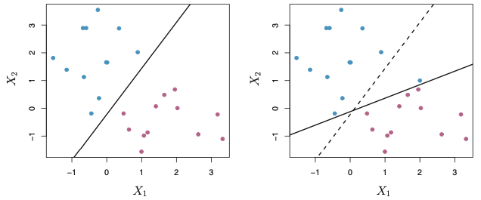

In this case, we might be willing to consider a classifier based on a hyperplane that does not perfectly separate the two classes, in the interest of:

* Greater robustness to new individual observations,
* Better classification of *most* of the training observations.

It could be worthwhile misclassifying a few training observations in order to do a better job of classifying the remaining observations. The *Support Vector Classifier,* sometimes called a *soft margin classifier,* does this.

Rather than seeking the largest possible margin so that every observation is not only on the correct side of the hyperplane but also on the correct side of the margin, we instead allow some observations to be on the incorrect side of the margin, or even the incorrect side of the hyperplane. (The margin is soft because it can be violated by some of the training observations.)

The support vector classifier classifies a test observation depending on which side of a hyperplane it lies. The hyperplane is chosen to correctly separate most of the training observations into the two classes, but may misclassify a few observations. It is the solution to the optimization problem:

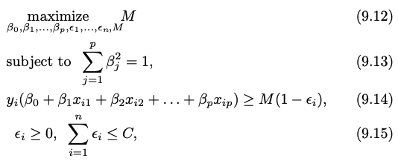

where C is a nonnegative tuning parameter. As in (9.11), M is the width of the margin; we seek to make this quantity as large as possible. In (9.14), ε1, . . . , εn are *slack* variables that allow individual observations to be on the wrong side of the margin or the hyperplane. We classify a test observation x∗ as before, by simply determining on which side of the hyperplane it lies. That is, we classify the test observation based on the s i g n o f f ( x ∗ ) = β 0 + β 1 x ∗1 + . . . + β p x ∗p .

First of all, the slack variable εi tells us where the ith observation is located, relative to the hyperplane and relative to the margin. If εi = 0 then the ith observation is on the correct side of the margin, as we saw in Section 9.1.4. If εi > 0 then the ith observation is on the wrong side of the margin, and we say that the ith observation has *violated* the margin. If εi > 1 then it is on the wrong side of the hyperplane.

We now consider the role of the tuning parameter C. In (9.15), C bounds the sum of the εi’s, and so it determines the number and severity of the vio- lations to the margin (and to the hyperplane) that we will tolerate. We can think of C as a budget for the amount that the margin can be violated by the n observations. If C = 0 then there is no budget for violations to the margin, and it must be the case that ε1 = ... = εn = 0, in which case (9.12)–(9.15) simply amounts to the maximal margin hyperplane optimiza- tion problem (9.9)–(9.11).

For C > 0 no more than C observa- tions can be on the wrong side of the hyperplane, because if an observation is on the wrong side of the hyperplane then εi > 1, and (9.15) requires that 􏰂ni=1 εi ≤ C. As the budget C increases, we become more tolerant of violations to the margin, and so the margin will widen. Conversely, as C decreases, we become less tolerant of violations to the margin and so the margin narrows. An example in shown in Figure 9.7. In practice, C is treated as a tuning parameter that is generally chosen via cross-validation. As with the tuning parameters that we have seen through- out this book, C controls the bias-variance trade-off of the statistical learn- ing technique. When C is small, we seek narrow margins that are rarely violated; this amounts to a classifier that is highly fit to the data, which may have low bias but high variance. On the other hand, when C is larger, the margin is wider and we allow more violations to it; this amounts to fitting the data less hard and obtaining a classifier that is potentially more biased but may have lower variance.

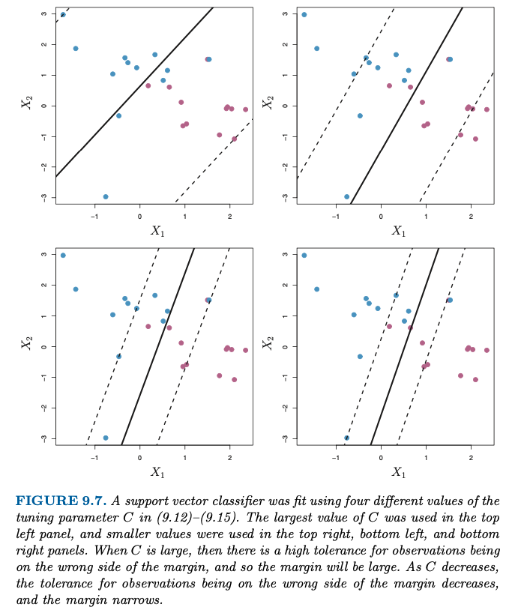

Graph

* Top left panel has low variance (since many training observations are support vectors) but potentially high bias.
* Bottom right panel shows only a few support vectors with C being small, which results in low bias but high variance.

The optimization problem (9.12)–(9.15) has a very interesting property: it turns out that only observations that either lie on the margin or that violate the margin will affect the hyperplane, and hence the classifier ob- tained. In other words, an observation that lies strictly on the correct side of the margin does not affect the support vector classifier! Changing the position of that observation would not change the classifier at all, provided that its position remains on the correct side of the margin. Observations that lie directly on the margin, or on the wrong side of the margin for their class, are known as support vectors. These observations do affect the support vector classifier. The fact that only support vectors affect the classifier is in line with our previous assertion that C controls the bias-variance trade-off of the support vector classifier. When the tuning parameter C is large, then the margin is wide, many observations violate the margin, and so there are many support vectors. In this case, many observations are involved in determining the hyperplane.

The fact that the support vector classifier’s decision rule is based only on a potentially small subset of the training observations (the support vec- tors) means that it is quite robust to the behavior of observations that are far away from the hyperplane. This property is distinct from some of the other classification methods that we have seen in preceding chapters, such as linear discriminant analysis .

**9.3 Support Vector Machines**

SVM is the transformation of the *Support Vector Classifier* to enable non-linear decision boundaries. This would be useful in cases such as the below, where a linear boundary performs classification poorly.

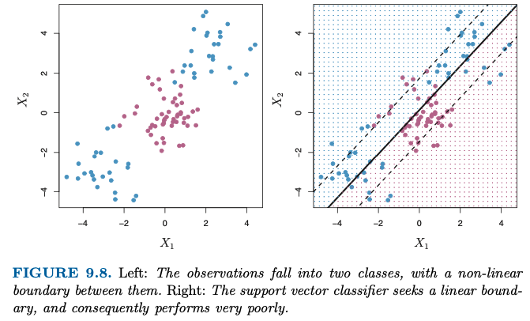

The support vector machine, which we present next, allows us to enlarge the feature space used by the support vector classifier in a way that leads to efficient computations. The **support vector machine (SVM)** is an extension of the support vector classifier that results from enlarging the feature space in a specific way, using *kernels*. The kernel approach that we describe here is simply an efficient computational approach for enacting this idea.

in representing the linear classifier f (x), and in computing its coefficients, all we need are ***inner products.***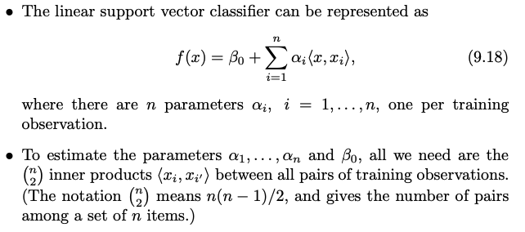

Now suppose that every time the inner product (9.17) appears in the representation (9.18), or in a calculation of the solution for the support vector classifier, we replace it with a generalization of the inner product of the form: K (xi , xi′ ),

where K is some function that we will refer to as a kernel. A kernel is a function that quantifies the similarity of two observations. For instance, we could simply take: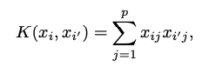

which would just give us back the support vector classifier. Equation 9.21 is known as a linear kernel because the support vector classifier is linear in the features; the linear kernel essentially quantifies the similarity of a pair of observations using Pearson (standard) correlation.

This is known as a polynomial kernel of degree d, where d is a positive integer. Using such a kernel with d > 1, instead of the standard linear kernel (9.21), in the support vector classifier algorithm leads to a much more flexible decision boundary. It essentially amounts to fitting a support vector classifier in a higher-dimensional space involving polynomials of degree d, rather than in the original feature space. When the support vector classifier is combined with a non-linear kernel such as (9.22), the resulting classifier is known as a support vector machine.

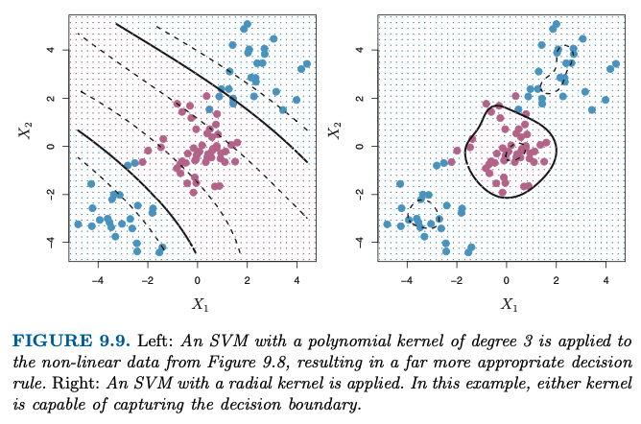

The left-hand panel of Figure 9.9 shows an example of an SVM with a polynomial kernel applied to the non-linear data from Figure 9.8. The fit is a substantial improvement over the linear support vector classifier. When d = 1, then the SVM reduces to the support vector classifier seen earlier in this chapter.

The polynomial kernel shown in (9.22) is one example of a possible non-linear kernel, but alternatives abound. Another popular choice is the radial kernel, which takes the form:

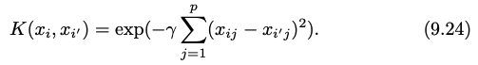

The radial kernel has very local behavior, in the sense that only nearby training observations have an effect on the class label of a test observation.

What is the advantage of using a kernel rather than simply enlarging the feature space using functions of the original features, as in (9.16)? One advantage is computational, and it amounts to the fact that using kernels, one need only compute K(xi, xi′ ) for all n2 distinct pairs i, i′. This can be done without explicitly working in the enlarged feature space. This is im- portant because in many applications of SVMs, the enlarged feature space is so large that computations are intractable. For some kernels, such as the radial kernel (9.24), the feature space is implicit and infinite-dimensional, so we could never do the computations there anyway!

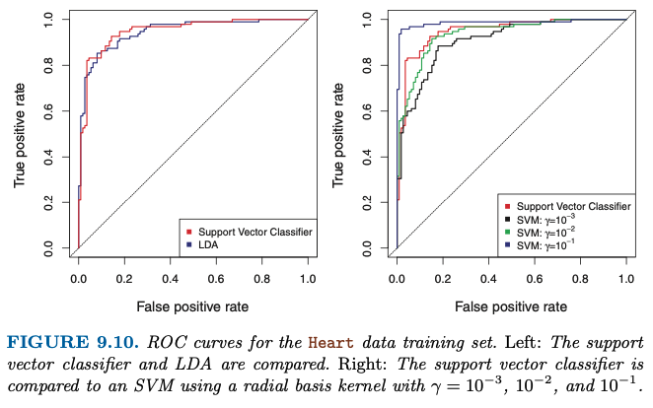

The right-hand panel of Figure 9.10 displays ROC curves for SVMs using a radial kernel, with various values of γ. As γ increases and the fit becomes more non-linear, the ROC curves improve. Using γ = 10−1 appears to give an almost perfect ROC curve. However, these curves represent training error rates, which can be misleading in terms of performance on new test data.

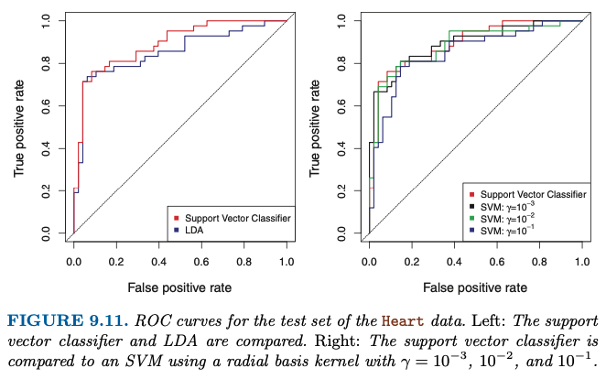

tions. We observe some differences from the training ROC curves. In the left-hand panel of Figure 9.11, the support vector classifier appears to have a small advantage over LDA (although these differences are not statisti- cally significant). In the right-hand panel, the SVM using γ = 10−1, which showed the best results on the training data, produces the worst estimates on the test data. This is once again evidence that while a more flexible method will often produce lower training error rates, this does not neces- sarily lead to improved performance on test data. The SVMs with γ = 10−2 and γ = 10−3 perform comparably to the support vector classifier, and all three outperform the SVM with γ = 10−1.

**9.4 SVMs with More than Two Classes**

How can we extend SVMs to the more general case where we have some arbitrary number of classes? It turns out that the concept of separating hyperplanes upon which SVMs are based does not lend itself naturally to more than two classes. Though a number of proposals for extending SVMs to the K-class case have been made, the two most popular are the one-versus-one and one-versus-all approaches.

**9.4.1 One-Versus-One Classification**

Suppose that we would like to perform classification using SVMs, and there are K > 2 classes. A one-versus-one or all-pairs approach constructs (K2) SVMs, each of which compares a pair of classes. For example, one such SVM might compare the kth class, coded as +1, to the k′th class, coded as −1. We classify a test observation using each of the (K2) classifiers, and we tally the number of times that the test observation is assigned to each of the K classes. The final classification is performed by assigning the test observation to the class to which it was most frequently assigned in these (K2) pairwise classifications.

**9.4.2 One-Versus-All Classification**

The one-versus-all approach is an alternative procedure for applying SVMs in the case of K > 2 classes. We fit K SVMs, each time comparing one of the K classes to the remaining K − 1 classes. Let β0k, β1k, . . . , βpk denotethe parameters that result from fitting an SVM comparing the kth class (coded as +1) to the others (coded as −1). Let x∗ denote a test observation. We assign the observation to the class for which β0k + β1k x∗1 + β2k x∗2 + . . . + βpkx∗p is largest, as this amounts to a high level of confidence that the test observation belongs to the kth class rather than to any of the other classes.

**Comparisons vs. Logistic Regression**

Though we have not addressed it here, there is in fact an extension of the SVM for regression (i.e. for a quantitative rather than a qualita- tive response), called support vector regression. In Chapter 3, we saw that least squares regression seeks coefficients β0,β1,...,βp such that the sum of squared residuals is as small as possible. (Recall from Chapter 3 that residuals are defined as yi − β0 − β1xi1 − · · · − βpxip.) Support vector regression instead seeks coefficients that minimize a different type of loss, where only residuals larger in absolute value than some positive constant contribute to the loss function. This is an extension of the margin used in support vector classifiers to the regression setting.

**8.2 Bagging, Random Forests, Boosting**

**8.2.1 Bagging**

The bootstrap, introduced in Chapter 5, is an extremely powerful idea. It is used in many situations in which it is hard or even impossible to directly compute the standard deviation of a quantity of interest. We see here that the bootstrap can be used in a completely different context, in order to improve statistical learning methods such as decision trees.

The decision trees discussed in Section 8.1 suffer from high variance. This means that if we split the training data into two parts at random, and fit a decision tree to both halves, the results that we get could be quite different. In contrast, a procedure with low variance will yield similar results if applied repeatedly to distinct data sets; linear regression tends to have low variance, if the ratio of n to p is moderately large. *Bootstrap aggregation,* or***bagging****,* is a general-purpose procedure for reducing the variance of a statistical learning method; we introduce it here because it is particularly useful and frequently used in the context of decision trees.

a natural way to reduce the variance and hence increase the prediction accuracy of a statistical learning method is to take many training sets from the population, build a separate prediction model using each training set, and average the resulting predictions. In other words, we could calculate fˆ1(x),fˆ2(x),...,fˆB(x) using B separate training sets, and average them in order to obtain a single low-variance statistical learning model.

Of course, this is not practical because we generally do not have access to multiple training sets. Instead, we can bootstrap, by taking repeated samples from the (single) training data set. In this approach we generate B different bootstrapped training data sets. We then train our method on the bth bootstrapped training set in order to get fˆ∗b(x), and finally average all the predictions , this is called bagging.

While bagging can improve predictions for many regression methods, it is particularly useful for decision trees. To apply bagging to regression trees, we simply construct B regression trees using B bootstrapped training sets, and average the resulting predictions. These trees are grown deep, and are not pruned. Hence each individual tree has high variance, but low bias. Averaging these B trees reduces the variance. Bagging has been demonstrated to give impressive improvements in accuracy by combining together hundreds or even thousands of trees into a single procedure.

Thus far, we have described the bagging procedure in the regression context, to predict a quantitative outcome Y . How can bagging be extended to a classification problem where Y is qualitative? In that situation, there are a few possible approaches, but the simplest is as follows. For a given test observation, we can record the class predicted by each of the B trees, and take a *majority vote:* the overall prediction is the most commonly occurring class among the B predictions.

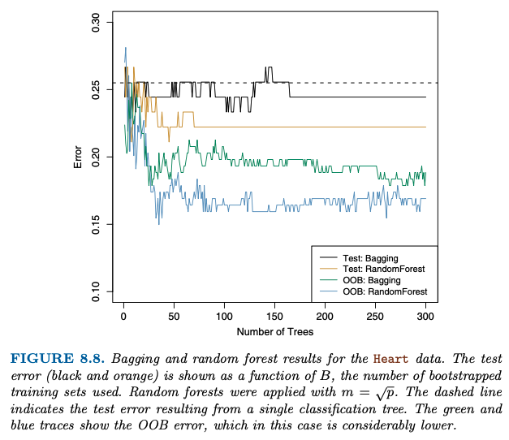

Out-of-Bag Error Estimation

It turns out that there is a very straightforward way to estimate the test error of a bagged model, without the need to perform cross-validation or the validation set approach. Recall that the key to bagging is that trees are repeatedly fit to bootstrapped subsets of the observations. One can show that on average, each bagged tree makes use of around two-thirds of the observations. The remaining one-third of the observations not used to fit a given bagged tree are referred to as the ***out-of-bag*** (OOB) observations. We can predict the response for the ith observation using each of the trees in which that observation was OOB. This will yield around B/3 predictions for the ith observation. In order to obtain a single prediction for the ith observation, we can average these predicted responses (if regression is the goal) or can take a majority vote (if classification is the goal). This leads to a single OOB prediction for the ith observation. An OOB prediction can be obtained in this way for each of the n observations, from which the overall OOB MSE (for a regression problem) or classification error (for a classification problem) can be computed. The resulting OOB error is a valid estimate of the test error for the bagged model, since the response for each observation is predicted using only the trees that were not fit using that observation.

It can be shown that with B sufficiently large, OOB error is virtually equivalent to leave-one-out cross-validation error. OOB approach for estimating test error is particularly convenient when using large datasets for which CV would be computationally expensive.

Variable Importance Measures

As we have discussed, bagging typically results in improved accuracy over prediction using a single tree. Unfortunately, however, it can be difficult to interpret the resulting model. Recall that one of the advantages of decision trees is the attractive and easily interpreted diagram that results, such as the one displayed in Figure 8.1. However, when we bag a large number of trees, it is no longer possible to represent the resulting statistical learning procedure using a single tree, and it is no longer clear which variables are most important to the procedure. Thus, bagging improves prediction accuracy at the expense of interpretability.

Although the collection of bagged trees is much more difficult to interpret than a single tree, one can obtain an overall summary of the importance of each predictor using the RSS (for bagging regression trees) or the Gini index (for bagging classification trees). In the case of bagging regression trees, we can record the total amount that the RSS (8.1) is decreased due to splits over a given predictor, averaged over all B trees. A large value indicates an important predictor. Similarly, in the context of bagging classification trees, we can add up the total amount that the Gini index (8.6) is decreased by splits over a given predictor, averaged over all B trees.

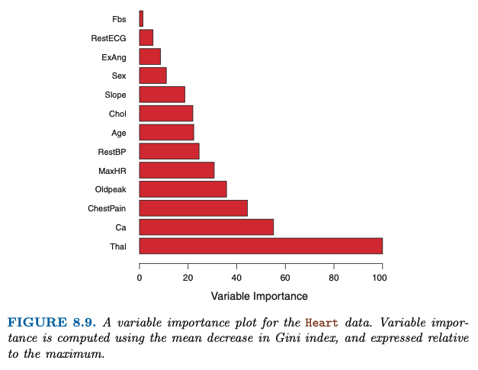

**8.2.2 Random Forests**

Random forests provide an improvement over bagged trees by way of a small tweak that decorrelates the trees. As in bagging, we build a number of decision trees on bootstrapped training samples. But when building these decision trees, each time a split in a tree is considered, a random sample of m predictors is chosen as split candidates from the full set of p predictors. The split is allowed to use only one of those m predictors. A fresh sample of m predictors is taken at each split, and typically we choose m ≈ √p—that is, the number of predictors considered at each split is approximately equal to the square root of the total number of predictors.

In other words, in building a random forest, at each split in the tree, the algorithm is not even allowed to consider a majority of the available predictors. Suppose that there is one very strong predictor in the data set, along with a num- ber of other moderately strong predictors. Then in the collection of bagged trees, most or all of the trees will use this strong predictor in the top split. Consequently, all of the bagged trees will look quite similar to each other. Hence the predictions from the bagged trees will be highly correlated. Un- fortunately, averaging many highly correlated quantities does not lead to as large of a reduction in variance as averaging many uncorrelated quanti- ties. In particular, this means that bagging will not lead to a substantial reduction in variance over a single tree in this setting. Random forests overcome this problem by forcing each split to consider only a subset of the predictors. Therefore, on average (p − m)/p of the splits will not even consider the strong predictor, and so other predictors will have more of a chance. We can think of this process as decorrelating the trees, thereby making the average of the resulting trees less variable and hence more reliable.

The main difference between bagging and random forests is the choice of predictor subset size m. For instance, if a random forest is built using m = p, then this amounts simply to bagging. On the Heart data, random forests using m = √p leads to a reduction in both test error and OOB error over bagging (Figure 8.8). Using a small value of m in building a random forest will typically be helpful when we have a large number of correlated predictors.

**8.2.3 Boosting**

We now discuss boosting, yet another approach for improving the predictions resulting from a decision tree. Like bagging, boosting is a general approach that can be applied to many statistical learning methods for regression or classification. Here we restrict our discussion of boosting to the context of decision trees.

Recall that bagging involves creating multiple copies of the original training data set using the bootstrap, fitting a separate decision tree to each copy, and then combining all of the trees in order to create a single predictive model. Notably, each tree is built on a bootstrap data set, independent of the other trees. Boosting works in a similar way, except that the trees are grown sequentially: each tree is grown using information from previously grown trees. Boosting does not involve bootstrap sampling; instead each tree is fit on a modified version of the original data set.

What is the idea behind this procedure? Unlike fitting a single large deci- sion tree to the data, which amounts to fitting the data hard and potentially overfitting, the boosting approach instead learns slowly. Given the current model, we fit a decision tree to the residuals from the model. That is, we fit a tree using the current residuals, rather than the outcome Y , as the re- sponse. We then add this new decision tree into the fitted function in order to update the residuals. Each of these trees can be rather small, with just a few terminal nodes, determined by the parameter d in the algorithm. By fitting small trees to the residuals, we slowly improve fˆ in areas where it does not perform well. The shrinkage parameter λ slows the process down even further, allowing more and different shaped trees to attack the resid- uals. In general, statistical learning approaches that learn slowly tend to perform well. Note that in boosting, unlike in bagging, the construction of each tree depends strongly on the trees that have already been grown.

We have just described the process of boosting regression trees. Boosting classification trees proceeds in a similar but slightly more complex way, and the details are omitted here.

Boosting has three tuning parameters:

1. The number of trees B. Unlike bagging and random forests, boosting can overfit if B is too large, although this overfitting tends to occur slowly if at all. We use cross-validation to select B.
2. The shrinkage parameter λ, a small positive number. This controls the rate at which boosting learns. Typical values are 0.01 or 0.001, and the right choice can depend on the problem. Very small λ can require using a very large value of B in order to achieve good performance.
3. The number d of splits in each tree, which controls the complexity of the boosted ensemble. Often d = 1 works well, in which case each tree is a stump, consisting of a single split. In this case, the boosted ensemble is fitting an additive model, since each term involves only a single variable. More generally d is the *interaction depth*, and controls the interaction order of the boosted model, since d splits can involve at most d variables.

one difference between boosting and random forests: in boosting, because the growth of a particular tree considers the other trees that have already been grown, smaller trees are typically sufficient. Using smaller trees can aid in interpretability as well; for instance, using stumps leads to an additive model.

**Week 7: A Mixture of Lectures from ‘Regularisation, Decision Trees’**

**Lecture 5: Regularisation, Decision Trees**

Ridge Regression & LASSO are regularised linear models.

* These models **constrain** or **regularise** coefficient estimates, or equivalenty, **shrink** coefficient estimates towards zero.
* Why would we want to shrink our coefficients?
  + Bias-variance tradeoff: The least squares estimates often have lower bias and higher variance, reducing variance could improve prediction.
  + Interpretation: With too many independent varaibles models become unparsimonious (kitchen sink) and difficult to interpret. Sometimes, regularisation can help us automatically perform **feature selection.**
  + Big p data: OLS models can not handle p > n.

**Ridge Regression**

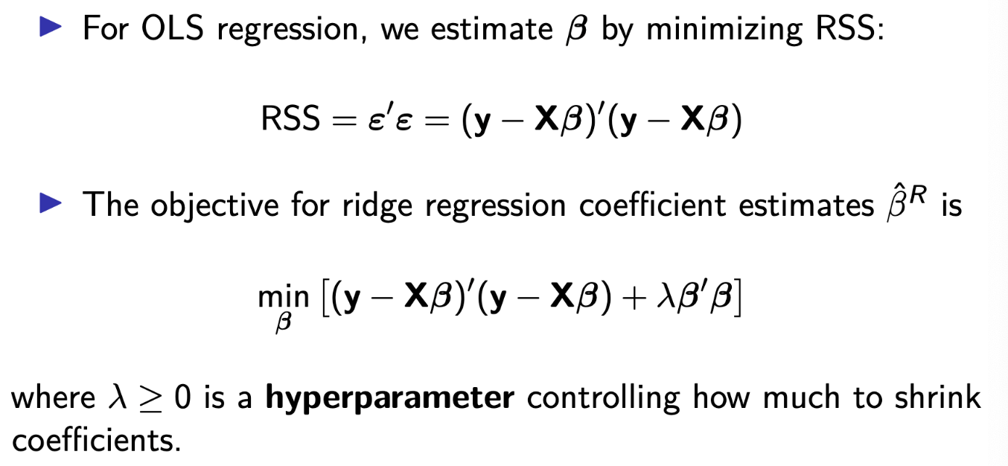

The objective is to minimise penalised RSS (PRSS), thus lowering variance by adding bias.

**Shrinkage Penalty**

* The l2 norm is ridge regression’s shrinkage penalty which controls the complexity of the model.
  + Trades variance for bias by managing how strongly our coefficient estimates match the training data.
* Why does making coefficients smaller make the model less complex?
  + - Pay a little bit less attention to the data.
* When coefficients are small, shrinkage penalty is small, and vice versa.
* PRSS(.) controls the tradeoff between fit to data and model complexity using lambda:
  + When lambda is large, we ‘shrink’ coefficients towards zero,
  + When lambda is small, it moves closer to OLS estimates.
* Selecting a good value for lambda is criticial, cross-validation is used for this.
  + Regularisation improves predictions by trading variance for bias; best tradeoff determined by cross-val.
    - Trading off how closely we fit to the data and how simple we want our model to be.

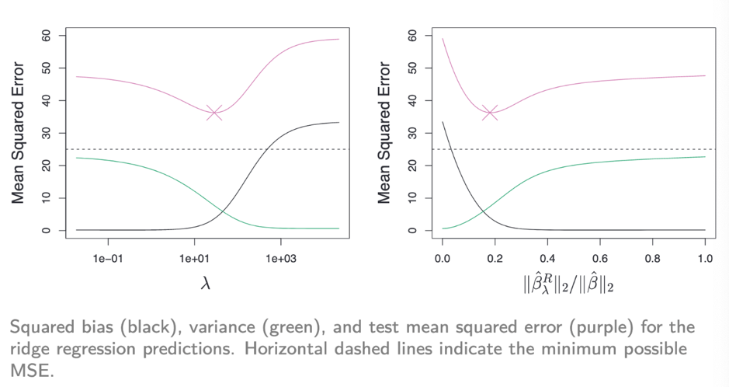

**LASSO (Least Absolute Shrinkage and Selection Operator)**

* RR has one obvious disadvantage: it does not select models that involve just a subset of the variables.
* RR will include all p predictors in the final model.
* LASSO overcomes this disadvantage and allows coefficient values to go to 0.
  + This automatically performs variable selection.
    - Yields a sparse (parsimonious) model.
  + 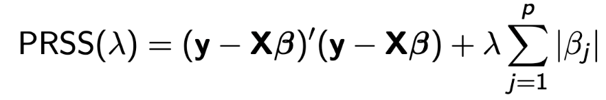
  + 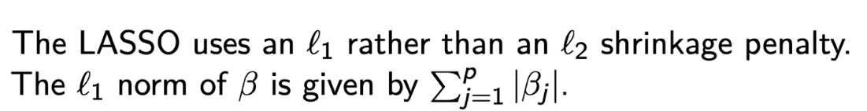
  + Choose the Betas that minimise the objective function, but with a budget s to constrain.
  + Lambda is the lagrange multiplier for this problem.

Contours represent RSS function, center represents the minimum least squares estimate of Beta-hat.

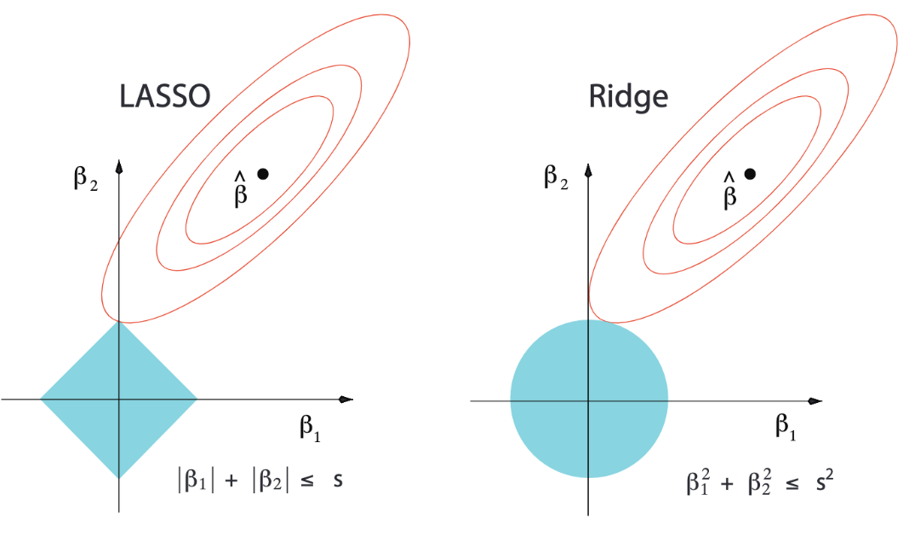

* The objective is to find the minimum value of RSS that satisfies the constaint (within blue area).
* L2 norm constraint region is circular, L1 is a diamond.

**Selecting the tuning parameter, Lambda**

* 1. Choose a grid search of lambda values (or equivalent method),
  2. Compute the CV error rate for each value of lambda.
  3. Select lambda where cross-validation error is either:
     1. Smallest, or
     2. One standard error from the smallest CV error (one s.e. rule).
  4. Refit model to available observations with selected value of lambda.

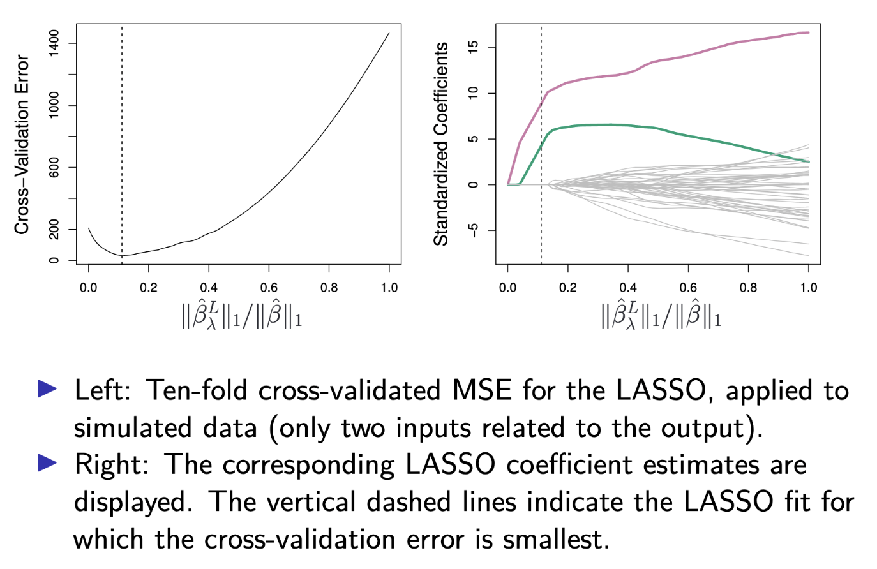

**Tree-based Methods**

* Trees recursively partition the feature space into smaller regions.
* Each region is created by a binary split at the value t-k of x-j.
* Each region corresponds to a single outcome of y.

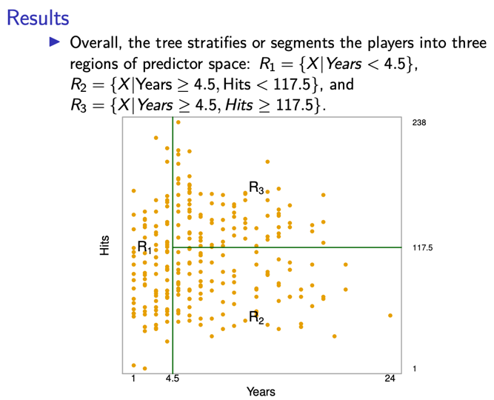 **baseball salary example**

Unfortunately, it is computationally infeasible to consider every possible partition of the feature space into J boxes. For this reason, we take a ***top-down, greedy approach*** that is known as recursive binary splitting.

* The approach is **top-down** because it begins at the top of the tree and then successively splits the predictor space; each split is indicated via two new branches further down on the tree.
* It is **greedy** because at each step of the tree-building process, the best split is made at that particular step, rather than looking ahead and picking a split that will lead to a better tree in some future step.

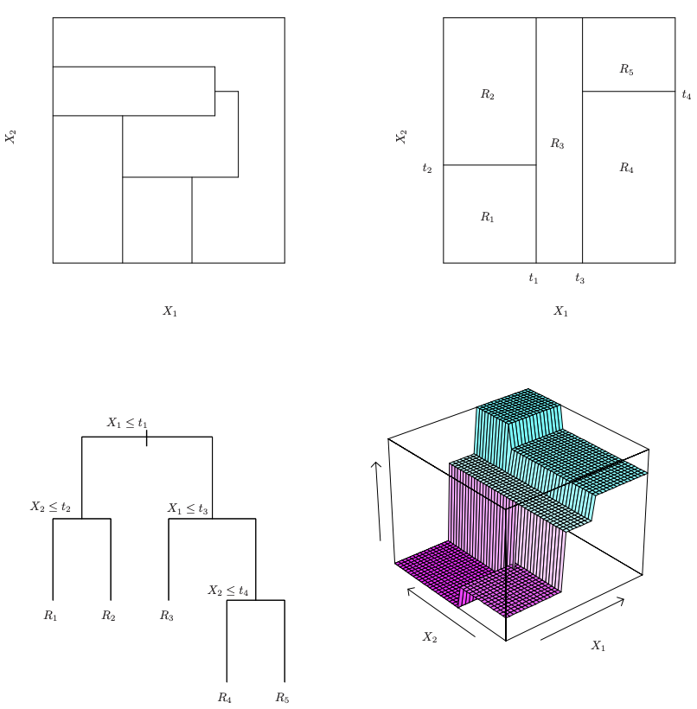

The above graphic illustrates top-dow and greedy. Top left is optimal split but we can’t do this because each split is binary (rectangular) and greedy (not looking to future splits). Instead, we end up with something more like the top right. The bottom graphics are associated with our **actual** model in the top-right.

**Pruning**

The process described above is prone to overfitting. We need to tradeoff between bias and variance.

* A smaller tree with fewer splits (fewer regions) might lead to lower variance and better interpretation at the cost of a little bias.
* One possible alternative to the process described above is to grow the tree only so long as the decrease in the RSS due to each split exceeds some threshold.
  + This strategy will result in smaller trees, but it is too **short-sighted:** a seemingly worthless split early on in the tree might be followed by a very good split – that is, a split that leads to a large reduction in RSS later on.
  + A better strategy is to grow a very large tree, T0, and then prune it back in order to obtain a subtree.
    - **Cost-complexity pruning** – also known as **weakest link pruning** – is used to do this.
    - RSS + penalty term that penalises based on the size of the tree.
    - 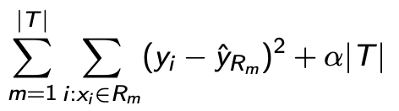
    - The tuning parameter alpha controls a trade-off between the subtree’s complexity and its fit to the training data.
      * Alpha = 0 corresponds to minimising training error.
      * Large alpha results in small trees.
    - We select an optinal value of alpha using CV.
    - We then return to the full data set and obtain the subtree corresponding to alpha.

**Classification Trees**

Very good graphic that shows splitting of donut data (slides 50-58)

In the classification setting, RSS cannot be used as a criterion for making the binary splits.

A natural alternative to RSS is the **classification error rate**. this is simply the fraction of the training observations in that region that do not belong to the most common class:

E = 1 – max-k(p-hat-mk) where p-hat-mk represents the proportion of training observation in the mth region that are from the kth class.

However, classification error is not sufficiently sensitive for tree-growing, and in practice two other measures are preferable.

**Gini index and Deviance**

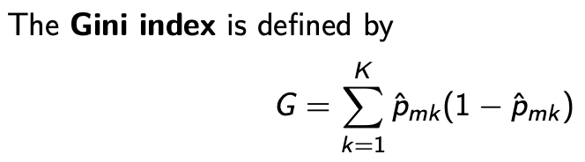

Small value if all values are close to 0 or 1 (classification is more pure in region-i).

* A measure of total variance across the K classes. Gini takes on a small value if all of the pˆmk ’s are close to 0 or 1.
* Gini represents the variance of a binomial distribution; the diagonal of the multinomial variance covariance matrix for > 2 classes
* For this reason the Gini index is referred to as a measure of **node purity** — a small value indicates that a node contains predominantly observations from a single class.

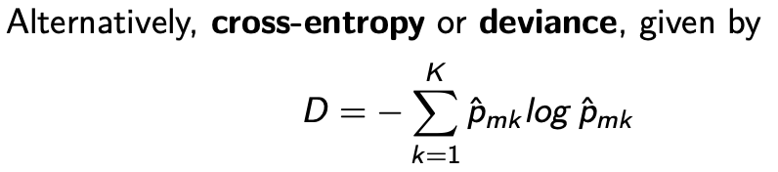

It turns out that the Gini index and the cross-entropy are very similar numerically.

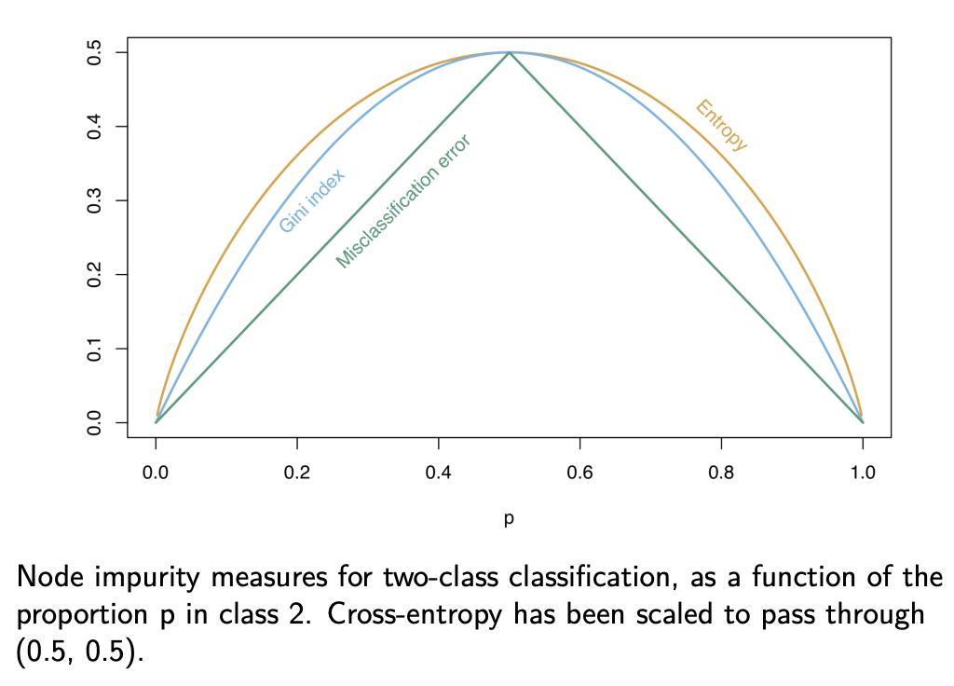 **Different errors to minimise essentially optimise for slightly different things!**

**Tree vs. Linear Models**

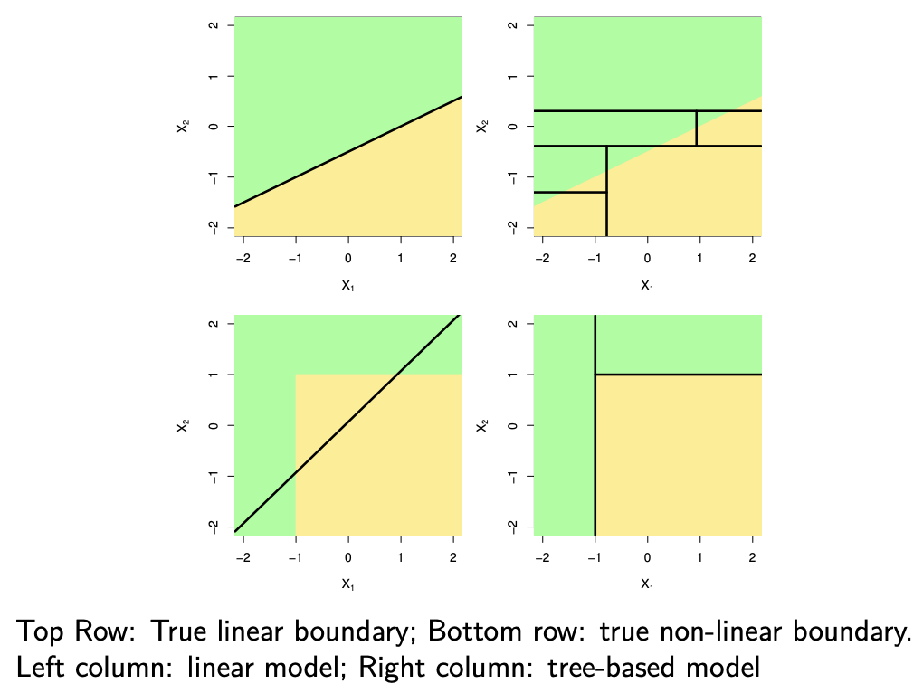

**Pretty obvious… right?**

**Support Vector Machines: Main Idea**

“Support-Vector Networks,” Vapnik (1995)

* Consider the simplest case of two linearly separable classes (separable by a line/plane/hyperplane)
* Devise a method for finding a “good” separating hyperplane.
* “Good” for SVM means with the largest margin between classes.
* We will focus on 2-class problems, although there are multi-class extensions.

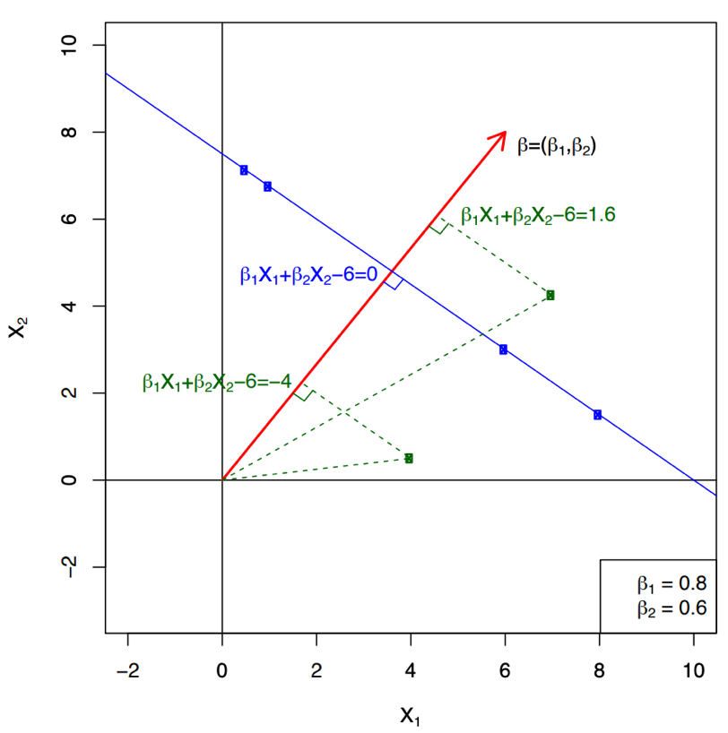

Main Concepts

* **Separating hyperplane:** a linear boundary between the classes
* **Margin:** distance from the separating hyperplane to each class (need to maximize)
* **Support vectors:** data points on the margin boundary (within)

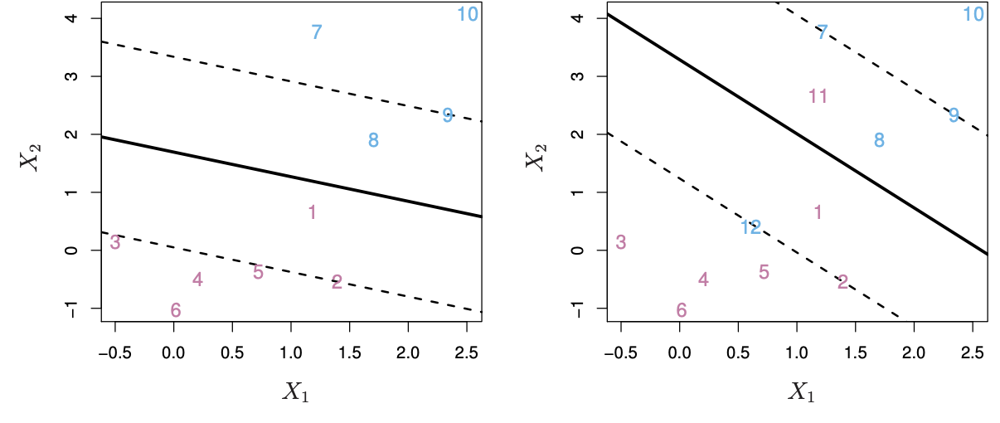

**Here, hyperplane is the full line, the margins are the dotted lines and the support vectors are observations between the margins.**

If f (X) = β0 + β1X1 + · · · + βpXp,then f (X) > 0 for points on one side of the hyperplane, and f (X) < 0 for points on the other.

If we code the colored points as Yi = +1 for blue, say, and Yi = −1 for mauve, then if Yi · f (Xi) > 0 for all i, f (X) = 0 **defines a separating hyperplane.**

**When classes are separable, we can always find a hyperplane that splits them.**

* But, we can usually draw multiple different hyperplanes. We need to find an optimal one.
* We want to maximise the **margin,** i.e. distance from the hyperplane to the nearest points.
  + We use the maximal-margin classifier to do so.
    - **This mathematical algo optimises for the largest distance between margin and hyperplane.**

But there are also non-separable cases. We need to allow some ‘slack’ or violations of **margin** in order to deal with non-separable cases.

* We set a budget for the amount of ‘slack’ in our margin.
  + Error measures refer to distance from observation to margin, which can be tuned! It’s a hyperparameter.
  + This parameter is called **C**, and is a regularisation parameter.
    - As we increase C, we allow for more violations of the margin.

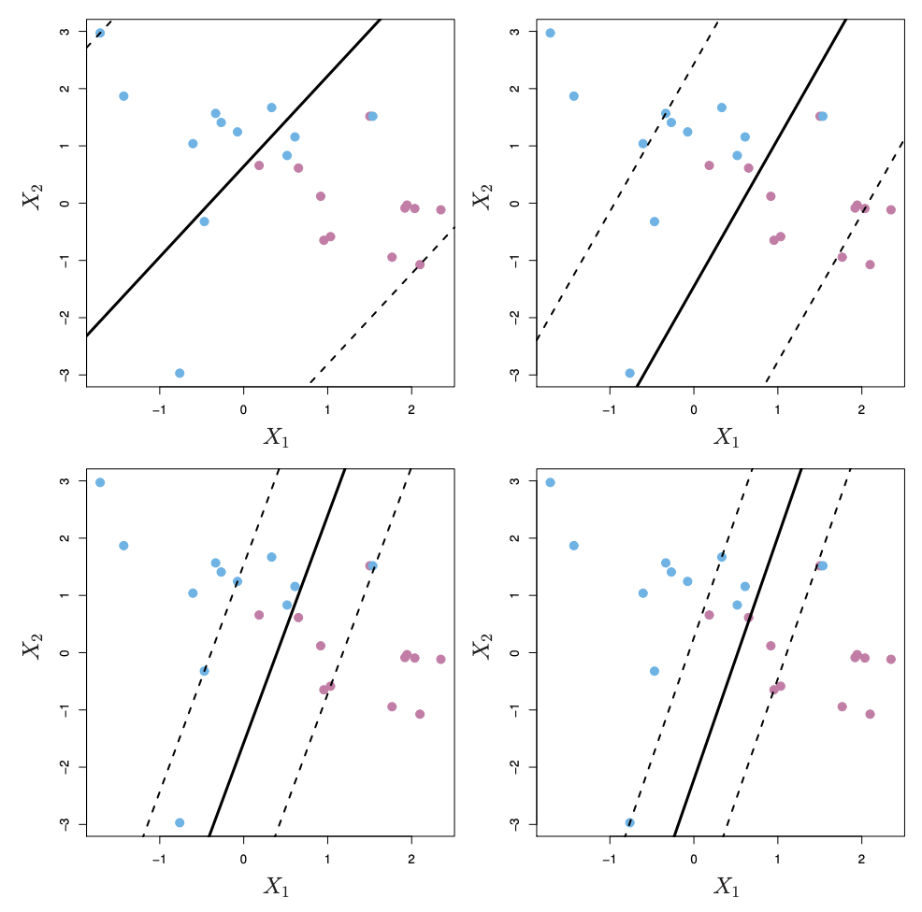

This can affect margin size – where large value of C might lead to larger margins and a smaller value might lead to a smaller space between margin and hyperplane.

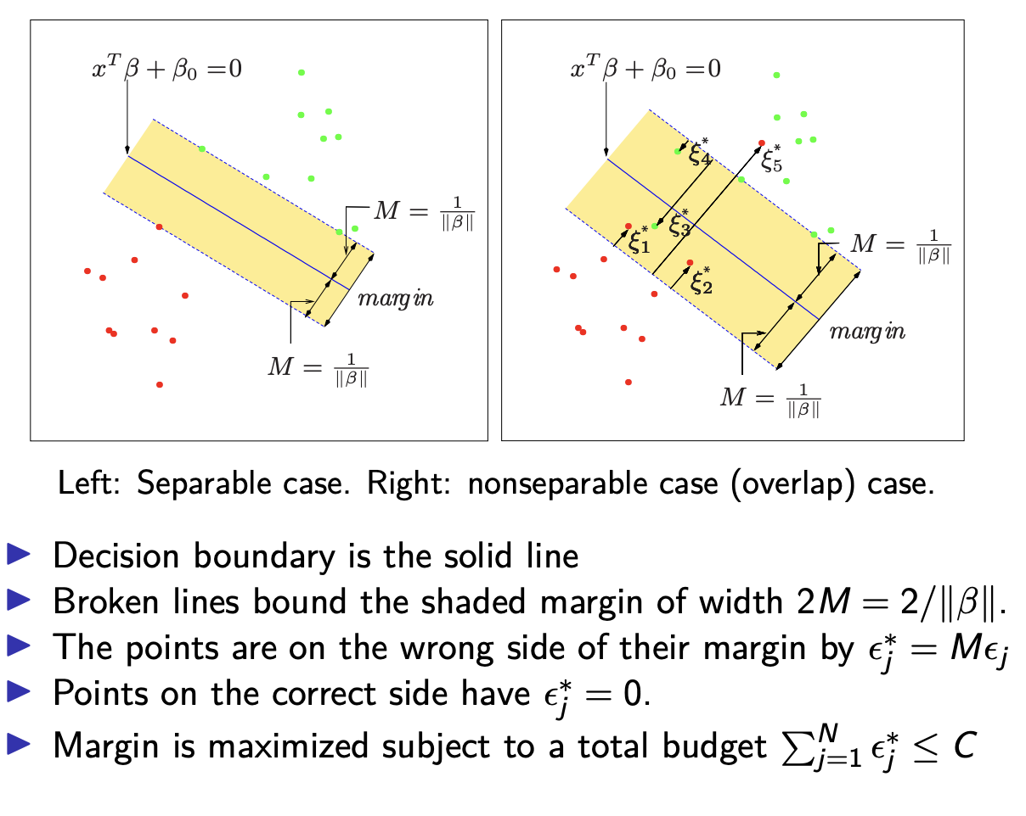

**Sometime a linear boundary simply won’t work, no matter what value of C. The example on the left is such a case. What to do?**

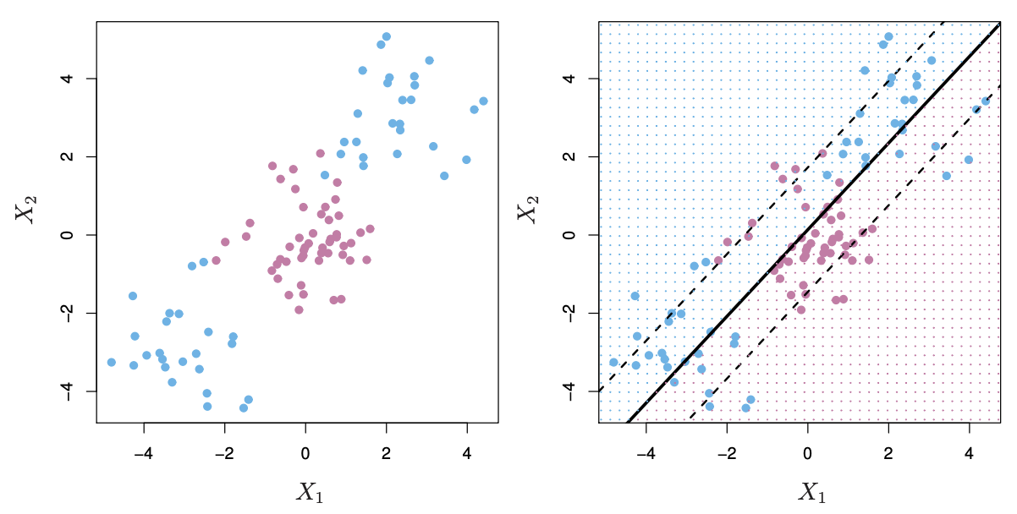

**Feature Expansion**

* Embed the data in a higher-dimensional space.
* For example, given p predictors X1, X2, . . . , Xp add new variables that are polynomials of those predictors.
* Then apply a linear method for separating the two classes.
* he higher the dimension, the easier it is to find a separating hyperplane.
* This results in non-linear decision boundaries in the original space.

**We project a 2D data set into higher dimensional space to separate.**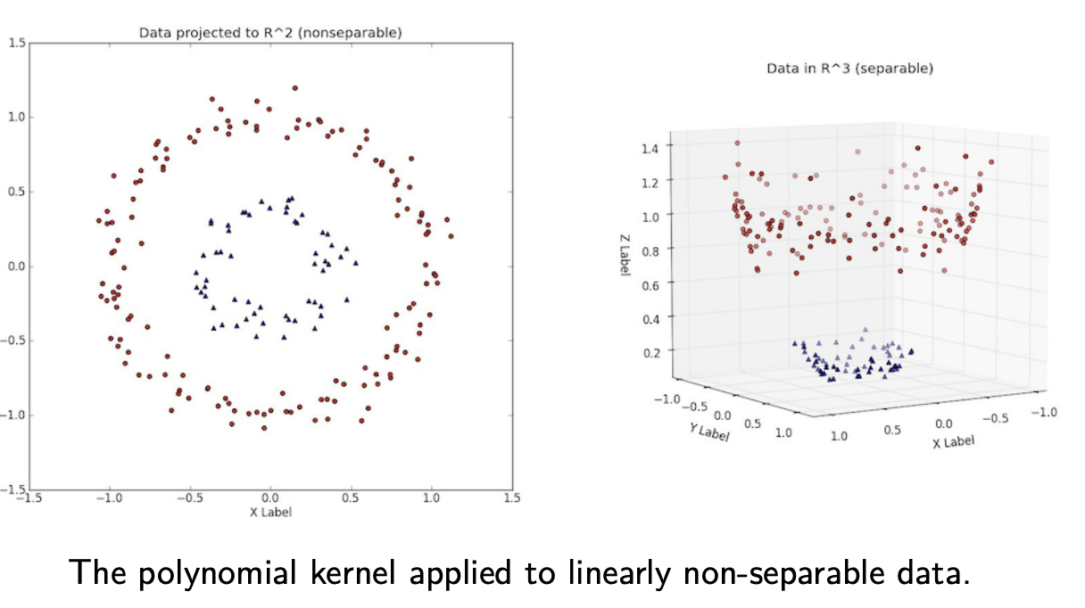

**Readings: Fairness & Bias**

[**Lee, Nicol Turner, Paul Resnick, and Genie Barton. “Algorithmic bias detection and mitigation: Best practices and policies to reduce consumer harms.” Brookings Institute: Washington, DC, USA (2019).**](https://www.brookings.edu/research/algorithmic-bias-detection-and-mitigation-best-practices-and-policies-to-reduce-consumer-harms/)

Wallach, Hanna. “Big Data, Machine Learning, and the Social Sciences: Fairness, Accountability, and Transparency.” NeurIPS Workshop on Fairness, Accountability, and Transparency in Machine Learning. 2014.

Deibert, Ronald J. “The Road to Digital Unfreedom: Three Painful Truths About Social Media.” Journal of Democracy 30.1 (2019): 25-39.

**Week 8: Lecture 7 – Bias, Fairness, and Ethics in Machine Learning**

Field of ML and Statistics conceptualiesed and typically owned and operated by rich white people.

**Algorithmic Bias**

*Definition:* An algorithm is biased when two conditions are met:

a. Disparities in outcome across groups causes harm.

b. Disparities in outcomes across groups are unjustified

**Where does it come from?**

1. **Biased Training Data** 
   1. Bias by Omission: Protected groups are underrepresented.
   2. Biased Labelers: Labelers decisions are based on biases about protected groups.
   3. Mismatched Domains: Training data come from a different domain than the target population.
2. **Proxy features:** socio-historical biases result in latent representations of protected traits in other variables.
   1. Example: Even if without race as a predictor, disparate impact could come from variables such as postal code.
3. **Social/structural factors:** 
   1. Decision-makers in government, tech, and academia are overwhelmingly white and male.
   2. Addressing bias is costly, not a priority for profit-minded corporations.

**Types of Harm from Bias**

*1. Harms of allocation:* opportunities and resources are unfairly allocated due to algorithmic intervention.

*2.* *Harms of representation:* algorithms produce representations that are discriminatory

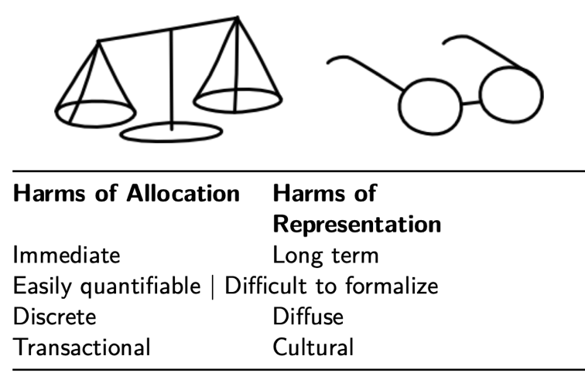

The main benchmark datasets for facial analysis are overwhelmingly light-skinned; Microsoft, IBM, Face++ systems are biased (Buolamwini and Gebru, 2018)

* Gender: Error rate for female faces 8.1%-20.6% greater than male faces
* Skin tone: Error rate for faces with darker skin tones 11.8-19.2% greater than faces with lighter skin tones.

At least 1/4 of US law enforcement agencies have access to facial recognition technology (Garvie et. al., 2016).

* In response to Black Lives Matter protests, Amazon, Microsoft, and IBM halted sale of facial recognition tech to US law enforcement (source).
* Harms of representation lead to hams of allocation.

**Identifying Bias**

Use interpretable models when possible:

* Easier to diagnose problems, identify how models are making decisions.
* Unfortunately, explainable models are less predictive.

Make use of “fairness forensics” to measure discrimination in algorithmic decisions.

* Group-level comparisons: Is there statistical parity among groups? (e.g. are Blacks and Whites misclassified at the same rate?)
* Individual-level comparisons: Do two otherwise similar individuals in different groups (race, gender, age, etc.) have similar outcomes?

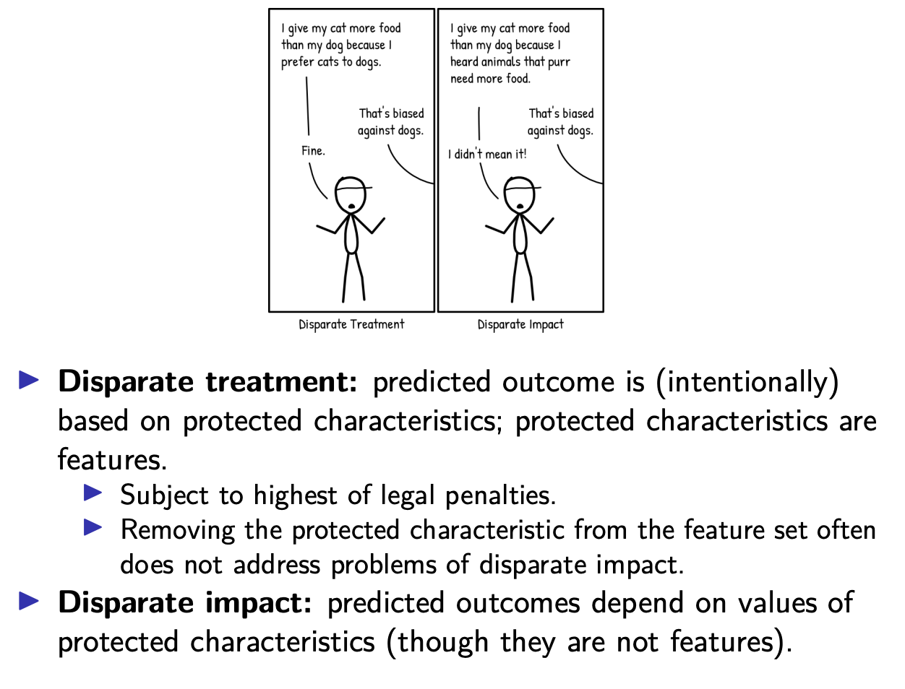

**Legal Example: Disparate Impact Guidelines (USA)**

Adopted in 1978 by the US Federal Government; standard used in US labor law

Disparate impact becomes “*adverse impact”* when the selection rate (e.g. for job candidates) for a protected group is *less than 80%* of the group with the highest selection rate, e.g.:

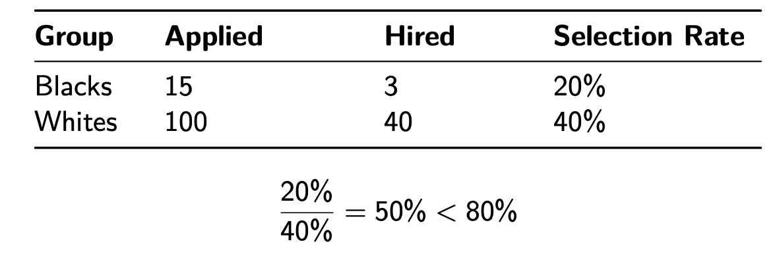

**Evaluating Bias**

Let’s imagine a population of individuals of different races R ∈ {Black, White} (a protected characteristic), features X, and outcomes: Y ∈ ( 0 if defaulted on loan. 1 if loan paid off.

*Goal: evaluate fairness (w.r.t. race R) of a learning algorithm g(X) that predicts credit-worthiness Yˆ ∈ {0, 1} based on observations of past loan outcomes.*

We can make use of three main diagnostic criteria for algorithmic bias:

**1. Demographic Parity (Independence): Yˆ ⊥R**

* Classifier makes positive predictions for each group at the same rate as the entire population.
* To satisfy ***independence****,* R must be statistically independent to the prediction Y-hat.
* P(Yˆ = 1|R = White) = P(Yˆ = 1|R = Black)
* Practically speaking, predicted positives rates calculated on TER=Black and TER=White should be equal.

**2. Equal Opportunity (Separation): Yˆ ⊥R|Y**

* The *true positive rates/recall* and *false positive rates* in each group are the same as entire population.
* Formally, to satisfy ***separation***, R must be statistically independent to the prediction Yˆ given the target value Y:
  + P(Yˆ = 1|Y = 1, R = White) = P(Yˆ = 1|Y = 1, R = Black),
  + P(Yˆ = 1|Y = 0, R = White) = P(Yˆ = 1|Y = 0, R = Black)
* Practically speaking, recall calculated on TER=Black and TER=White should be equal.

**3. Equalized Odds (Sufficiency): Y ⊥R|Y**

* Classifier should have both equal true positive rates (precision) and false positive rates on a protected population group as those of the entire population.
* To satisfy ***sufficiency***, R must be statistically independent to the target value Y given the prediction Y:
  + P(Y = 1|Yˆ = 1, R = White) = P(Y = 1|Yˆ = 1, R = Black)
* Practically speaking, precision calculated on TER=Black and TER=White should be equal.

**Adding Slack**

We might want to relax our fairness criteria, allowing small deviations from perfect fairness.

Example, for *demographic parity,* our fairness objective with slack is: P(Yˆ = 1|R = White) ≥ P(Yˆ = 1|R = Black) – ε.

Circling back to the legal definition of disparate impact, we may choose to formalize the 80% rule by setting ε = .2.

**Bias Correction**

**Before/During Data Collection**

1. Ensure Adequate Representation
   1. When collecting data, we need to be clear what the target population looks like.
      1. Underrepresenting one group could have serious consequences.
      2. To ensure fairness, we may want to over-sample underrepresented groups.
   2. If our goals are predictive accuracy and fairness, we may want to stratify our sample by group to ensure our model has enough information about all groups.
   3. Do we have adequate variation in feature values across groups?
      1. Are we capturing all relevant sub-populations within each group?
      2. Example: sampling minority groups from predominantly wealthier neighborhoods may result in bias affecting those living in poor neighborhoods, even if we oversample.
2. Train/Audit Labelers
   1. If an ML algorithm relies on human-labeled data:
      1. Train labelers to adhere to a clear and exhaustive codebook.
      2. Regularly audit labelers to ensure adherence to codebook instructions.
      3. Most social networks hire humans to moderate banned content.
         1. Labelers are outsourced to countries like the Phillippines.
         2. Conceptions of “sexually explicit” vary by culture, religion, etc.
            1. LGBT individuals could be disparately impacted through moderation of:

Posts using words like “fag” in a reclaimed, positive sense.

Posts of queer people showing affection, labeled as “sexually explicit” despite not meeting the definition set out in the codebook.

* + - * 1. Possible solutions:

Track coder reliability by labeling some observations several times (more on this here). Examine disagreements, intervene when necessary.

Allow user feedback to alert auditors when the coder gets it wrong.

**After Data Collection**

**Techniques for Correcting Disparate Impact**

* Pre-processing the data, adjusting feature values to remove disparate impact.
  + Goal: Learn a new feature representation *W* from *X* that removes information correlated to a protected characteristic while preserving enough information from *X* for a model to be sufficiently accurate.
    - <https://arxiv.org/pdf/1412.3756.pdf>
    - **Two problems:** 
      * 1. There are several dimensions of bias (race, gender, sexual orientation, etc.). Adjusting for all dimensions is challenging, especially if accuracy is important.
      * 2. Transforming raw data according to protected characteristics can be illegal.
        + <https://papers.ssrn.com/sol3/papers.cfm?abstract_id=2477899>
* Modifying the loss function used during training to optimize fit and a fairness criterion.
  + 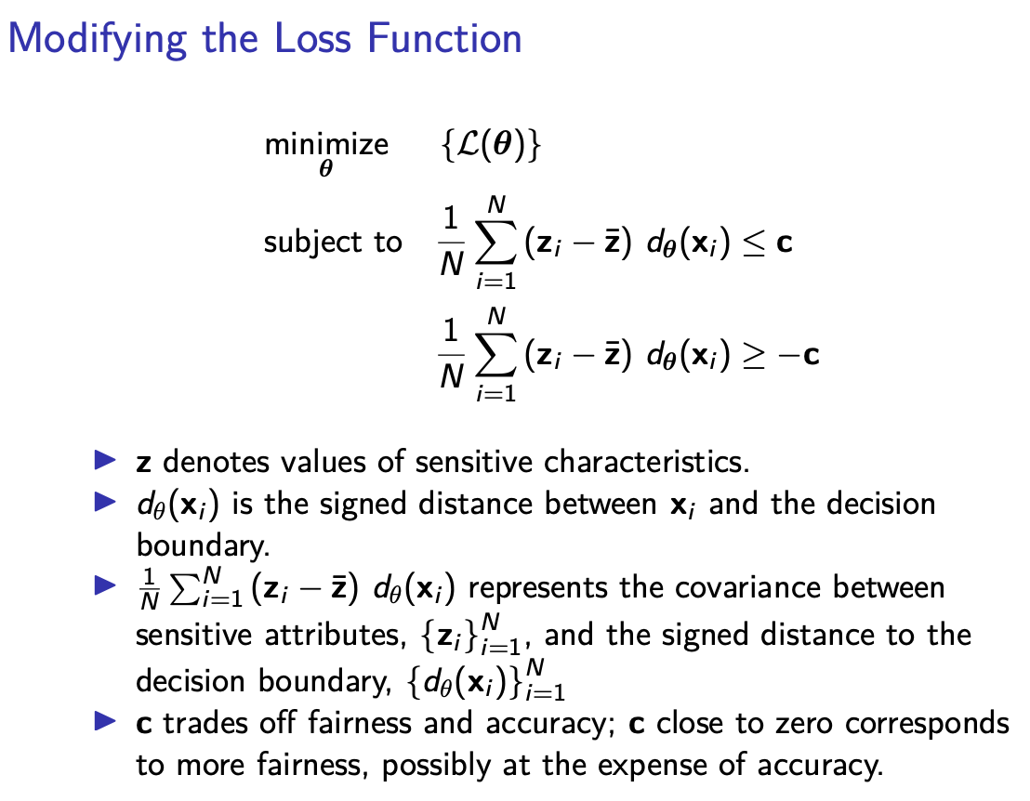
* Post-processing the predicted outcomes of the model to remove disparate impact.
  + Goal: Manipulate *yˆ* to achieve a fairness criterion while maintaining accuracy.
    - <https://proceedings.neurips.cc/paper/2016/file/a486cd07e4ac3d270571622f4f316ec5-Paper.pdf>
    - Word embeddings represent words as fixed-dimensional vectors such that:
      * similar words (e.g. good, great) → similar vector representations
      * vector directions encode syntactic and semantic information.
      * Vector operations can be used to construct analogies: man − woman ≈ king – queen.
        + Can be bad when: man – woman ≈ computer programmer – homemaker.
      * Embeddings are often inputs to ML models of natural language.
      * 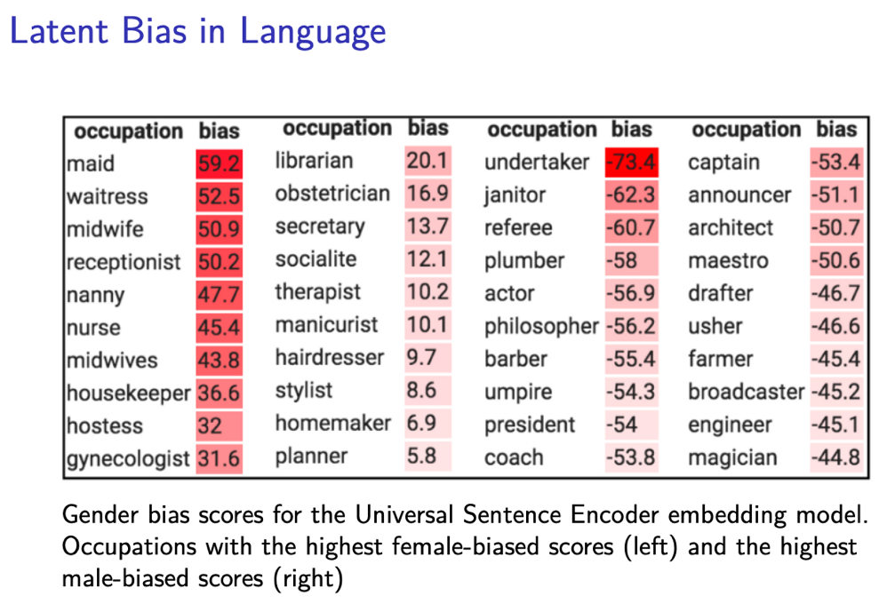
        + Identify direction of bias.
        + Neutralise: For all non-definitional words, project to get rid of bias.
        + Equalise pairs of words we want to differ only through the gender property (e.g. he/she).

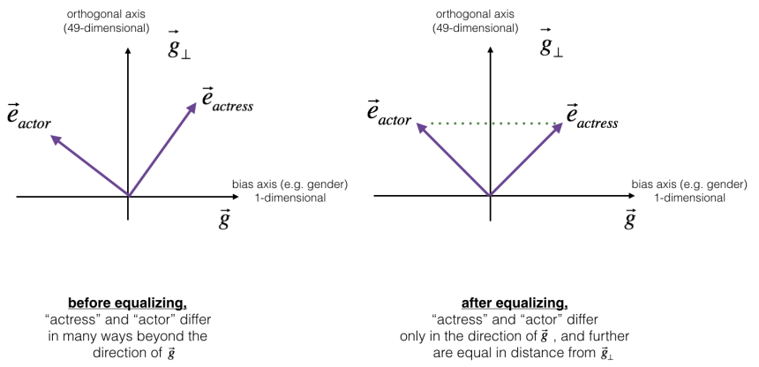

Equalization makes sure that a particular pair of words are equidistant from the orthogonal non-bias vector.

This ensures that the words actress and actor are equidistant from any other word that has been neutralized (e.g. babysitter).

**Lecture 9: Ensemble Methods, Bagging, Random Forests, Boosting**

* **Ensembles,**
* **Bagging,**
* **Random Forests,**
* **Boosting,**
* **Guided Coding**

**Bootstrap**

Trying to simulate how you created the dataset, but does it one step down the chain (from our dataset). This maintains population distributions. **We sample with replacement!**

On average, each bootstrap contains 2/3 of original data, because of pulling duplicate values. The remaining 1/3 is the Out-of-the-bag sample (OOB Sample).

**Out-of-Bag Error**

OOB error is an estimate of the test error, and is computed by generating error on the 1/3 per bootstrap that is OOB.

**Ensembles**

**Simple**

* Idea is to build a prediction model y combining strengths of a collection of simpler base models.
* Constructed using a committee of learners
* Take the mean for regression or majority vote for classification

**Ensembles Applied to Trees**

Trees are simple but unstable! They overfit, and don’t generalise well. The re-estimation on another sample would look very different. We can overcome by averaging across a bunch of trees to reduce variance.

* **Bagging (Bootstrap Aggregation)**
  + Fit many large trees to bootstrap resampled versions of the training data.
    - General-purpose procedure for reducing the variance of a statistical learning method.
    - Averaging a set of observations reduces variance.
    - Trees will be correlated, but averaging over trees will help (unless perfectly correlated)
    - Reduces variance of individual high variance at the cost of interpretability.
* **Random Forests**
  + Randomisation on subset of features for each tree. This is in an effort to decorrelate the trees on the individual samples. This reduces the variance further.
    - A random selection of M variables are selected as split candidates from the full set of P predictors. The split is allowed to use only one of those m predictors.
    - Great baseline for m is sqrt(p).
  + Feature Importance
    - We can record the total amount that the RSS is decreased due to splits over a given predictor, averaged over all B trees.
    - We can also add up the total amount that the criterion (e.g. Gini Index or accuracy) is decreased by splits over a given predictor, averaged over all B trees.
* Boosting
  + Sequentially fit many typically small trees to reweighted versions of the training data.
    - Key difference is that in boosting we use the same data set and repeatedly fit small trees sequentially. Each tree is grown using information from the previous tree.
  + 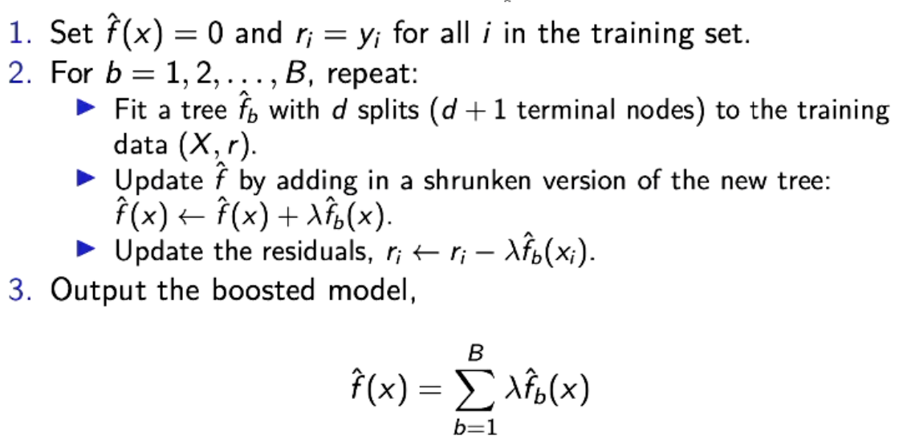
  + 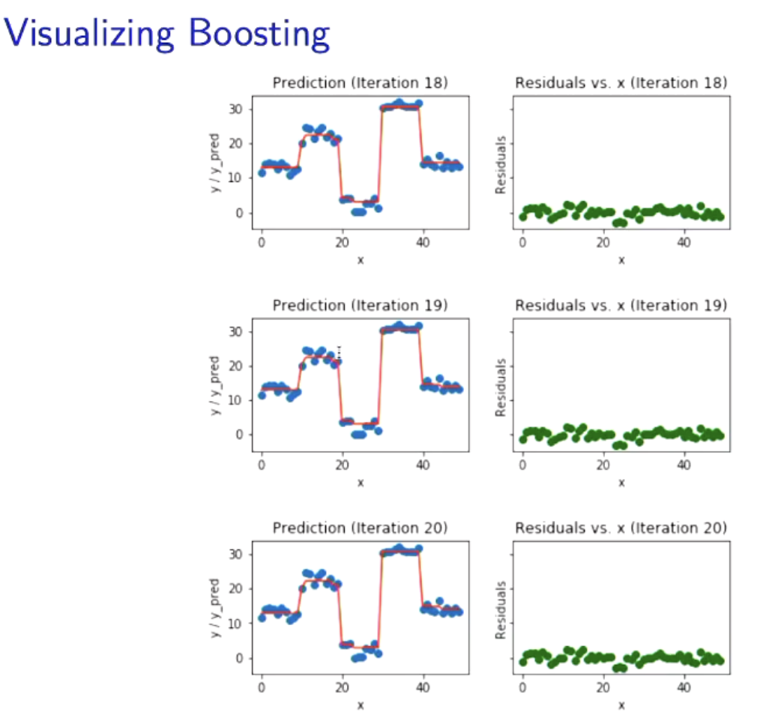
  + How do we optimise the boosting?
    - We have an evaluation data set (out-of-sample) and as soon as error goes up, we stop fitting.
    - Unlike fitting a single large decision tree to the data, which can quickly overfit, the boosting approach instead learns slowly.
    - Given the current model, we fit a decision tree to the residuals from the model. We then add this new decision tree into the fitted function in order to update the residuals.
    - Each tree is small (stump).
    - They key to modern boosting algo generalisability is that they fit the gradient of a loss function with reference to the prediction. Hence, they are commonly referred to as ‘Gradient Boosting.’ Gbm is a good R package for this.

**Permutation Importance (Feature Importance)**

A model-agnostic feature importance measure:

1. Permute/shuffle observations of first feature column in X.

2. Make predictions with the new input X-permuted – don’t re-estimate model

3. Record the change in some metric such as RMSE for regression or accuracy for classification.

4. Restore the feature’s original observations and shuffle the next feature, predict, so on. Do this for all features and eventually compare how much shuffling each increased the error. The change in error can be viewed as feature importance.

**Limitations of variable importance**

* Correlations between variables makes it so when you remove one, it seems like the other variable had picked up park of its task if the model has been re-estimated.

**Week 10: Neural Networks & Deep Learning**

Neural Networks are helpful when:

* We have lots of data.
* Function is very non-linear.

**Fundamental Architecture: From the Single Layer Perceptron to the CNN**

**Single layer perceptron (SLP)**

* A (feedforward) NN with no hidden layer, and an output layer with a single neuron and activation
* **Weights** are **coefficients** in regression and **bias** is the **intercept**.
* a = g(z) where g(z) is called **activation** **function**.
  + The original perceptron had a linear activation g(z) = z and output = 1 if z => 0, or 0 otherwise.
  + But, this can only correctly classify observations that are linearly seperable.
* When the sigmoid activation is added, this is just transformed to logistic regression!
  + People don’t often use sigmoids these days because the gradient next to 0 or 1 is so shallow that the NN learns very slow.

**Multi-layer Perceptron (MLP)**

* Cells called neurons/unit/node, layers with **many neurons** are called **wide**.
* Networks with **many hidden layers** are called **deep**.

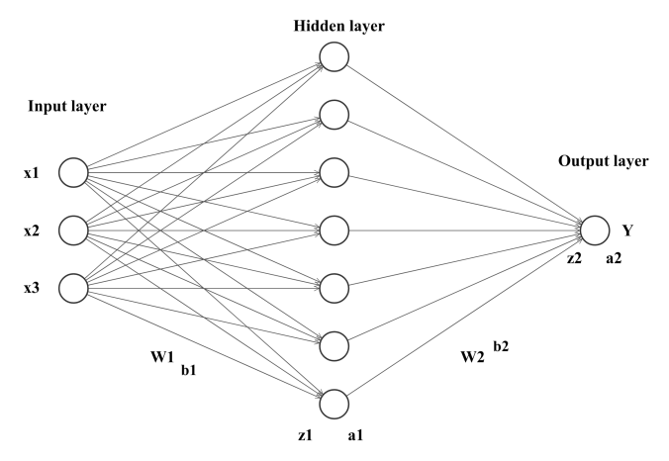

Ultimately, leads to the following for **one observation:**

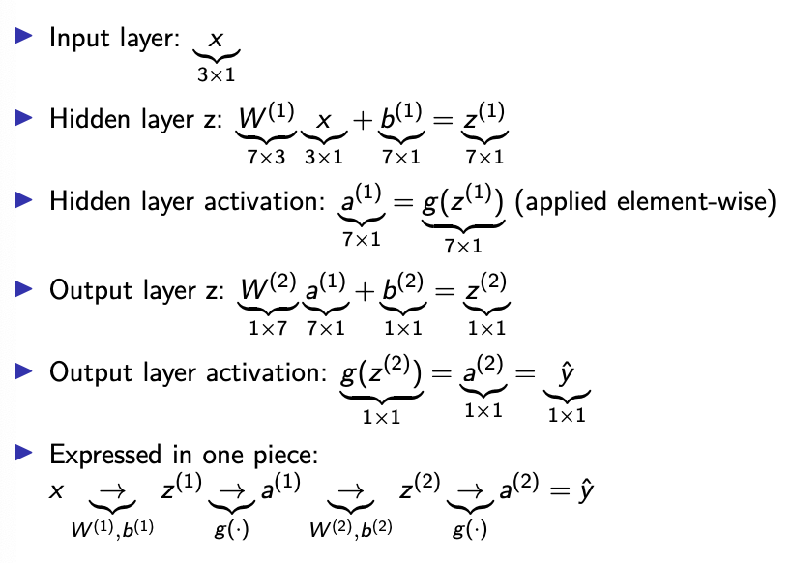

**Universal Approximation Theorem**

* Under certain regularity conditions, a single hidden layer neural network can approximate continuous functions, that map from [0, 1]^k to the real number line arbitrarily close.
* This says **nothing** about how we can practically find the optimal weights of such a network, just that it exists.
  + Networks are shown to react more quickly and improve quicker to greater depth than width for finding optimal weights.

**Cost Function: The loss aggregated over training observations.**

* Often shown in terms of Theta.

**How do we compute things in a network?**

**1. Forward Pass**

The computation of output values from some input samples is called **forward pass.**

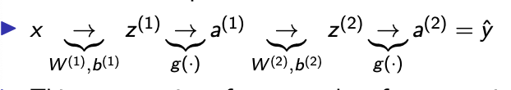

Recall the chain rule: 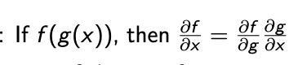

Next, we derive the gradient vector of the cost function to use it in gradient descent.

**2. Backpropagation**

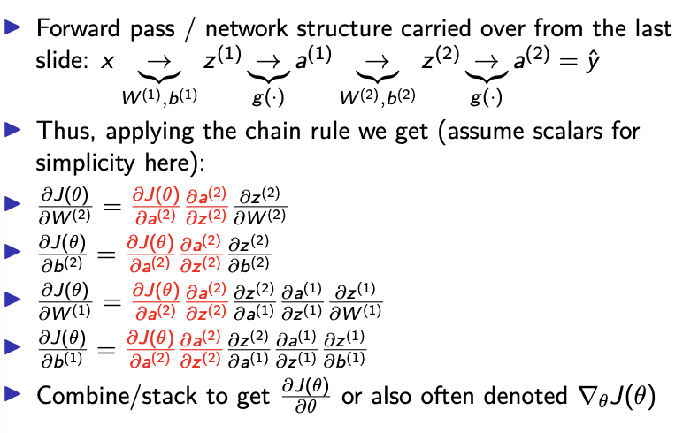

Why do we care about backpropogation? It gives us the derivate that we then use to optimise the network!

**Computation Graphs**

Modern libraries such as PyTorch and TensorFlow depict networks as computation graphs. The gradients they compute flow through the individual elements of that graph. This modular structure allows to easily process gradients also in much more complex architecture than the one shown below.

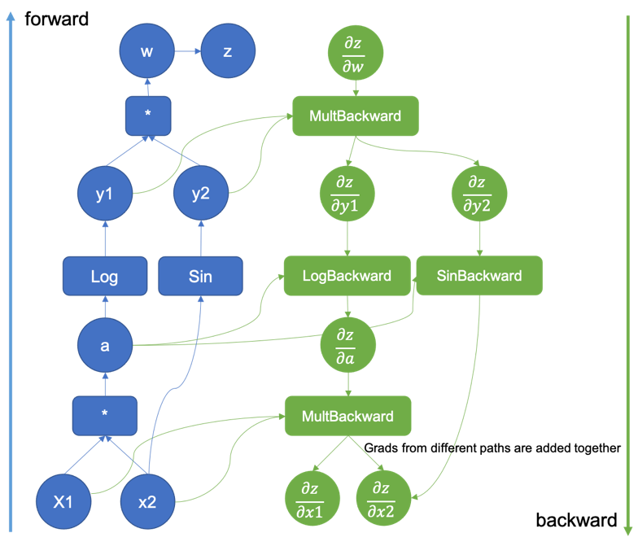

**Gradient Descent for Neural Networks**

Computing the gradient for the entire dataset **(full batch gradient descent)** is usually computationally too costly. Instead, we approximate the gradient of the full training data with either the gradient of a single observations **(stochastic gradient descent**) or with the gradient over a small batch of data **(mini batch gradient descent).** Importantly, note that as cost/loss functions for neural networks are mostly **nonconvex**, these algorithms may converge to **local optima,** but typically not global ones. There are also likely many **cost/loss saddle points** in high dimensional parameter spaces. Why?

**Stochastic**

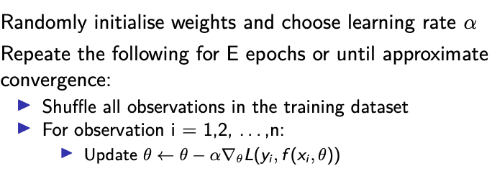

**Mini Batch**

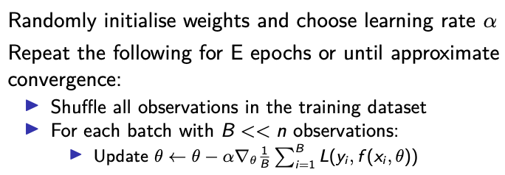

**Gradient Descent Optimiser Options:**

* SGD is too noisy, mini batch optimisation is the most common choice.
* There are some particularly popular optimisers which have proven robust and applicable to a wide range of tasks and models, e.g., Adam or RMSprop
* Include moving average-based momentum of gradients that is not part of plain vanilla gradient descent.
* A good starting point is usually Adam.

**Regularisation**

With their very high numbers of parameters, neural networks can memorise large amounts of data and relatively easy over-fit.

Possible approaches to counter over-fitting are:

* Add L1 or L2 norms of weights to objective function.
* Dropout: Randomly set a fraction of p neurons in a layer to zero during training and thereby force a warying sets of neurons to learn patterns. In essence trains an ensemble
* Early stopping: Stop the gradient descent once the loss on some validation set increases.
* Add noise to activities during training.

Other options might be:

* Batch normalisation: Normalise over observations in a batch.
* Layer normalisation: Normalise over activations in a layer for each observation.
  + Weights are initialised randomly, but the approach matters. For example, have a look at heuristics such as “He” or “Xavier” initialisations.
* Residual connections/skip connections/shortcut connections:
  + Skip some layers and directly connect output of one layer to another layer allowing some information to flow more easily.
* In general, often helpful to first fit the model to a very small sample of the data and see whether it can perfectly fit it. If not, then there might be some issues.

**Hyperparameter Optimisation**

The amount of **hidden layers, activations, neurons per hidden layer, the learning rate, dropout percentages, degree of regularisation with norms, etc.**

* Imagine you have 10 hyper-parameters and for each of them 10 possible values in mind, then you would have to search through a grid with 10ˆ10 possible combinations and train a model for each of them (this quickly becomes infeasible and is referred to as the curse of dimensionality).

**Convolutional Neural Networks**

Convolutional neural networks are often used for computer vision, but can also be used for other tasks. They **learn filters** and **combine operations** such as convolutions and pooling.

We use filters that we learnt with gradient descent. The first filter tends to blur an image, with the second one detecting the edges of the image.

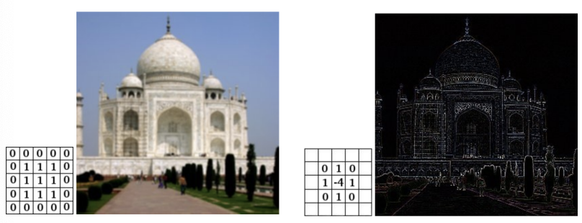

**Pooling**

We take a convolved image that we get from applying filter to image and we use ‘max pooling’ which takses the largest value of each slice, such as follows:

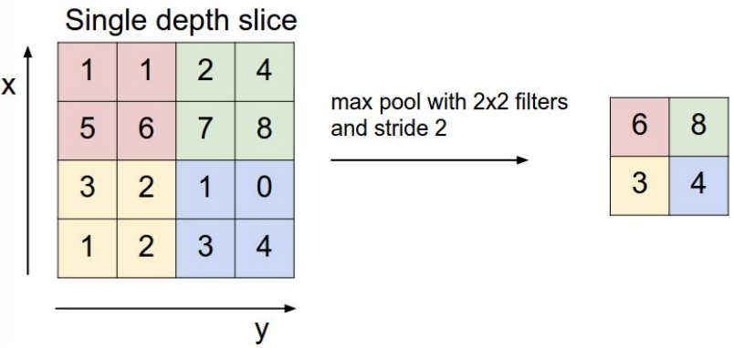

We can also use average pooling!

**Recurrent Neural Networks**

Recurrent neural networks (RNNs) can process sequences of inputs and predict sequences of outputs. Single-layer perceptron before feeds into next, which learns from next, etc.

* RNNs are e.g., used in machine translation, sentence completion, sentiment analysis, image captioning, etc.
* Common types of RNNs such as Long Short-Term Memory (LSTM) or those with Gated Recurrent Units (GRUs) are based on cells which improve the model’s ability to remember long term dependencies.
* Potential challenges: Vanishing/exploding gradients and limited parallelisability of sequential computation.
* More recently, transformer neural networks have taken over a lot of these tasks (discussed in a bit).

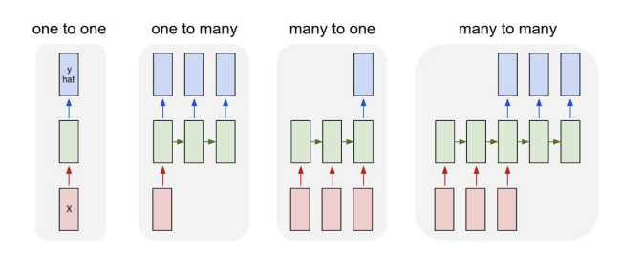

* Arrows are functions/transformations, rectangles are vectors, green rectangles hold states.
  + One to one: Standard feedforward neural network/MLP
  + One to many: RNN that e.g., takes an image as input and then outputs a sentence describing it.
  + Many to one: RNN that e.g., inputs a sequence of words and outputs a sentiment label .
  + Many to many: RNN that e.g., inputs a sentence in one language and outputs it in another language.

**Transformers**

A key innovation in machine learning in the last years has been the transformer architecture.

**Context**: Text up to a maximum length in which dependencies between words can be considered. Let’s use “Machine learning is interesting” as an example

**Tokenisation**: “Machine learning is interesting” might become [4, 42, 17, 100] with each integer referring to a word in an overall vocabulary (assume for simplicity here that tokenisation is done at the word level). Hence, these models actually just input sequences of integers and also output integers and these have to be translated back into text

**Embeddings**: Each token is represented by a numerical vector of some chosen dimension - a so called embedding (in transformers there are actually also additional vectors representing each position in the context).

**Attention (much simplified):** Weights on vectors in a context that encapsulate how relevant each is for each other’s meaning. For the text “not a good day”, an updated vector for “not” should depend more on/communicate with/pay attention to/have a higher weight on the vector of “good” than on that of “day”. A set of attention weights sums up to one

**Feedforward neural network:** Just the MLPs discussed before

Attention weights and other network parameters are learned through training on very large amounts of text and with typical variants of gradient descent

**Transformers**

Minimising loss function is central to how transformers learn.

* **Tokenisation** 
  + *A text such as “Machine learning is interesting” might become [4, 42, 17, 100]. Each integer maps to a word in an overall vocabulary.*
* **Context**
  + *A sequence of tokens between which the model is able to consider dependencies; there is a maximum context length.*
* **Embeddings**
  + *Each token is represented by a numerical vector of some chosen dimension – a so called embedding (in transformers there are actually also additional vectors representing each position in context). Embedding puts a token in some space – tokens should move closer together if more similar.*
* **Attention**
  + *Weights on vectors in a sequence that encapsulate how relevant each is for each others’ meaning. For text ‘not a good day,’ an updated vector for ‘good’ should depend more on or communicate more with or pay attention to ‘not’ more than ‘day.’*
  + *The temperature parameter determines what probability distribution next tokens are sampled from. A high temperature allows for more tokens with low probability to be predicted next.*
  + *A set of attention weights sums up to one:*
* **Feedforward Neural Networks**
  + *MLPs discussed before*
* **Attention Weights**
  + *Learned through training and iterations.*

**Chat GPT (Generative Pre-trained Transformer)**

* Function needs a very rich contextuality to get level of coherence.
* Ends when it samples an ‘end-of-answer’ token, which is a special token.
* Supervised learning to begin:
  + Begin with human prompts and human answers
  + Then train on rest of internet
  + Then reinforcement learning and active learning approaches.

**Unsupervised & Reinforcement Learning**

For unsupervised learning, we discuss two facets:

* Dimensionality Reduction
  + Reducing amount of columns
* Clustering
  + Picking appropriate subsets of rows.
  + Hierarchical or non-hierarchal.

**Dimensionality Reduction**

Often, we have correlated and noisy features. Ideally, we would like our features to each convey independent information. In reality, we often have redundant or superfluous features. In some supervised learning applications the goal is to extract the main components out a range of noisy features and then use them as regressors.

We are also often limited by computational complexity of classifiers, and even when we can train – our function cannot be visualised easily.

**Principal Component Analysis (PCA)**

Principal Component Analysis (PCA) yields a low-dimensional representation of a dataset. It finds derived variables which are linear combinations of the old variables, have maximal variance, and are mutually uncorrelated. We are maximising the variance captured using only X columns. PC’s are linear combinations of other features.

A PC is characterised by a loading vector and a singular-value decomposition.

First, we centre dataset to have mean zero by subtracting mean. We then look for the linear combination of the sample feature values.

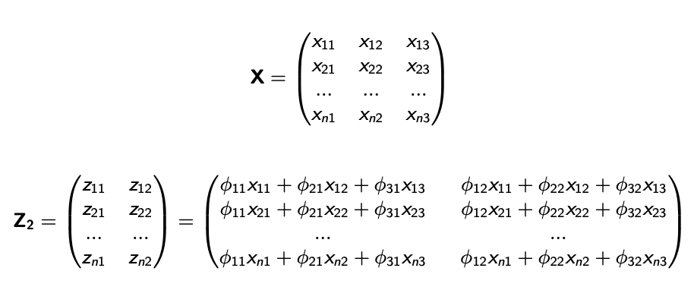

Then, we plug in zi1, the first principal component loading vector, to maximise variance, and solve the following optimisation problem:

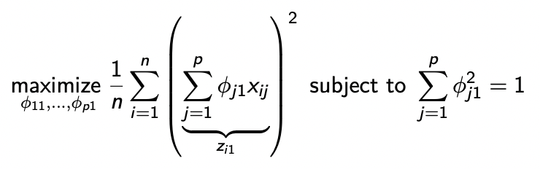

The problem can be solved via a singular-value decomposition of the de-meaned matrix X, a technique from linear algebra.

The loading vector for PC-1 defines a direction in feature space along which the data vary the most. The second principal component (in a two-PC analysis) is *orthogonal* with the first PC, meaning it has a dot product of 0 with the first PC and thus is **completely unocorrelated** with the first PC.

Scaling matters! Everything needs to be de-meaned so that we account for differences in absolute values which affair variance statistics. 